New Service – Adding School Breakfast for The Very Young
Impact of hunger on children
Research shows that skipping breakfast affects the cognitive abilities of children resulting in poor alertness, attention, memory, processing of complex visual display, problem solving, and mathematics. Children who come to school hungry are also more likely to repeat grades and manifest behavioral and emotional problems. Today we have very clear evidence for the correlation between undernutrition and poor cognitive functioning. This is why IFA began serving school breakfast for the very young in addition to the noon time nutritious meals.
Health and Learning Gains of Eating breakfast
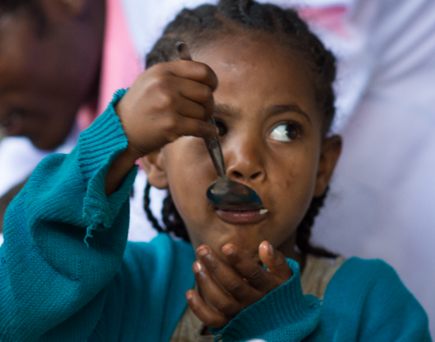
By providing breakfast to the KG students at Lafto Primary School and Hana Primary School we expect to make a difference in the lives the children, both health wise and academically. School breakfast will amplify the benefits as it will also result in improved school attendance. Such gains have a more pronounced effect on children from food insecure households. We have already witnessed decreased symptoms of hunger and have plans to further improve the nutritional content of the breakfast menu.

To inspire your generosity…”Doubling Your Dollar Matching Fund”
International Fund for Africa believes that children living in poverty should be given the chance to rise above their circumstances by gaining access to quality education and health services. We are excited about an opportunity that will position IFA to continue our work through a matching fund that is capped at 100,000.00 USD by a generous, anonymous philanthropist.
This means your gift of $100 will be matched with an additional $100, making a total of $200 available to provide a nutritious school meal for 100 school children for one month at one of the rural schools IFA is supporting -Jihur Primary school.
So please help IFA take advantage of this exciting opportunity by acting now so that our generous donor will match what you give, dollar-for-dollar, until we reach 100,000. We have six months left to meet this the deadline.
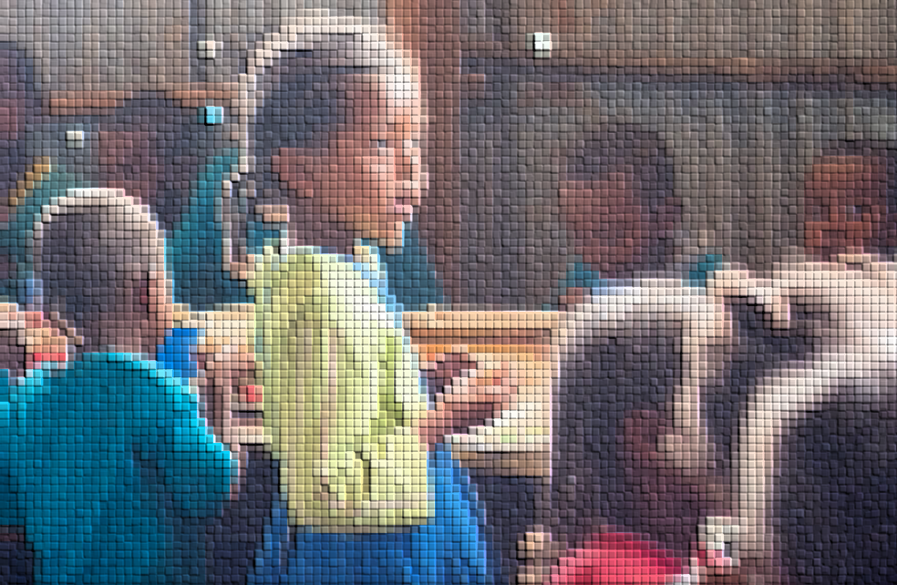
All photo credits go to Jo-Anne MacArthur

