IFA’s NEW VENTURE - VOCATIONAL TRAINING IN TAILORING AND DRESSMAKING
In line with IFA’s vision of improving the lives of the disadvantaged who face the many challenges of multidimensional poverty in Ethiopia, IFA is adding a new project in vocational training through the support of private corporations. We believe such projects that invest in the lives youth and adolescents will have far reaching consequences, as verified by the new report published by The Lancet in April 2017. The report estimated that an investment of 4.60 USD per person per year in projects that target adolescents will have a tenfold return on investment.
The under 25 population in Ethiopia, like other countries in Africa is around 60%, and ensuring that this demography become skilled workers will alleviate poverty, but the failure to do so poses many risks to societies and communities.
Taking such clear data into consideration IFA is launching one of the several vocational training projects which are in the pipeline. For our first vocational training program – IFA in consultation with district officers is in the process of selecting 12 high school dropout girls as the first batch of cohorts to train as tailors at Arakele PLC and equipping each with a starter tailoring kit.
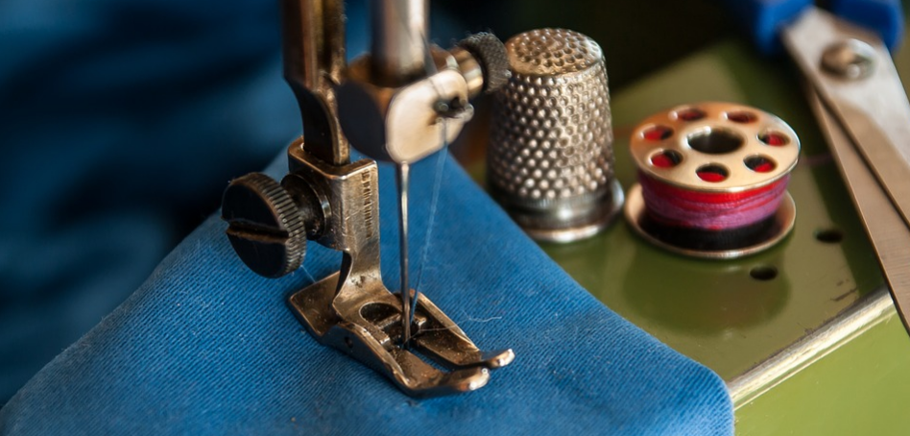
This project is built upon our relationship with the founder of Arakele PLC, which has a social enterprise wing through which IFA’s beneficiaries are receiving tuition free training in tailoring. Graduates will be closely mentored and assisted in job placement or self-employment.
We have the following vocational training programs in the pipeline:
- Seek more sponsorship opportunities for vocational trainees to enroll in certified vocational training g programs
- A three-month certificate level vocational training program in mushroom production
- A three-month certificate vocational training program in bread baking
One of IFA’s long-term plan is to setup its own certified, vocational skill training center.
IFA is eager to scale up and expand such vocational training projects which will take advantage of ETHIOPIA’S “DEMOGRAPHIC DIVIDEND” thus ensuring sustainable impact.
You can join us by investing in our youth and seeing remarkable, sustainable and lifechanging returns.

