IFA’s Celebrates Earth Day Throughout the Year

At IFA we
Make Everyday Earth Day
by promoting
PLANT-BASED EATING

IFA supports the growing trend toward healthier and more sustainable living in Ethiopia through the School Health and Nutrition Program in public schools. Two times a day IFA servs school meals that reflect a strong commitment to high-quality, local, fresh produce.
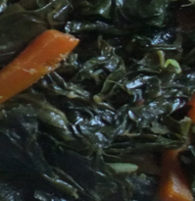
Cabbage & Carrots Collard Green & Carrots Avocado & Tomato
Plant Based Diets and Earth Day
Less greenhouse gas emissions Producing plant-based meat alternatives generates 10x fewer greenhouse gas emissions than producing similar beef-based products. Providing beans instead of meat reduces greenhouse gas emission.
Efficient use of land, water, fuel, and fertilizer - Producing 1kg of kidney bean protein requires 18x less land, 10x less water, 9x less fuel, 12x less fertilizer, and 10x less pesticides than producing 1kg of beef protein. Substituting beans for beef in the diet would free up large swathes of cropland.
Promote efficient consumption of protein - It takes 10g of vegetable protein to create every 1g of animal protein
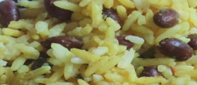
Beans & Rice
At IFA we Make Everyday Earth Day through our Mushroom Farm that is Designed to Steward the Environment
According to a new study mushroom is not only healthy, it’s also gentle on the planet based on measuring the water, energy and carbon emissions required to grow and harvest fresh mushrooms. The study found producing one pound of mushrooms requires only 1.8 gallons of water and 1.0 kilowatt hours of energy and generates only 0.7 pounds of CO2 equivalent emissions. In addition, the annual average yield of mushrooms is 7.1 pounds per square foot – meaning up to 1 million pounds of mushrooms can be produced on just one acre.

IFA want to ‘do better’ when it comes to being stewards of the environment. We are eager to finally launch our mushroom farm next month as it is a means of not only providing nutritious meals, but we are proud that it is a project that has a low environmental footprint.
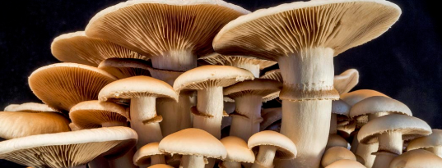

Mushrooms require:
- little water
- little electricity and fuel for composting and growing
- little growing space therefore conserves soil

Join and support IFA and together let us steward our activities to make everyday Earth Day!

