IFA Welcomes New Project Staff

Tigist Yohannes – School Eye Health
It is with pleasure that IFA welcomes Tigist Yohannes to join the School Eye Health Project of the Sustainable School Health and Nutrition Program as an Optometrist.
Tigist has a BSc in Optometry from Gondar University and is licensed as a junior optometrist by FMHACA (Food, Medicine and Healthcare Administration and Control Authority). She comes with over four years of experience garnered from both the private and public sectors of the healthcare delivery system of Ethiopia. Tigist has the relevant mix of skills and qualities that IFA looks for among its staff, such as good effective communication skills, a flexible approach and good work ethics.
Tigist’s decision to join IFA was guided by her strong desire to serve under privileged children as she gave up a more lucrative job to join IFA. She is a vibrant and hardworking young woman who will help IFA realize its plans for scaling up the School Eye health project. She is looking forward to working in such a non-government, charity-based organization such as IFA to develop new skills in project management and coordination.
We thank our partner “Better Sight for Better Learning” for supporting the School Eye Health project so generously.

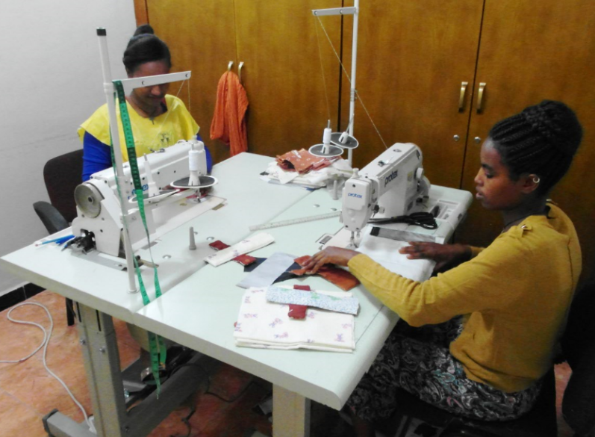
Frehiwot Tadesse and Tirhas Berihun – School WASH
It is with great pleasure and pride that IFA welcomes Frehiwot Tadesse and Tirhas Berihun as they are among the first cohort to graduate from the vocational training program in tailoring that IFA sponsored in partnership with Arakelle Fashion Design School, a private enterprise practicing corporate responsibility.
Both are now engaged in producing well-made and durable re-usable sanitary pads to be distributed to beneficiaries in the menstrual hygiene management project of the School WASH program, a component of the School Health and Nutrition Program.
Frehiwot and Tirhas were recruited and selected based on their performance, recommendation of their trainers and because of their ability to pass the stringent national competence certifying exam in tailoring. They are exceeding expectations in their new role and will be role models for future graduates.
Both Frehiwot and Tirhas are happy to be gainfully employed as a year ago they were unable to complete high school and lacked the skills required for meaningful work – their future loomed dim but today they are proud and confident in their skills and in their ability to augment the income of their families.

Every Day is Earth Day at IFA
“Earth Provides enough to satisfy every man’s need but not every man’s greed” Ghandi
On April 22 Earth Day is celebrated around the world. At IFA we are conscious of Earth Day all year round through the design of the school meals that protect the earth and help build the health of school children. Some of the specific ways we do this is by:
- Minimizing food wastage. Globally, 1.3 billion tons of edible food is wasted every year
- Serving plant-based meals which serves to reduce greenhouse emissions
- Serving locally grown foods which helps preserve plant species that are native to Ethiopia
- Serving a diversified diet

We invite you to reflect on your eating habits and share your thoughts and recommendation as we together encourage one another to take better care of the earth.

