Summer 2107 at IFA

In the summer of 2017, IFA finds itself undergoing growing pains again as we prepare to expand our flagship program - the Sustainable School Health and Nutrition - to reach a total of 700 students. The expansion will take place in the two schools: Hana PS and Jihur PS – our two most vulnerable school communities where there is higher prevalence of chronic malnutrition among school children.
During the summer months (known as “kiremet” in amahric - the main rainy season in Ethiopia), IFA’s staff engaged in:
- conducting stakeholder meetings
- analyzing and addressing gaps
- finalizing the launch of the IGA’s
- working on improving school sanitation while schools are out
- writing up annual reports
IFA positioned itself to meet the growing demands of the organization by hiring two staff members profiled in this newsletter:

Eden Getachew – Finance Officer

Eden Getachew is young lady who joined IFA as our finance officer and has a BA in accounting from Alpha University College. She comes to IFA with five years of experience in accounting under her belt. She is well versed in the Ethiopian accounting and taxation system and has already provided a much-needed relief to our Admin and Accounting team.
Eden is a hard worker whose is already showing strong evidence of her skills with the how speedily she is updating and encoding the backlog of financials documents.
Eden plans on continuing her studies to obtain her Masters in Finance and Accounting as she thoroughly enjoys her profession. She is an avid swimmer and reader.

Sirak Ayalew - Purchaser and Driver

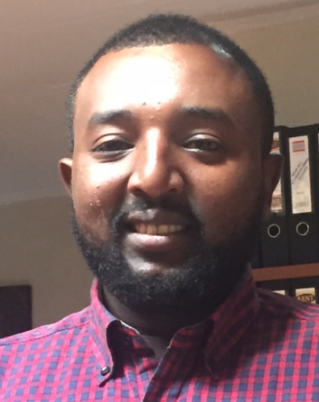
Sirak is a young and energetic gentleman who graduated with a diploma in computer networking but who worked as a liaison officer for various companies. These positions demanded a versatile set of skills, beginning from driving, purchasing, and communicating with people from all walks of life.
IFA, as a small sized company and as one that runs a tight ship was pleased to employ Sirak, who in addition to the above-mentioned skills is an excellent team player able to step in willingly where ever he is needed.
Sirak is very cosmopolitan as he was born and raised in Addis Abeba, which eases his work load as he navigates on behalf of IFA to reach projects, vendors and stakeholders.
Sirak is married and enjoys reading, watching movies and attending church services in his spare time. He aspires to become a self-employed businessman in the import and export sector as he develops his career.

