ADDRESSING A CROSS CUTTING CHALLENGE
Menstruating school girls in developing countries like Ethiopia face many taboos and lack access to hygienic products compounded by poor sanitary facilities resulting in missed school days. IFA’s Menstrual Hygiene Management (MHM) project is addressing such crosscutting issues - sanitation, education, and human rights.

The Challenge
Girls in Ethiopia face many challenges; menstruation management being one, resulting in poor school attendance and academic performance, thus hampering the realization of the SDGs (quality education and gender equality). IFA’s survey among adolescent school girls revealed:
- girls lack information about puberty and hygienic methods of managing menstruation therefore they are insecure and ashamed about manage menstruation
- girls face unsupportive social and physical environment, such as poor access to sanitary facilities and material
- girls are exposed to bullying, teasing and social isolation
This results in school absenteeism, poor class participation and low self-esteem. UNESCO (2014) estimates about one in ten school-age African girl don’t attend school during menstruation or drop out at puberty. A study conducted in Ethiopia showed sanitary napkin use was low at 37.6%, while 62.4% use rags. Urban–rural disparity in access to sanitary napkins shows 37.1% vs 1.6% (BMC Public Health, 2014). Girls participation in class was low due to fear of sudden menstrual blood leakage, as they did not use proper sanitary napkins. Many girls face risk of getting genitourinary tract infections due to unhygienic practices.

The Solution
IFA implements MHM as a component of the School Health and Nutrition Program, which provides school meals, eye health and sanitation to ensure an enabling learning environment. IFA’s MHM intervention includes:
- Promotion of community ownership:
- Begin with multiple stakeholder participation to strengthen community participation by working in collaboration with the Woreda (district) Health, Education and Women, Youth and Children’ offices
- Reaching 5 schools per year – around 2,100 adolescent girls per year
- Capacity building for girl empowerment:
- Provide expert trainer to train teachers, girls and boys on puberty and MHM
- Purchase standardized training materials in Amharic
- Deliver menstrual hygiene management training in 5 schools/year

The Focus Is Not Just the Provision of Pads
- Sustainability
- Setup a small-scale sanitary pad production team to produce re-usable, washable and environmentally friendly pads that will serve as healthy and sustainable option to school girls and that can serve as an income generating activity when sold on the market
- Distribute free of charge 5 reusable sanitary pads with 2 pad holders for 2,100 girls over the age of 12 years from 5 public schools (4 poor urban schools in Addis Ababa and 1 rural school in Amhara region) per year
- Conduct monitoring and evaluation of the project
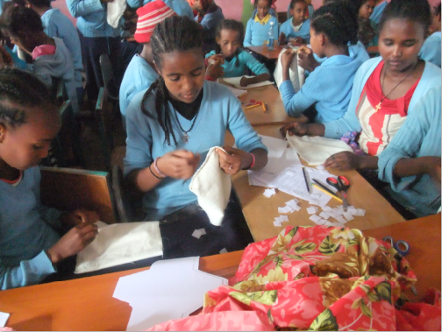
Girls making their own reusable pads

The Results
- Increased participation of girls in class during menstruation
- Improved retention and grade promotion of school girls
- Reduced menstruation-related absenteeism
- Increased advocacy of MHM interventions by schools
- Increased percentage of girls that can answer basic questions about MHM
- Increased percentage of girls hygienically using reusable sanitary pads.
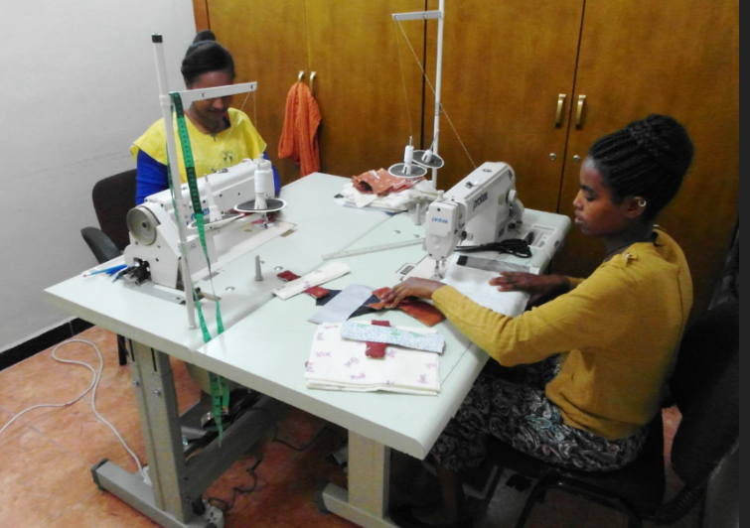
Small scale reusable sanitary pad production by IFA

Educating girls makes a huge difference!

Please join our efforts!

