WOW Moments of Summer 2019 for IFA

IFA Observed Ethiopia’s National Green Legacy Day
The summer months in Ethiopia are called “Kirmet”, the season when Ethiopia experiences heavy monsoon rains and cold temperatures. Schools are closed and many children help their parent plough and sow the land.
This year Ethiopia launched an ambitious nation-wide tree planting initiative. On July 29 Ethiopia celebrated GREEN LEGACY DAY BY PLANTING 200 MILLION TREES IN A DAY. IFA joined this great initiative by planting 200 trees at Hana Primary School where IFA runs a summer program for 250 students.
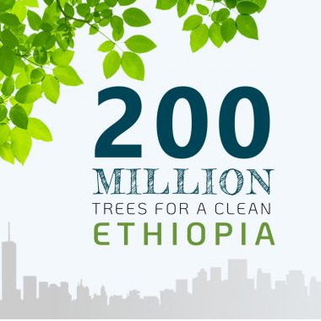
This year’s summer program started by promoting the importance of planting trees in schools. Students were sharing their knowledge with each other about the many benefits of trees - how it improves air quality, reduces temperatures and provides shade in hot temperatures and creates a favorable habitat for birds and animals. They were excited to learn that a large tree can supply a day's supply of oxygen for four people.
The enthusiasm of both the students and IFA’s staff was palpable at the realization of how even the smallest environmental investment can pay dividends for decades to come.
Students served as the primary tree planters thus allowing them to take ownership of the project and responsibility for the trees. The pre-planting activities connected them to the benefits of trees.
The tree planting project improved the aesthetic appearance of the school grounds making the campus more inviting for students, parents, teachers and the surrounding community. It also provided an outdoor teaching tool. Students learnt the species of the trees they were planting and how to properly handle, plant and the value trees. Three types of three were planted at Hana Primary School – Acacia (Gerar), Evergreen (Tid) and Cedar (Zigba). The students and the school are committed to post-planting maintenance plan.
It is good to bear in mind that there is talk of needing a trillion more trees globally – this means at a rate of planting 350 million new trees a day it would take almost 8 years (The Guardian July/2019).

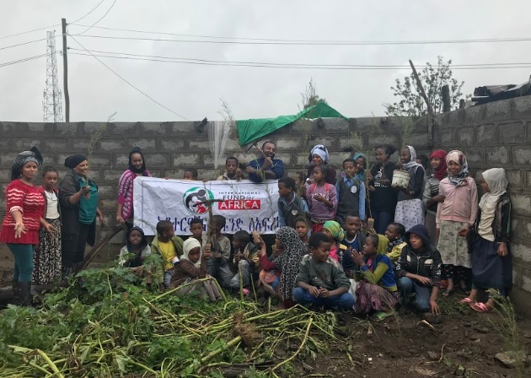
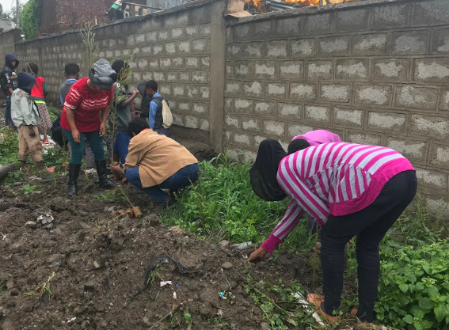

2019 Summer School Full of Fun Learning Activities
Again, this summer IFA launched a summer camp at Hana Primary School that was creatively designed by IFA’s staff with the help of volunteers from various professions. The summer program included fun learning activities leaving a memorable summer experience for the students. Some activities included:
- A bus ride to a children’s theater that was a new experience for most of the children
- All the children were taught sign language and their awareness on disability raised to help them improve their interaction with persons who have various types of disabilities
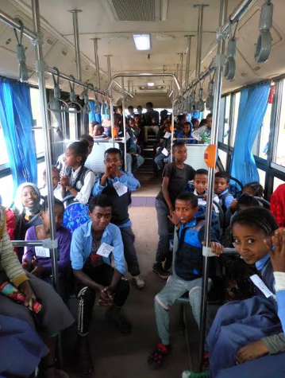
- Arts and handicraft were activities where children developed their creativity, especially by recycling waste products such as plastic bags to make
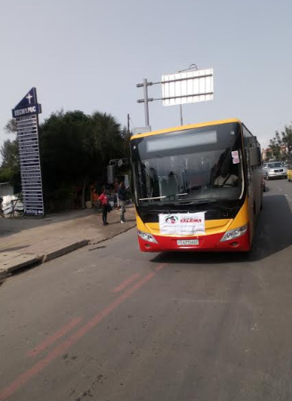
Bus ride to the Children’s Theater

All summer school students at Hana Primary School were a nutritious mid-day meal to support families as the kremt season is the leanest season for most families facing food insecurity.

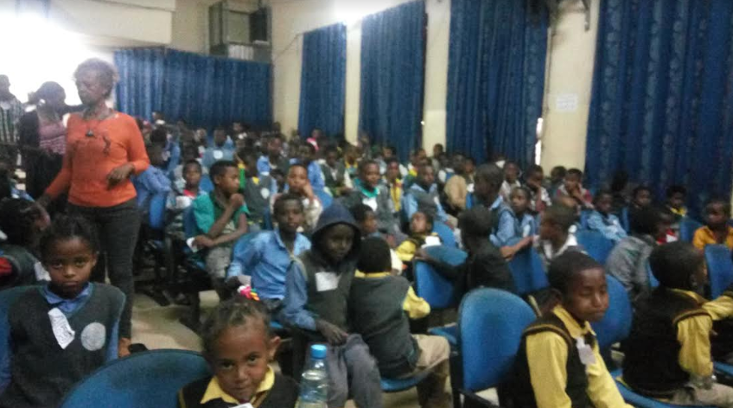
Summer School Students at The Children’s Theater

IFA is gearing up for the new school year – 2019/2020.

We Aim to:

Serve 220,000 school meals

Provide vision screening for 12,000 primary school children

Provide 156 ton of multi-grain take home rations

Distribute 10,000 reusable sanitary pads

WE INVITE YOU TO PLEASE JOIN OUR EFFORTS

AND

WE WISH YOU A HAPPY ETHIOPIAN NEW YEAR

