IFA – NOT SO TRADITIONAL

“We tend to think that, in a traditional organization, people are producing results because management wants results, but the essence of a high-quality organization is people producing results because they want the results. It’s puzzling we find that hard to understand, that if people are really enjoying, they’ll innovate, they’ll take risks, they’ll have trust with one another because they are really committed to what they’re doing and it’s fun” —Peter Senge, MIT systems scientist

Building an Engaged Team - to increase efficiencies and workplace camaraderie
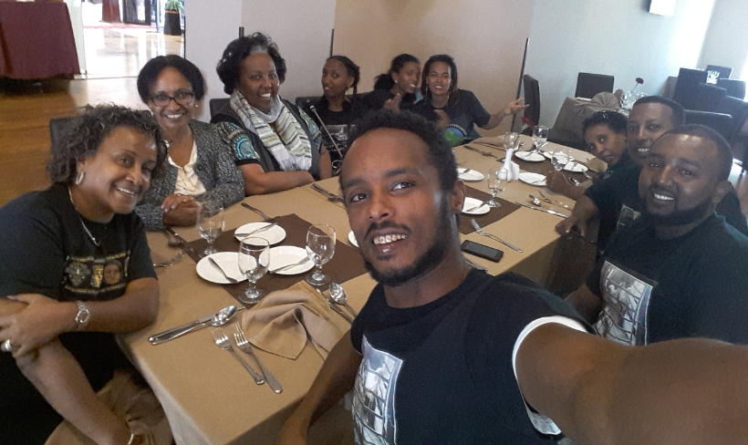
At IFA, we realized we must capitalize on our strengths and manage our weaknesses. We have a team that love their work and as we strengthen our capacity to work well together we can best balance productivity and camaraderie. So, at the end of 2017 we spent a day away from the office in a relaxed setting, reflecting and planning on how we can best strengthen and promote a culture in which coaching, communication and feedback are the cornerstones.
“A team that eats together stays together”
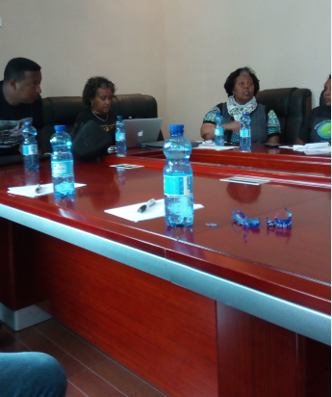
Our Country Director and the co-founder of IFA, Seble Nebiyeloul set the tone for the day by sharing her contagious passion for why she and the co-founder of IFA, Dr Anteneh Roba launched IFA 11 years ago. Listening to the birthing process of IFA was emotional for all the staff, especially as we realized how far we have come in just over 10 years. Our confidence soared as we renewed our commitment to the vision and mission of IFA. The staff were re-inspired to continue with greater determination and to work more closely together in improving the quality of life for all the vulnerable communities IFA serves.

The day was spent on reviewing:
- Where we are now? – we reviewed our mission statement to evaluated if we were still relevant and reiterated our top priorities
- Where we want to be in a year? – all the staff shared the outcomes they desired as we agreed on goals and objectives.
- How to get there? – the staff discussed a general action plans to be followed up at staff meetings with the specifics to calculates the human, capital and operating resources required to implement the plan. Going forward quarterly self-evaluation will be done to determine what is working and where the organization is stuck so that we can identify and remove barriers to improvement.
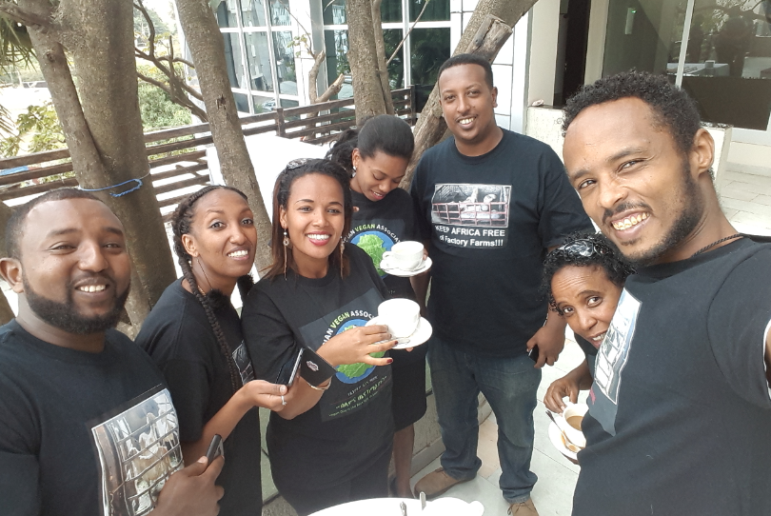
“A team that plans together stays together”

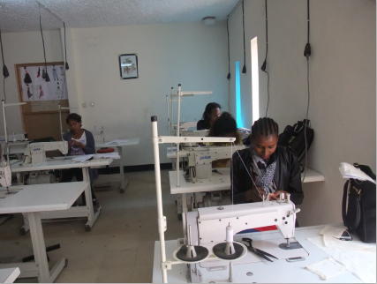
IFA – Welcoming 2018

By Strengthening its Vocational Training Initiative
In 2017, IFA launched its vocational training for youth initiative that is also focused on promoting gender equality as the initiative especially targets girls/ women. The first cohort of 11 girls received a six-month long training at a well-recognized and accredited training center in fashion design and tailoring. Most have obtained their certificates of competency and are now well positioned to compete in the job market.
Already, implementation is underway to launch a mushroom production training for 20 youth school drop outs. On completion of their 3-month long training they will be equipped with start-up kit. Thus, IFA will equip them with the knowledge and skills and a startup capital to launch their own business as mushroom producers and they can join this growing value chain.

Please join us in 2018 by sponsoring the youth vocational training project
IFA continues to work towards achieving its mission and is well positioned to deliver and implement its projects as planned. We, at IFA, whole-heartedly appreciate all our supporters and look forward to a year of working together fruitfully.
Wishing you all a Happy New Year

