IFA - Focusing on Sustainability in 2019

The Pillars of IFA’s Sustainability Plan
One of IFA’s core value is ensuring sustainability of all its programs. Such a successful transition away from donor dependency requires innovative and strategic planning. The main pillars or our sustainability plan are:
- Investing in capacity development – this entails developing the capacity of its beneficiaries through various trainings on hygiene and nutrition and by strengthening institutional capacity
- Promoting community ownership – this entails improving community participation and ownership by strengthening the School Health and Nutrition committee which is made up of local community members who are responsible for managing the SHN program. Community mobilization has resulted in participation through in-kind contributions and volunteerism.
- Launching income generating activities (IGAs) – IGAs are designed to generate profit that will ensure the economic sustainability of IFA’s the School Health Program. To this end IFA has built and equipped two bakeries which will open their doors to business once bureaucratic red tape is removed. Additionally, IFA has successfully piloted a mushroom production project in the past and is now ready to scaleup and launch a mushroom farm as an urban agricultural venture.

IFA’s Mushroom Farm
Mushroom production is a feasible IGA as there is a growing demand for mushroom in Addis Ababa. In the past IFA renovated some rooms at Sibiste Negassi Primary School (SNPS)- one of the schools where IFA run an SHN program. The trial run of the pilot scheme was successful and with the experience and lessons learnt from the pilot IFA is now ready for scale up and launch a Mushroom Farm.
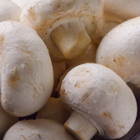
Our first attempt to produce mushroom in 2016 was initiated during one of the coldest months of the year and despite low output the result was inspiring. The output was low due to the use of excess fertilizer per square meter by workers. The workers were volunteers from Woreda Agriculture Bureau who were trained in mushroom cultivation. The initial success plus the demand for mushroom signaled that mushroom cultivation is a viable and feasible means of income generation. The high demand amongst consumers in Addis Ababa inspired us to scaleup and launch the new mushroom farm – in fact the demand shows no sign of waning.
We have found that the benefits of mushroom farming are many:
- Suitability - Unlike some other urban food crops, mushrooms do not require gardens or greenhouses and can grow inside in repurposed rooms all year round in small spaces. IFA has purchased two 40ft containers to repurpose and setup the mushroom production unit according to the plan designed below (which was developed in collaboration Addis Ababa University).
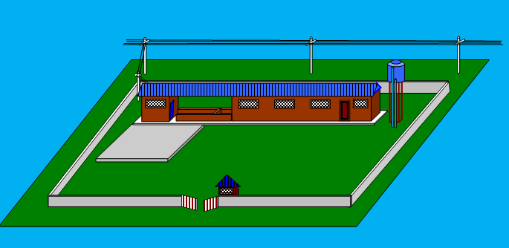

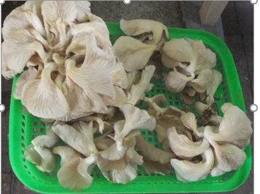
- Health Benefits - Mushrooms are delicious and rich in proteins, vitamins, and minerals while containing little fat. Certain mushroom species are known to provide anticancer and anti-viral properties and have the potential to reduce cholesterol and the risk of heart disease therefore mushrooms are a good addition to the school meals IFA serves.
- Socio - Economic Reasons - Mushroom farming can have a significant role in supporting the local economy and generating additional employment. It requires relatively low set up costs and in Addis Ababa, the demand for mushroom and its market value are high. Besides its income generating aim, IFAs mushroom farm will be used as a training center for Harvest from pilot project youth who drop out of high school to gain knowledge and skills in mushroom cultivation and entrepreneurship and create self-employment opportunity.
- Environmental benefit - Production of mushrooms is known to use waste as substrate, thus helps in disposing huge quantities of dead organic waste.

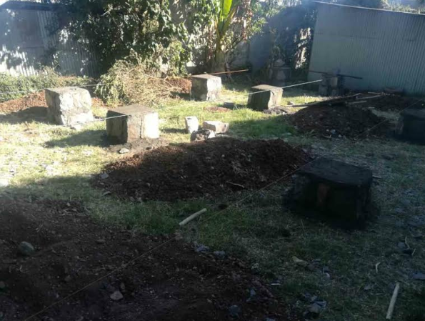
Mushroom Farm - site preparation for setting up refurbish containers

At the close of 2018 – we thank you for your interest, support and involvement in IFA’s work in Ethiopia.

WE WISH YOU A HAPPY AND FRUITFUL NEW YEAR

WE LOOK FORWARD TO MAKING 2019 A YEAR DEDICATED TO ACHIEVING SUSTAINABILITY WITH YOU

