The Year 2019 Pictorially
As we look back at 2019, IFA is grateful for our partners, supporters and the communities we work with to improve the well-being of vulnerable school children in Ethiopia.
Although it’s difficult to capture every training workshop, encounter, connection, and the high and low moments of implementing the sustainable school health program, IFA shares photos that catch memorable moments of 2019.

IFA’s School Eye Health Program
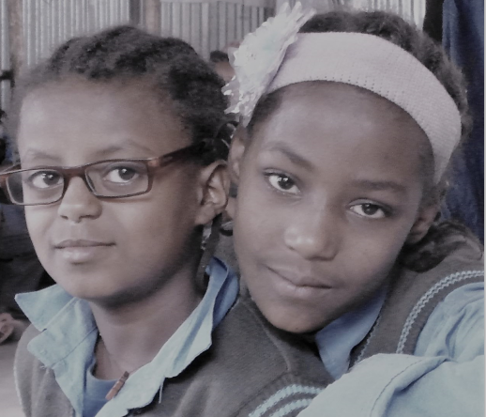
In a country like Ethiopia where the prevalence of uncorrected refractive error is around 4.8%, the majority of children do not have access to affordable eye care and eyeglasses. In 2019, IFA provided vision screening and free corrective eyeglasses to schoolchildren with poor vision in 16 primary schools. This service helped to improve the academic achievement of students so that they can grow up to lead productive lives.

IFA’s School Feeding Program – Nutritious Meals
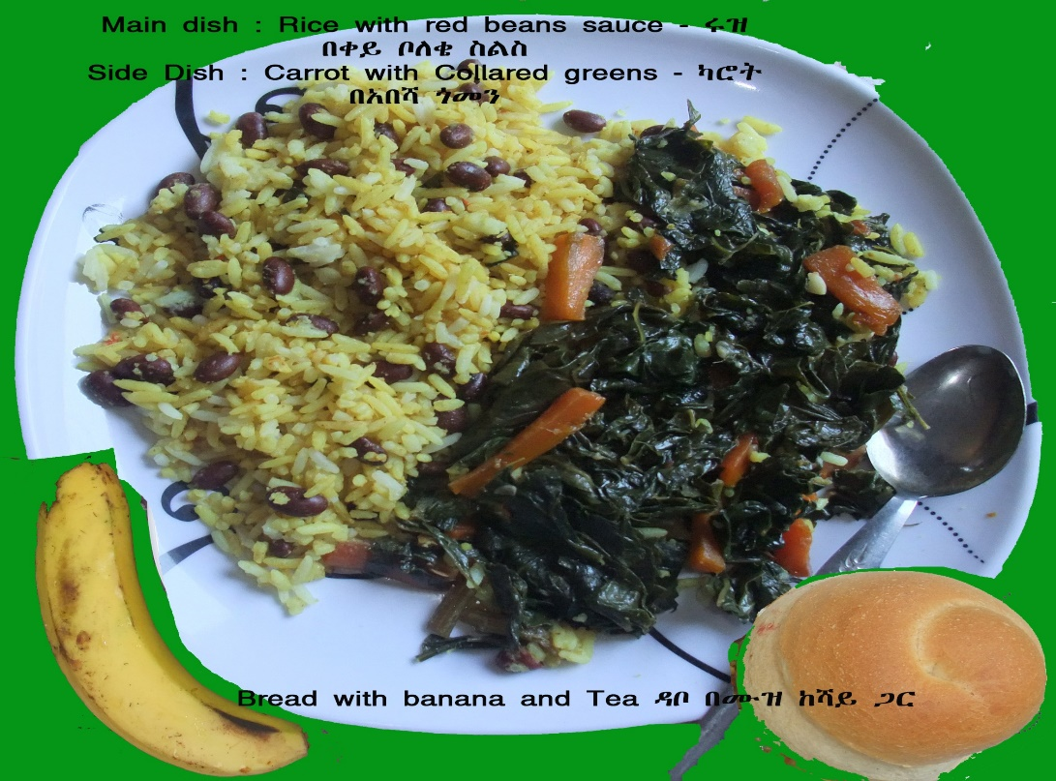

IFA’s School Feeding Program – Take Home Rations
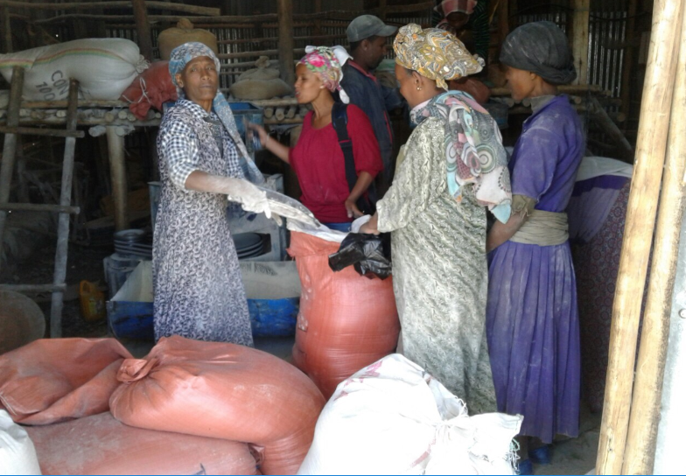

IFA, in contexts of extreme poverty and social vulnerability, is for the fifth year serving well-balanced nutritious meals to 800 school children in Addis Ababa and take-home multi-grain rations for 156 student in a rural school. The school feeding program is helping children’s academic performance by maximizing their cognitive potential. The school meals are provided in an integrated manner by addressing health care needs related to infectious diseases.

IFA’s School Hygiene and Sanitation Program
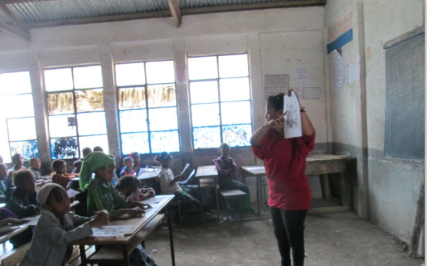
The School Sanitation and Hygiene Program is implemented to provide training, resource and infrastructure to ensure a safe learning environment for students and to reduce diseases caused by poor hygiene. IFA installed hand washing facilities, provided soap and improved access to clean water by installing large capacity water tanks.
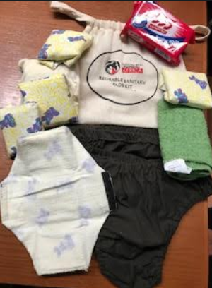
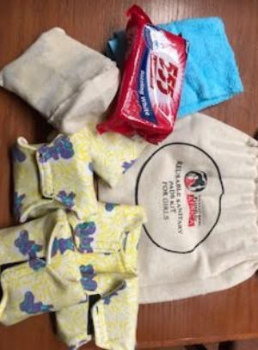
IFA is in its third year of implementing a menstrual hygiene management project by providing training and reusable sanitary pads. Studies conducted in Ethiopia show that, though most (92%) students were aware of menstruation before menarche, their utilization of sanitary napkins was low at 37.6% and a significant proportion, 62.4% were using rags and pieces of cloth. Urban–rural disparity in access to sanitary napkins indicated that, 37.1% of urban girls used sanitary napkins while only 1.6% of rural girls used this product. Menstruation-related problems resulted in 43% - 50.7% of students being absent from school between 1-4 days per month. In addition to supplying pads, IFA through its training is addressing gender-based discrimination and stigma issues associated with menstruation.

IFA’s Mushroom Farm
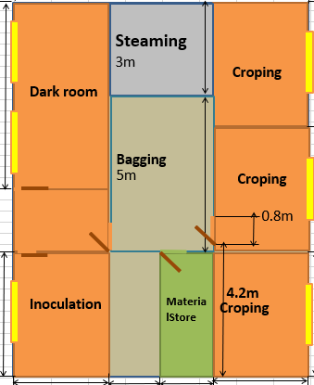
Floor plan of IFA’s mushroom farm

IFA wants to ‘do better’ when it comes to being stewards of the environment. We are eager to finally launch our mushroom farm next month as it is a means of not only providing nutritious meals, but we are proud that it is a project that has a low environmental footprint. The income generating mushroom farm will ensure sustainability by helping the SHN transition away from donor dependence and to expand the current coverage to more schools.
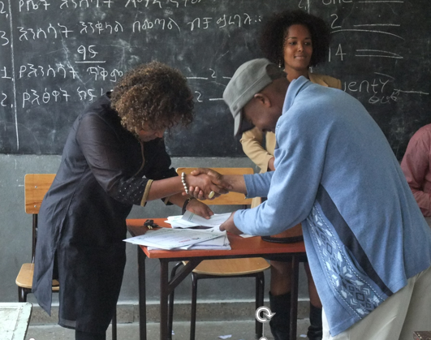
IFA works in close partnership with the school community, parents and government offices.

We thank all for helping to make all of this work possible. We're excited to continue working and learning together in 2020.

