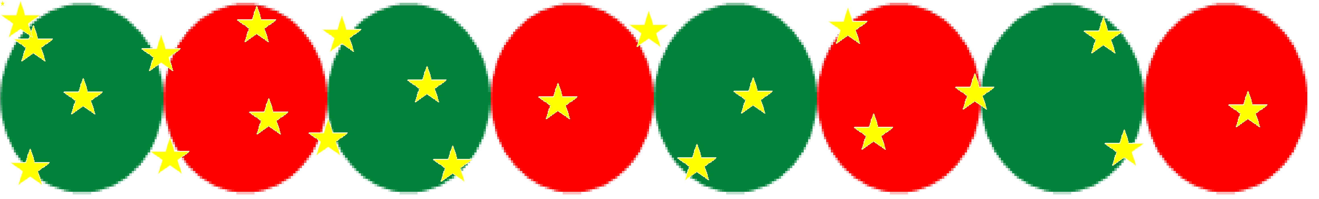

***Happy New Year 2016 from***

***International Fund for Africa***

The team at International Fund for Africa wishes you peace, joy and prosperity throughout the coming year. Thank you for your continued support and partnership.

We look forward to working with you in the years to come. With your support, we are now moving into the New Year and we take this opportunity to reflect on ourselves and take stock of how far we have come so far. Your valuable support helps us strengthen and expand our work.

We now have an established income generating activity, which is set for growth and expansion. IFA has ambitious goals for 2106; we plan to support 800 children through the school health and nutrition program, which will provide a comprehensive package: school meals, micronutrient supplementation, prevention of parasitic diseases, eye health care, improved sanitation and a menstrual hygiene management training that will reach 1,350 girls. This is why we ask that you stand with us and reap the rewards of your investments as you witness the change in the lives of children that are deprived of what so many of us take for granted..

There are many ways you can help us:

* Donate to the program through our website, here is the [link](http://ifundafrica.org/index.php?option=com_content&view=article&id=51)
* Make an in-kind donation
* Volunteer on site or remotely
* Consider supporting International Fund with your Amazon purchases this holiday season by using the smile.amazon.com page and selecting International Fund Africa as the non-profit organization of your choice. Amazon will donate 0.5% of your purchase to International Fund for Africa. The donation comes from Amazon, not you so it will not cost you a penny. If interested, [click here](https://smile.amazon.com/) and select International Fund for Africa. Please share this news with your friends and families by using the option that appears on the Confirmation page after your order is complete.

***Wishing you again a happy and prosperous*** ***2016!***







International Fund for Africa

Wishes you a

Happy Holiday!

www.ifundafrica.org