Recent Highlight
With 2017 on the horizon, the holiday season offers a moment to reflect on the impact of your generous and enthusiastic support which has allowed IFA to finish the year successfully. We are delighted to share a few recent highlights.
- We are now serving 500 vulnerable school children with two nutritious meals per school day
- Have beautifully furnished the dining room at Hana Primary to the delight of the students and the teachers – have a look at the before and after picture:
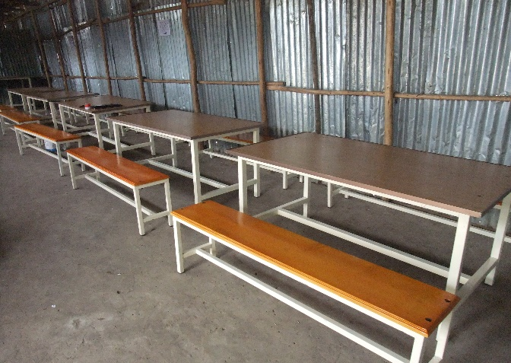
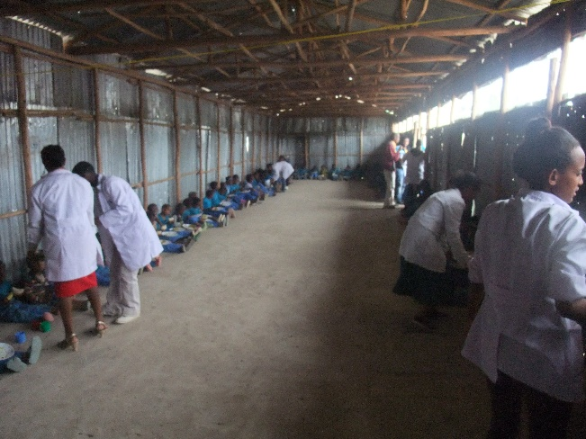

Celebrating IFA’s Supporters and Partners
We could not do this without our incredibly generous supporters and funders, who have donated their time and money so that the mission of ensuring the well-being of vulnerable children in Ethiopia becomes a reality as we renew our efforts to reach 1000 children. This is worth celebrating!
We have won grants to launch a vocational training project for 8th school drop-outs, another to expand the capacity of the bakeries (which will soon become operational) to produce injera – the much loved, traditional bread made of “teff “, a supper grain. We have the funds now to build adequate handwashing facilities for two of our schools …. many more exciting projects are being launched in 2017!

We End 2016 by Sharing some of the saying that have inspired us:
"Children are our most valuable resource."
— Herbert Hoover, 31st President of the United States

"Children are the living messages we send to a time we will not see."
— John F. Kennedy, 35th President of the United States

"There can be no keener revelation of a society's soul than the way in which it treats its children."
— Nelson Mandela, Former President of South Africa

"Children are likely to live up to what you believe of them."
— Lady Bird Johnson, Former First Lady of the United States

"When I approach a child, he inspires in me two sentiments — tenderness for what he is and respect for what he may become."
— Louis Pasteur, French chemist and microbiologist

"I continue to believe that if children are given the necessary tools to succeed, they will succeed beyond their wildest dreams!"
— David Vitter, U.S. senator

“School feeding not only fills stomachs, but has a proven track record of boosting enrollment, attendance and academic performance. For just pennies a day per child, this program changes lives – and ultimately can impact the futures of poor countries around the world in a profound way.”
-- Drew Barrymore – 1975 WFP Ambassador

As we send you our warm wishes for a joyous holiday season and a wonderful New Year we ask if you will be willing to make a special year-end donation of $50, $100 or whatever you can afford - to change lives
