IFA’s work with Debre Berhan University

About Debre Berhan
Debre Berhan is a city and woreda in central Ethiopia, located in Northern Shewa Zone of the Amhara Region, 130 kilometers north east of Addis Ababa at an elevation of 2,840 meters. It was an early capital of Ethiopia, today it is an administrative center.
In the 16th century Debre Berhan is mentioned as a mustering center and became the capital of Shewa in 1878 under the rule of one of Ethiopia’s renowned leaders – Emperor Menelik. It was the historian David Buxton who said that it was inevitable that Debre Berhan would gain importance, "Although a somewhat cold and inhospitable place," he writes about the town, "it has an obvious advantage as commanding what must always have been an important focus of routes. Even in modern times it was inevitable that the Asmara road should be brought through this easy passage, avoiding the impassable gorges on the other."
Debre Berhan’s modernization progressed as electricity was installed in 1955, schools were opened making it one of the 27 places in Ethiopia ranked as First-Class Township. According to the last national census, Debre Berhan has a total population of 65,231, of whom 31,668 are men and 33,563 women, with the majority being Amhara Christians.
Debre Berhan city is one of the coolest cities of Ethiopia, with an average annual temperature of 17.8 °C during the day and 8.83 °C at night and an average annual precipitation of 66.17mm.

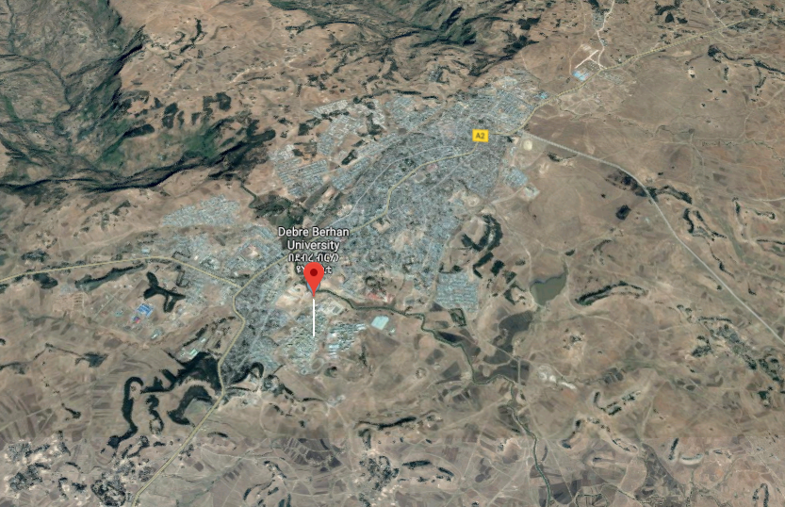

About Debre Berhane University
Debre Berhan University is found in the southern part of Debre Berhan, where IFA has and is implementing other projects IFA.
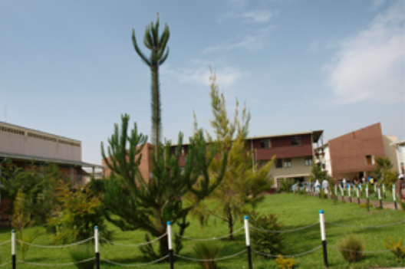
Debre Berhan University is a relatively new University founded in 2007; built on 102 hectares and displaying beautiful landscape. The intake capacity of the university has reached more than 13,000 students. It has 33 departments under four colleges, three schools, one institute and four post graduate programs.

IFA’s work in partnership with the Gender Directorate of Debre Berhan University to make it a comfortable place for girls
The 2018 Demographic profile of Ethiopia published by Index Mundi shows close to 50% of Ethiopia’s population are girls and women who fall within the reproductive age group (15-55). Women in this age bracket have a special period marker – menstruation.
In Ethiopia although menstruation is a natural process, it is associated with misconceptions, malpractices and challenges, resulting in school-absenteeism and dropout, especially in rural Ethiopia. Managing menstruation is essentially for continuing regular activities like going to school, working etc.
There are several published studies that examine the state of female students’ enrollment and dismissal rate and major factors that cause them to dropout from the higher learning institutions. Such studies reveal increasing female enrollment, but dismissal rates of female students are greater than males. The major factors for this are: harassment, homesickness, lack of assertiveness training, teachers gender insensitivity, absence of special support program, poor time management, anxiety, financial problems, lack of proper guidance and counseling services. Lack of adequate MHM is one of the gender related factors.
Over the last two years IFA has implemented a robust MHM program by providing 6,186 reusable sanitary pads, when available, as a kit which includes soap and pad holders. This program drew the attention of the Gender Directorate of Debre Berhan University whereby IFA was invited to partner with the university in their work of empowering girls.
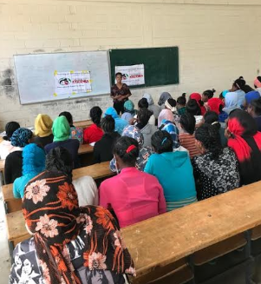

IFA conducted a need assessment and identified the target beneficiaries at Debre Berhan University (DBU). IFA’s team were thus able to deliver a customized MHM training and provide 100 girls with 10 reusable sanitary pads each. During the training university girls were sharing their stories and difficulties of their experience – most face unavailability of affordable sanitary pads and constantly fear sudden episodes of bleeding resulting in absenteeism, poor class participation and embarrassment.

IFA greatly appreciated the opportunity to work alongside the Gender Directorate office of DBU in improving retention and performance of female students. They are working at solving the financial problem of female students through grant scheme by mobilizing funds from the business sector of Debre Berhan city.
Through such projects IFA’s supporters are making a difference in the lives of many girls. All interested to participate and partner with IFA are welcome to join. We thank all who have already joined.

