IFA’s Sustainable School Health and Nutrition Program
IFA’s theory of change for the Sustainable School Health and Nutrition Program is designed to support a nutritionally smart development of interventions, bringing together key stakeholders to achieve impact. Additionally, it provides a rich process and impact framework to guide implementation and evaluation, addressing barriers to implementation, and incorporating the rationale behind approaches taking into consideration contextual influences. The framework:
Vision:
- End child undernutrition
Objective:
- Health Related - Increase availability of school-based nutrition and health services by providing two nutritious plant-based meals per day, micronutrient supplements, deworming tablets and improving hygiene and sanitation in schools
- Education Related - Increase attendance; reduce drop-out rate; Improve educational achievements/completion rates
Input:
- Targeted feeding of the vulnerable,
- Menu designed to provide plant based nutritious meals,
- Procurement of food commodities prioritizing local food sourcing,
- Delivery of meals on school site,
- Provision of complimentary health services,
- Multi-sectoral coordination,
- Financial management and resource mobilization,
- Monitoring and evaluation
Outcome:
- Improved retention,
- Improved nutritional status and health,
- Increased school achievement,
- Increased household income,
- Reduced incidence of early marriage for girls
Impact:
- Increased and inclusive social development

Local Food Sourcing
Local food sourcing is another smart intervention. Sourcing food from local producers shorten supply chains. It also reduces carbon footprint. Shorter supply chain minimizes costs of school feeding, guarantee freshness of ingredients and reduces the need for processing of the food product and other costly post-harvest handling facilities.
At IFA we simplify and facilitate the procurement system by contracting food sources based on proximity. Proximity in turn facilitates the traceability of food sources and increases access to information on the conditions of production, thereby helping IFA make healthier and better choices.

Nutritional Smartness Related to Nutritional Value
Each year school meal menus are redesigned by taking into consideration the following factors:
- the nutritional value,
- the cost effectiveness,
- local availability of ingredients
- local preferences, customs and taste
School meals for 2019/2020 were revised and on average each school child receives around 900 kilocalories from the meals served at school - this is higher than what most school feeding programs offer in Ethiopia.

Day | Main Dish | Side Dish
Monday | Macaroni with whole lentils | Carrot and cabbage
Tuesday | Red bean with carrot | Potato with Beetroot
Wednesday | Chickpea sauce | Carrot and potato salad
Thursday | Pasta with soya sauce | String bean with carrot
Friday | Fava bean sauce | Collard green with potato

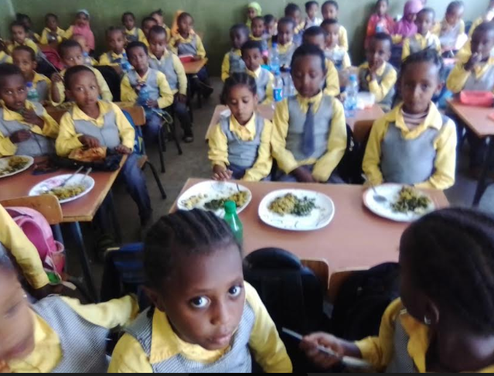
Childhood years are limited, and each day that passes without action to address stunting and improve other nutrition outcomes diminishes the potential to save children’s lives and build future human capital.
Ending child undernutrition provides equal opportunity for all children to engage in the economic growth for themselves, their families and society at large. Not only will investment in school health interventions benefit the children who are directly affected but it also benefits everyone as the its social value has a transformative effect in building an equitable society.
