IFA’s Radical Interventions – Empowering Unemployed Youth

Human Development in Ethiopia
The human development ranking has placed Ethiopia among countries which have low human development rankings. Among the indicators captured to rank human development are - life expectancy, expected years of schooling and gross national income (GNI) per capita.
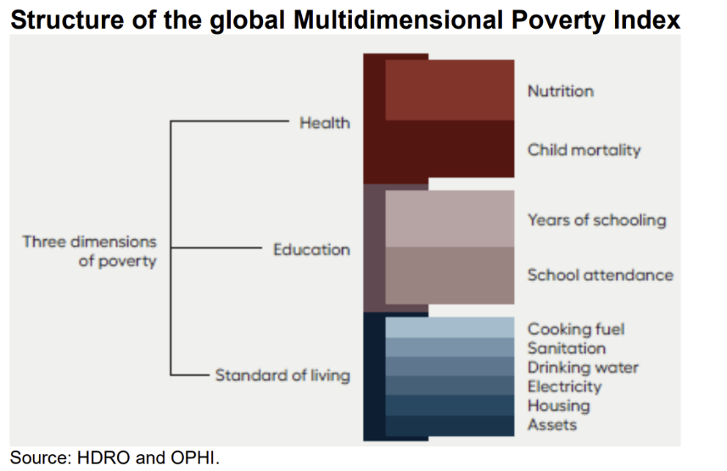
Another international ranking uses the percentage of Ethiopian population living on less than $1.90 a day as a measure to gauge income poverty. Using this measurement of poverty, Ethiopia is reported as having 31% of its population living in poverty, placing Ethiopia 22nd among the 78 countries which have people living in poverty.”(WB)
The Multi-dimensional poverty indicators (MPI), complements the other measures by identifying who is multidimensionally poor using health , education and standard of living indicators . Ethiopia’s MPI estimation refer to 2019 surveys and based on these estimates, 68.7 percent of the population in Ethiopia is multidimensionally poor while an additional 18.4 percent is classified as vulnerable to multidimensional poverty.
Poverty and its effect on health, education and total well-being has made many vulnerable. IFA’s mission is to ensure the well-being of vulnerable community members. Working to alleviate poverty clearly will improve health, education, and social wellbeing.

IFA’s Vocational Training & Livelihood Project
The task is daunting, and IFA as small organization has chosen to engage at the “human level”, not at the societal level . One project that links education, health, economics, and social issues is our “Vocational training and Livelihood Project”. The main objectives of the project are to:
- reach vulnerable youth
- shorten the transition between school and the labor market
- improving the livelihood of youth out of school
- enable graduates of a vocational training program to establish their own micro-enterprise to promote sustainability.

The project addresses the need for youth to develop skills and competencies that meet the market demands. Out of school youth, especially young women, who are unable to pursue further formal-academic education are targeted. Selection of beneficiaries are done carefully in partnership with district women, youth and children’s officers who are frontline workers and know the families in their district.`

Vocational training in Tailoring and Fashion Design
IFA has two main streams for vocational training – one in tailoring and fashion design and another in urban agriculture as means of creating jobs and or gainful employment . To date IFA has three successful cohorts in tailoring . The last cohort received sewing machines to launch their own enterprise . To prevent dependency and inspire the practice of giving back , the ones who received sewing machines made commitments to produce reusable sanitary pads to be distributed to rural schoolgirls.
Here are some the photos of the recent graduates and the program
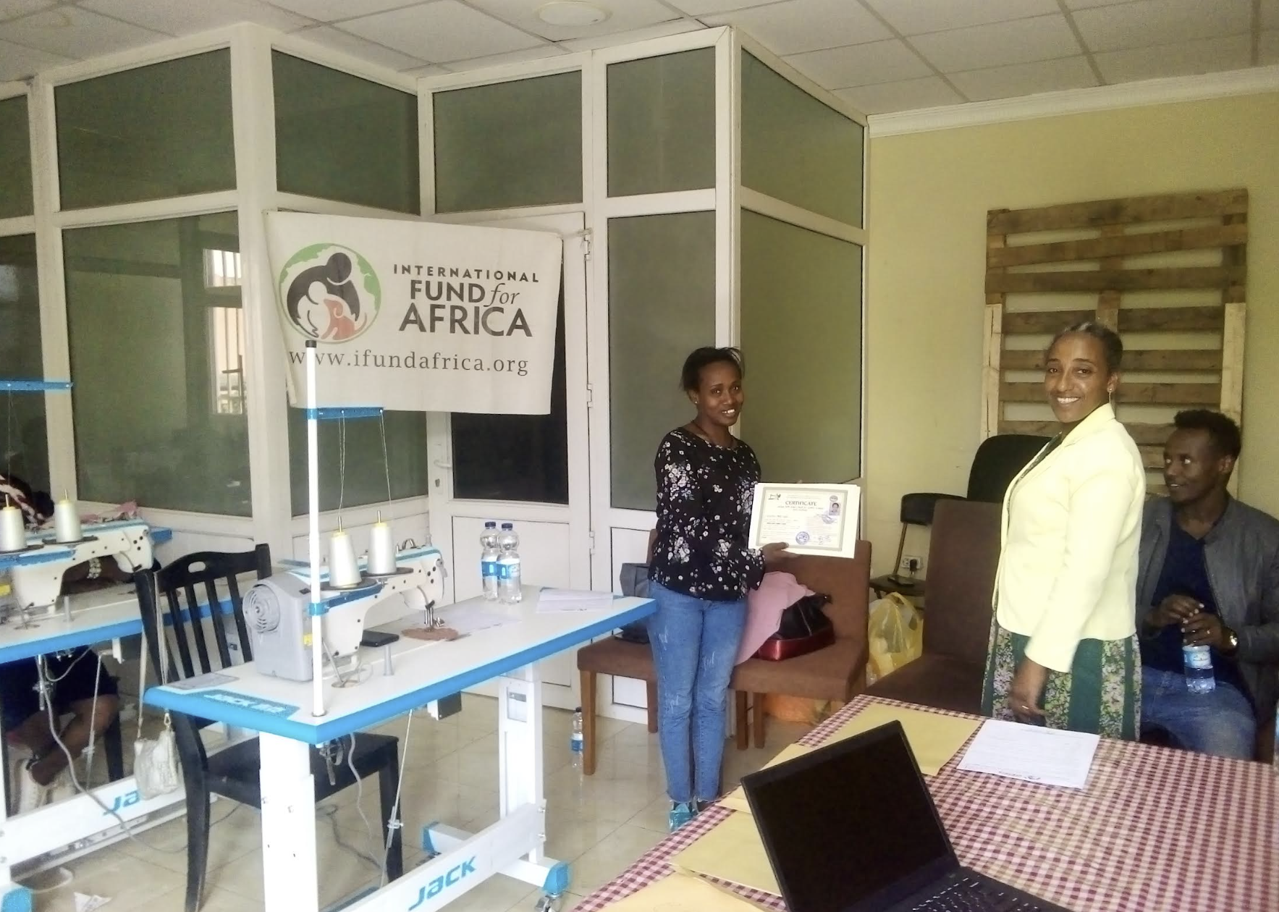
Completion Certificates awarded to graduates by the Addis Abeba Women, Youth and Children Social Affairs Officer.
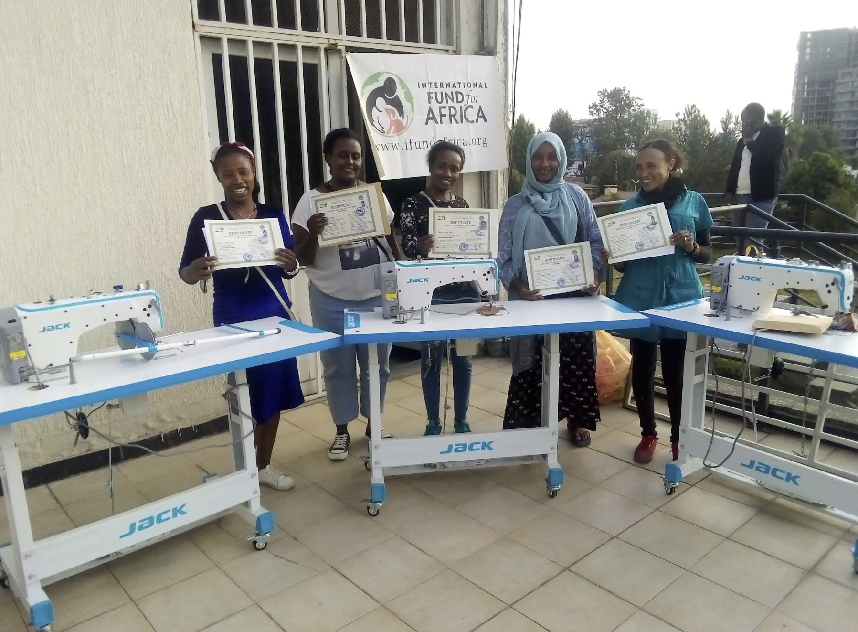
Graduates who qualified to receive sewing machines with IFA’s program coordinator.

Mushroom cultivation training in progress
The other stream IFA is providing vocation training in is urban mushroom cultivation. Graduates from this cohort will join IFA as outgrowers for of IFA’s Mushroom Farm which is the social enterprise project IFA launched in 2022.
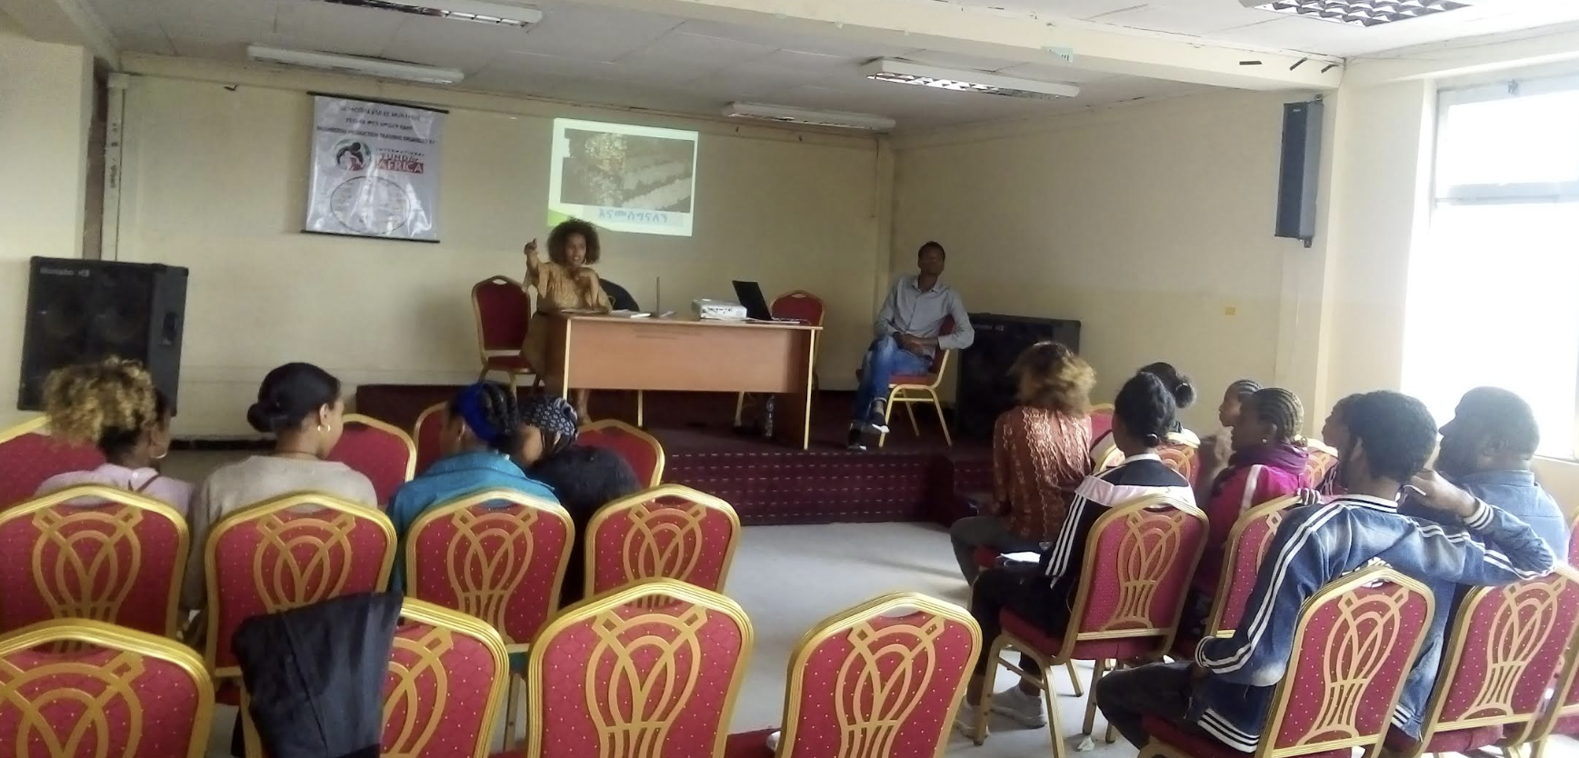
Theoretical training
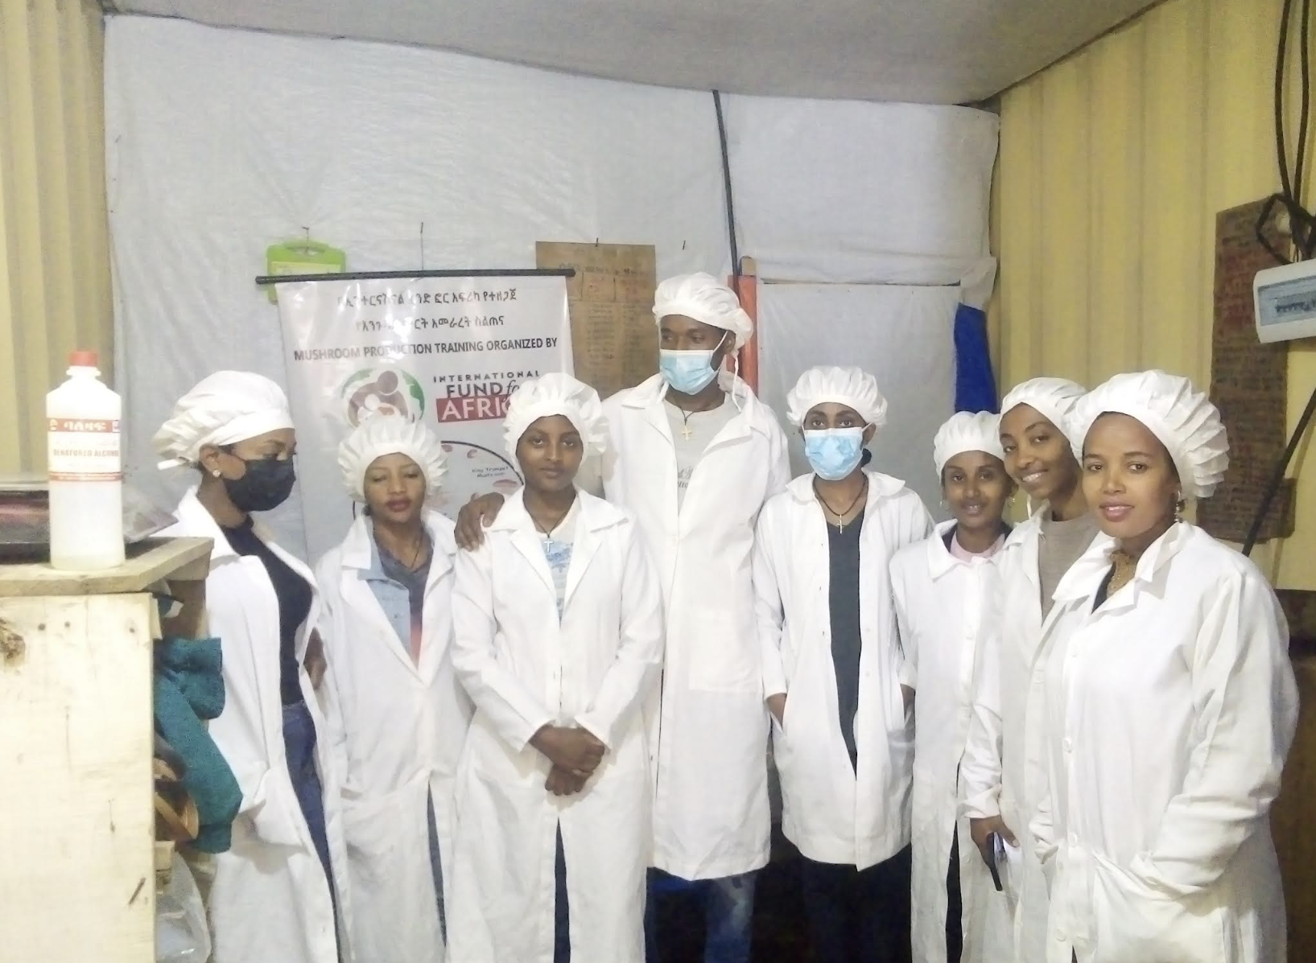
Practical training

Please Join us in Making a Difference!

