Hunger in Ethiopia
The United Nations estimates more than 220 million people are facing hunger across the African continent. (Feb 2018)
In Ethiopia, the number of woredas (districts) requiring urgent humanitarian response has returned to levels not seen since the height of El Niño drought impacts in 2016 and have increased in terms of total number affected and those classified as Priority 1 (FAO June 2017).
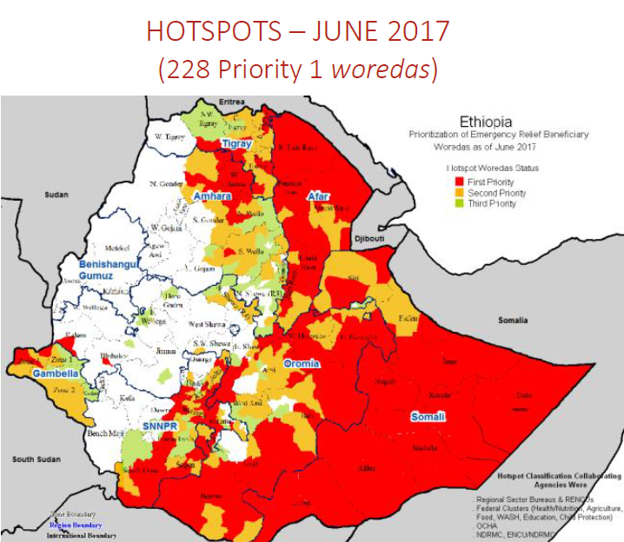

IFA’s Positive Impact Using Take Home Rations for Rural School Children
School meals may not target the underlying causes of malnutrition and food security, but they have many benefits.
Definition of School Feeding:
"targeted social safety nets that provide both educational and health benefits to the most vulnerable children, thereby increasing enrollment rates, reducing absenteeism, and improving food security at the household level". World Bank
School feeding programs use two main ways to distribute : on-site meals and take-home rations. IFA served on-site meals to children at all the five schools it is working with but as of the beginning of the current school year we started using the take-home rations (THR) method at Jihur Primary school which serves both the town dwellers of Jihur and the nearby rural community.
Each month, IFA prepares a 10kg multigrain mix for each child which contains : Barely, Oats, Teff , Corn , Wheat , Peas, Beans, Sunflower , Niger, Flaxseed, Fenugreek, Soy beans, Sorghum, Peanut and salt.
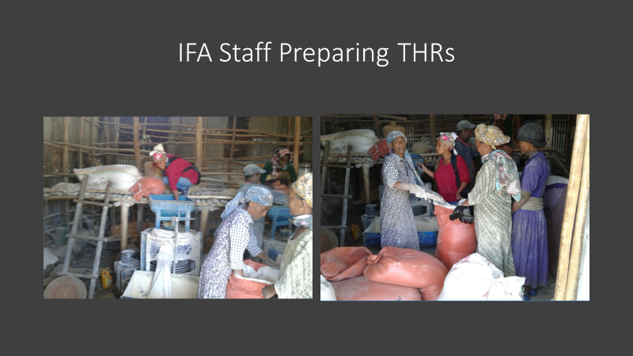

THE CHANGE THEORY OF THR
The monthly take-home ration (THR) has several benefits:
- It is shared with the whole family - Targeted take-home rations increase the nutrition of the family as a whole, and not just the members of a given family that are of primary-school age
- It is in line with what is called "home-grown school feeding," where the food provided is produced and purchased within the country, thus allowing smallholder farmers to benefit from access to a market with stable, structured, and predictable demand
- It links agriculture, nutrition and education
Linking school feeding with small-holder agriculture has a three-pronged effect (Masset, Edoardo and Aulo Gelli. (2013):
- Food security: supporting incomes of recipient households (those consuming food) and farmer households (those providing the food)
- Education: increasing school enrolment, attendance and reducing drop-out, and improving cognition and learning achievement
- Health: improving nutritional status of school age children
In countries like Ethiopia, where the prevalence of undernutrition and stunting is high, helping families feed all its members is important, regardless of whether they are in school or not.

THR – A GOOD DISTRIBUTION SYSTEMS
A recent opinion survey of the THR done at Jihur Primary School revealed that 96% of the parents and 60% of the students favor the THR more than the school meals.

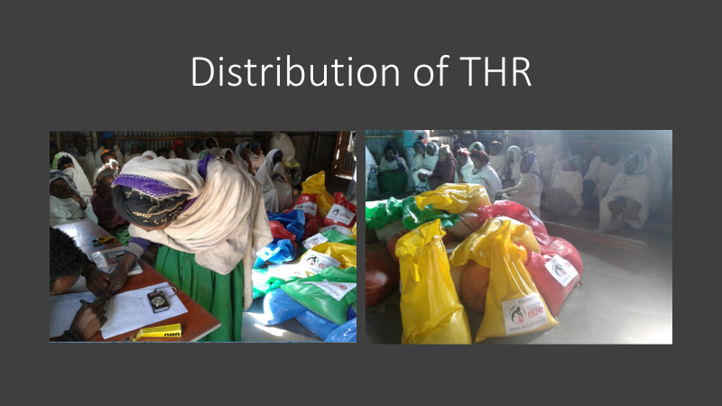

Please join IFA and sponsor the monthly take home rations delivered to children in communities that live within some of the hard-hit hot spots.

The monthly cost of for a 10kg THR is 11 USD.

The yearly cost is 110 USD.

