IFA Works to Reduce Maternal and Newborn Death

Newborn and maternal mortality rates are the most important indicators for measuring the wellbeing of women and children and also an indicator of the development of nations as it clearly reflects access to adequate health care and nutrition among other factors.

Current Status of Maternal and Newborn Health in Ethiopia
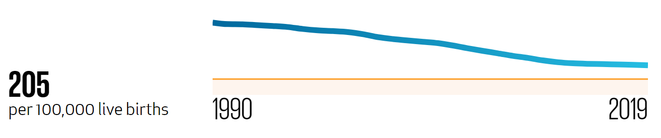
2020 Goalkeepers Report
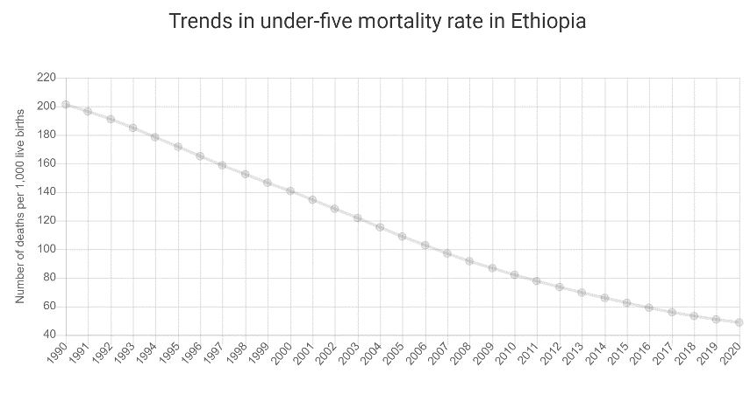
Under 5 mortality rate is 49 (2020)
UNICEF

IFA’s Intervention rationale
IFA has historically worked on maternal and newborn care by partnering with government hospitals in Ethiopia to build the capacity of health facilities by providing much needed medical equipment and supplies. Currently as part of its capacity development and rural health system strengthening program IFA is building on its achievements in the past by focusing on safe motherhood programs. Such program addresses issues of clean and safe deliveries, essential obstetric care, and preventable death and disability among mothers, expectant mothers and newborns by promoting institutional delivery and skilled birth attendant.
Interventions that increase access to institutional delivery and skilled birth attendant is a program that is proven to reduce maternal and newborn mortality. Of the many intervention one that IFA is implementing is the non-monetary incentive programs of providing baby kits to pregnant mothers. Baby Kits containing essential items for newborns and mothers who come to the maternal waiting homes. The baby kit will contain essential health and hygiene items which will help improve the lives of mothers' and babies' thus giving babies a good start in life.
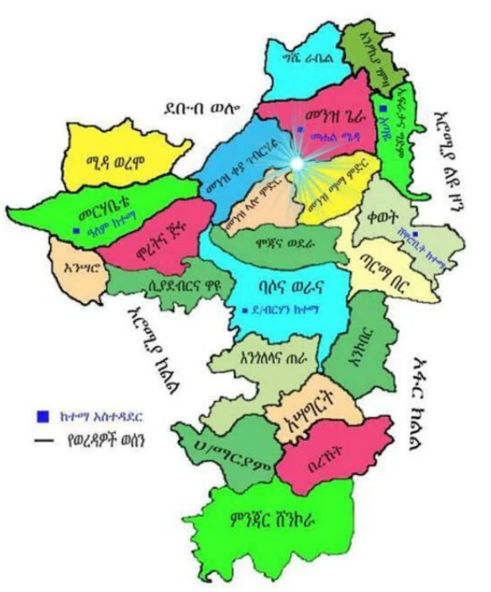
Baby Kits serve to mitigate one of the factors that hinders pregnant women from delivering at health facilities, which is the embarrassment mothers feel when coming to health facilities with poor clothing and baby wrappers – in some settings this was cited as the biggest challenge mothers feared. With this “wonder kits”, mothers will mobilize fellow mothers and amplified impact will be reduction in both maternal and newborn mortality rate.

IFA in partnership with North Shew Health Office is working with four health centers in the following districts
- Asagerit District – Ginger Health Center
- Moretena Jiru District – Enwari Heath Center
- Tarma Berr District – Mezezo Health Center
- Gishe District – Rabel Health Center
During the first round 200 baby kits were distributed. Each baby kit contains:
- 2 Newborn reusable diaper with 4 inserts
- 4 Newborn clothes and 1 towel
- 1 pair of socks
- 1 Blanket/ Comforter 110 cm X 130 cm
- 1 Wash towel
- 4 Reusable sanitary pad ( for post-partum use )
- 1 large soap
- 1 carrying bag

Let us together ensure the sustainability and scale up of interventions that improve the wellbeing of women and children.

