IFA Engages in bridging and the Humanitarian Development Gap in Ethiopia
The humanitarian situation in Ethiopia is worsening due to internal conflicts, with the number of internally displaced persons reaching 1.4 million according to IDMC, surpassing both Syria and the Democratic Republic of Congo. This is happening in a country where poverty is highly prevalent and where the ability to absorb additional shocks and stress is very challenging.
Recently, tragedy struck close when residents of Burayu, a town lying on the outskirts of Addis Ababa, started fleeing from violent clashes in September 2018. This resulted in mainly urban poor and marginalized communities being disproportionately affected as over 10,000 fled their ravaged homes and sought shelter in Addis Ababa – the city where IFA’s head office is located in Ethiopia.
We, at IFA acted swiftly by delivering much need supplies - from mattresses, soap, food, diapers, sanitary pads to clothes for over 300 displaced families who were temporarily sheltered at a school and a church in Gulele sub city. In alignment with our mission we targeted most of our humanitarian help at women and children. At time of delivery we found many women and children numbering around two hundred sitting on carpets and plastic chairs as we passed out gift packages with the hopes of offering comfort.
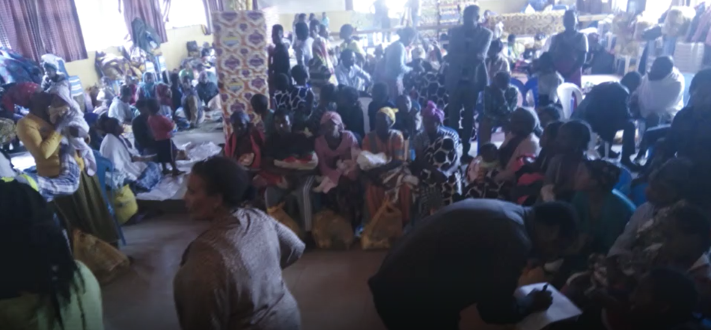
Many of the displaced person shared with us how much the care packages we delivered at the shelter helped to renew their trust in their fellow citizens and diminish the effect of the recent traumatic events. Through this firsthand, raw experience we realized how powerfully small but tangible engagements can be in addressing and reducing the impacts of displacement.
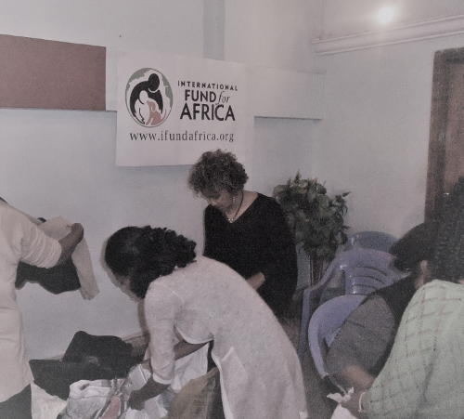
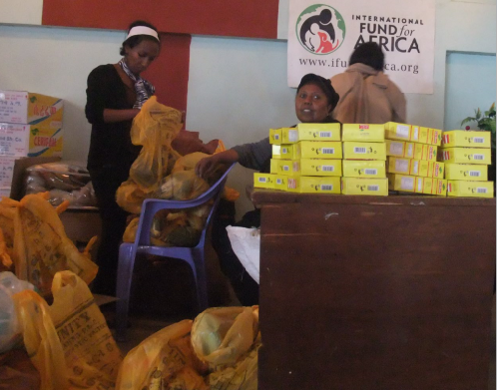
At present, city officials, non-displaced communities and other stakeholders working together tirelessly, have managed to contain and resolve the crises according to Addis Ababa City Administration. Thanks to these efforts, the majority of the displaced have returned to their homes.
IFA’s determination in bridging the humanitarian development gap is strengthened as we further our development work in impoverished schools that addresses chronic urban poverty among those that are not displaced but who lack basics services.
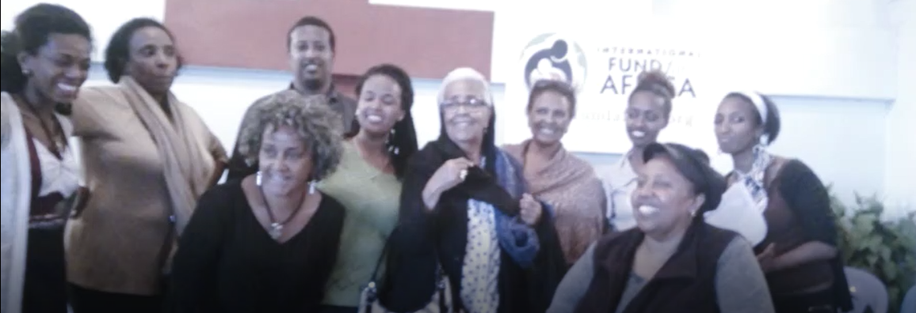 IFA’s deeply satisfied team after accomplishing a very meaningful humanitarian mission

The 2018 Africa Animal Welfare Conference
Dr Anteneh Roba, President of IFA spoke at The Africa Animal Welfare Conference 2018 at the United Nations Complex in Nairobi, Kenya, on September 4, 2018. The theme of the conference was: “People, Animals and Planet: One Health, One Welfare”. His talk was on Emerging infectious and lifestyle diseases.
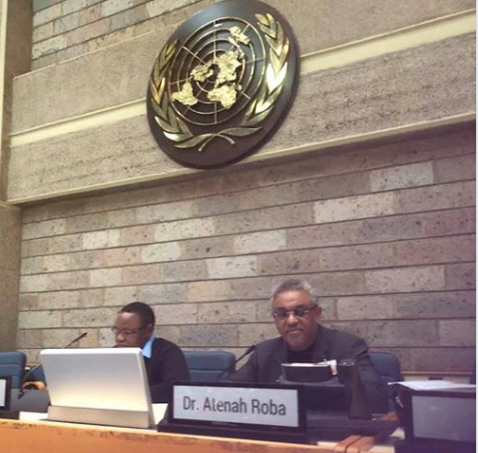

IFA appreciates and is grateful for the continued partnerships and support it receives from organizations and individuals.
Please join us as we further the work of bridging the gap

