Jihur Primary School Project
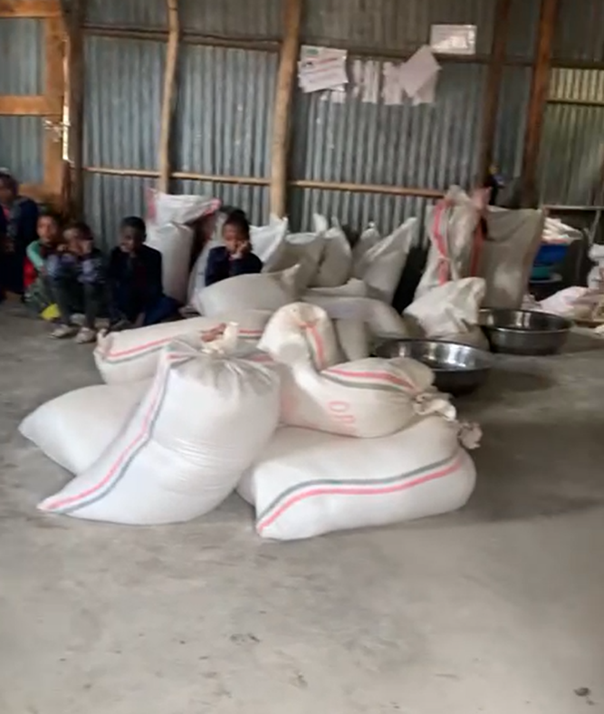
IFA with the support of Vegan Compassion Group, a UK based charity, is supporting 124 school children with multigrain flour take-home-ration (THR) at a rural Primary School in Jihur. The most vulnerable children were selected as beneficiaries and instruction are given to parents on how to prepare plant based meals for the children at home, especially for breakfast.
Take home rations alleviate and reduce the consequences of food insecurity . According to FAO 2022 report - malnutrition is the no. 1 killer of children worldwide.
The take-home rations typically include food items such as grains and pulses, which have a range of benefits for school children. The impact observed are:
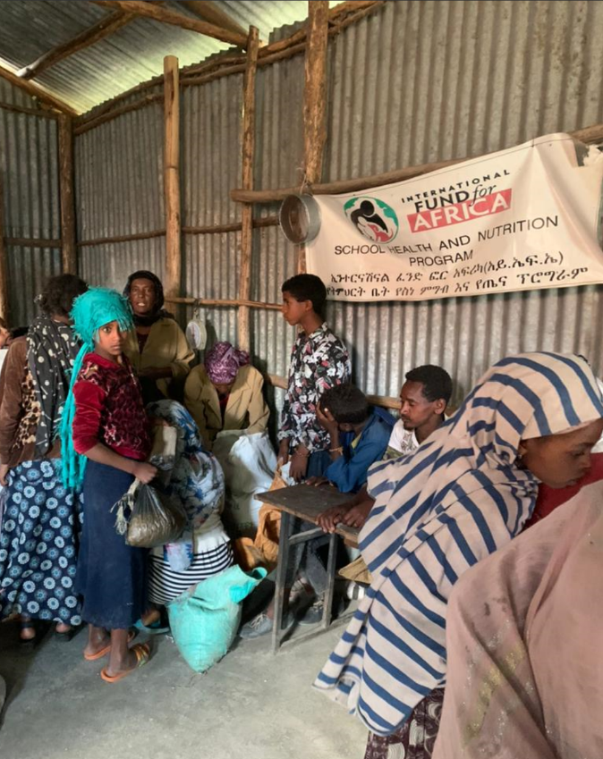
1. Improved health: Providing nutritious take-home rations can help reduce malnutrition and improve overall health among school children.
2. Increased school attendance: Children who receive take-home rations attend school regularly, as they are more motivated to attend classes knowing they will receive food to take home.
3. Improved academic performance: improved nutrition aids cognitive development and learning and providing take-home rations has been shown to improve academic performance among school children.
4. Reduced poverty: Take-home rations can help reduce economic pressure on families and alleviate poverty for those who struggle to provide adequate food for their children.
Below are some photographs taken while IFA staf and volunteer teachers are distributing the the THRs to parents and the children
