From Farm to School

IFA’s School Meal Menu Won the Apperception of School District Inspectors
IFA’s School Health and Nutrition Programs (SHNP) is helping ensure that schoolchildren are receiving nutritious meals that promote their health and educational readiness. IFA’s school meals have won the appreciation of district school inspectors. The school district evaluation concluded with following observation about IFA’s SHNP:
- School meals were served according to the preplanned menu of the week
- School meal preparation excelled in meeting hygienic standards
- Schools meals were adequate in amount, well balanced and nourishing, tastefull and very palatable
We put great emphasis on vegetables and many other foods that come from local farmers and markets. Over the years we have introduced new foods to the menu that are not commonly consumed in Ethiopian homes, like avocado, soya, string beans, etc. We prepare the school meals using a variety of spices that add taste and help to make the school meals to taste as good or better than homemade meals.
Delivery of school meals by IFA’s School Health and Nutrition Program uses a streamlined approach to ensure standardization – we first build and team, then plan the menu to identify and purchase locally available food commodities. Food safety measures are closely monitored, taking into consideration the evaluations and feedbacks we gather from the beneficiary students.
IFA’s School Meal Shining Light on Vegetables
We pride ourselves in ensuring that we serve well balanced meals – the quality of the ingredients and some of the food choices we use and the methods we use to prepare them are highlighted below.

Category I – Easy to slice and must not be overcooked
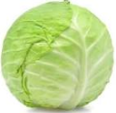
Cabbage – it’s a vegetable that is rich in vitamins, minerals and antioxidants. It’s a good source of vitamin C and K. It is rich in vitamin B6 and folate, both of which are essential for energy metabolism and the normal functioning of the nervous system. Cabbage contains powerful antioxidants that help reduce inflammation. Cabbage contains insoluble fiber, which keeps the digestive system healthy by providing fuel for friendly bacteria and promoting regular bowel movements.

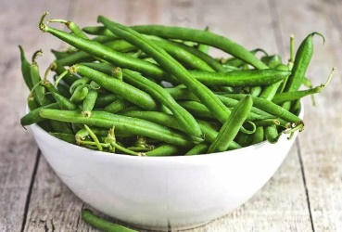
String Beans - a good source of minerals, especially manganese, which supports metabolism, bone health and promotes wound healing. It contains Vitamin A which is important to our immunity and health and healthy vision. Other vitamins found n string beans are Vitamin C and folate

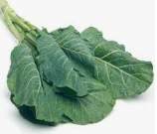
Collard Greens – a leafy green vegetable that is well loved by Ethiopians. They have thick leaves and are bitter in taste. They’re one of the best sources of vitamin K, which helps reduce blood clots and promotes healthy bones.

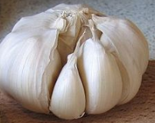
Garlic- is commonly used in Ethiopian cuisine; we use it to add flavor in the sauces we serve. It contains several nutrients – vitamin B6, C, manganese and phosphorous.

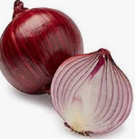
Onions- multiple varieties of onions are used in Ethiopian dishes. From red to white onions, these add flavor, fiber, color and texture to pasta, salad and sauce. Onions may be chopped and used raw in a salad or sautéed in oil for main dishes.

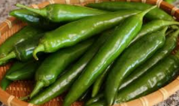
Peppers- Peppers are very popular in Ethiopian cuisine. They add color and flavor to any dish. Peppers are added to grain dishes, stews, etc. They are high in vitamin C.

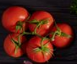
Tomatoes- add color, texture and taste to nearly any dish. We add diced tomatoes can be added to sauce and stew we serve in our school meals. Despite its classification as a fruit, it is generally categorized as a vegetable. They are also a great source of vitamin C, potassium, folate and vitamin K. They are especially high in lycopene, a plant compound that has been linked to improved heart health, cancer prevention

Category II – Hard to chop and must be cooked until tender
Carrots – are root vegetables that are often claimed to be the perfect health food. They consistof 85-90% water ant the remaining is carbohydrate - starch, fiber and simple sugars. Carrots are an excellent source of vitamin A in the form of beta-carotene. They are also a good source of several B-vitamins, vitamin K and potassium
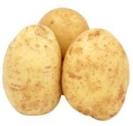
Potatoes – are starchy root vegetable that are a good source of vitamin B6, vitamin C, and niacin and contains the minerals potassium, copper, manganese, and phosphorus. In fact, white potatoes contain more potassium per standard serving than any other vegetable. Potatoes even contain a variety of phytonutrients, nutrients produced by plants that help promote overall health.

Category III – Served raw
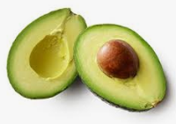
Avocado – is a unique fruit, unlike most other fruits which primarily consist of carbohydrate, avocado is high in healthy fats. It contains more potassium than banana. It is also rich in fiber which promotes metabolic health.

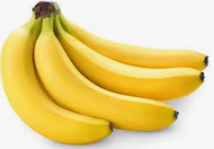
Banana – are loved by the children as they are delicious and healthy. Bananas are rich in fiber, antioxidants and several nutrients. As a rich source of potassium and magnesium, bananas support heart health.

The two-key people at IFA who drive and shape the value of the melas we serve our own staff, Nardos Alemayehu – who is a professional nutritionist and the co-founder of IFA, Seble Nebiyeloul, who in addition to the many roles she holds, is a culinary expert with a passion for creating healthy and delicious plant- based meals.
