IFA’s WORK, WAY and IMPACT

The Problem
- High Neonatal Mortality Rate – of 29 deaths per 1000 live births mainly due to preventable causes
- Under nutrition – is a major public health problem among children in Ethiopia, with chronic malnutrition constituting 80% of all forms of malnutrition, resulting in stunting of 40% of all Ethiopian children, which in turn leads to severe infections secondary to compromised immune responses, which is further compounded by the high prevalence of bacterial and parasitic diseases, thus aggravating malnutrition among children. Thus, in Ethiopia malnutrition contributes to over half of child deaths.
- Poor water, sanitation, and hygiene – is the cause of almost three quarters of health problems and communicable disease in children. Only 32.5% of schools have drinking water facilities and only 4% have hand washing facilities. The pupil to latrine ratio is also very high at 1:164 for boys and 1: 177 for girls, which is much lower than the optimum ratio of 1:30.
- Uncorrected Vision Problems – Many school children in Ethiopia face learning difficulties often due to a refractive error. Vision problems can and do affect the physical, intellectual, social and emotional development of children
- High Youth Unemployment – Unemployment among women and youth is a significant issue with an average unemployment rate of 19.88 % (estimated to be higher for youth)
- Donor dependence and fatigue – long-term aid results in dependency and donor fatigue, especially in a country like Ethiopia that suffers from recurrent drought
The Intervention
- Improving Neonatal Services - by providing health facilities with the necessary medical equipment and the establishment of neonatal intensive care units
- Provision of School Meals – which incorporates diet diversification, micronutrient supplementation and biannual deworming tablets. The number of kilocalories in a child’s diet is expanded when they are given nutritional resources that they would otherwise have little or no access to.
- Improve access to safe water and sanitation – tied with School WASH training and capacity building.
- Menstrual Hygiene Management Training – provide girls with of reusable sanitary pads
- Early detection, treatment and correction of vision problems – through vision screening and the provision of spectacles for those with uncorrected refractive error
- Vocational Training – in tailoring and mushroom production (later in the pipeline) for school drop outs
- Capacity Building – establishment of SHN committee to promote community ownership through participatory planning, monitoring and evaluation
- Income Generating activities – setup two bakeries and is in the process of launching a mushroom production unit
The Outputs
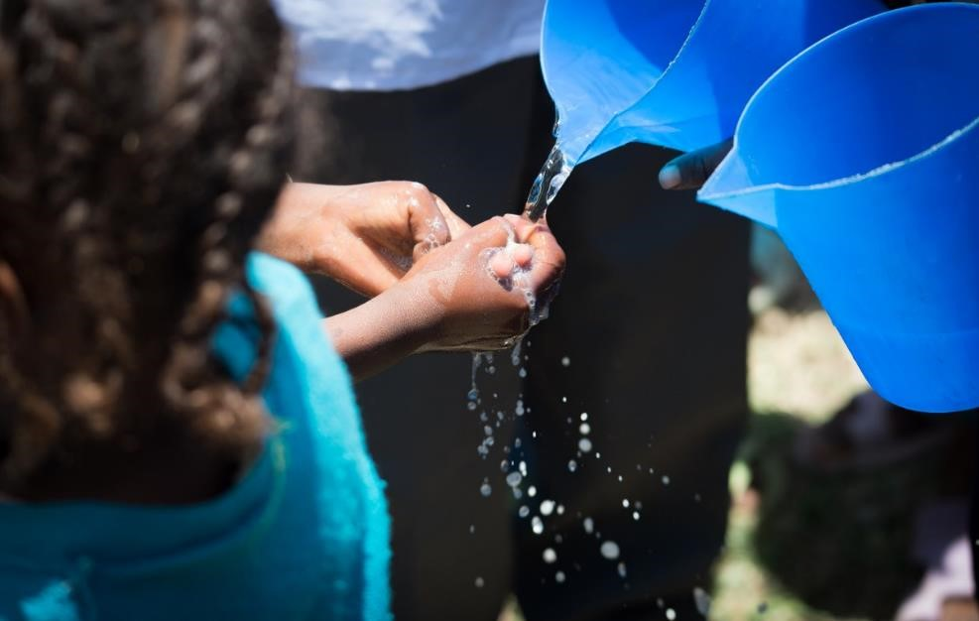
- School Based Nutrition Services Established - through the setting up school kitchens, training of cooks and the delivery of two school meals on all school days
- Water, Hygiene and Sanitation Services Established - water tanks installed, hand washing facilities built, septic tanks installed
- Implementation of School Eye Health – where teachers are trained in vision screening, refraction is done at school site, treatment is provided, and spectacles are distributed
- School community strengthening
- Sustainable model through income generating bakeries and mushroom production
The Outcomes
- Elimination of hunger and improvement in nutritional status.
- Improved educational performance and attendance of beneficiaries
- Improved learning abilities of children receiving spectacles
- Encourage families to keep their children in school and so help them build better futures
- School feeding also serves as a social protection system for vulnerable families and children.
- will provide school children with a greater opportunity for success in their education and their future life
- Reduced parasitic infections and improved health of 1000 beneficiaries
- Reduction of institutional neonatal morbidity and mortality at targeted health facilities
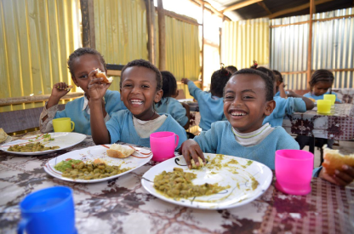
- Equip school dropouts with marketable skills and create employment opportunities
- Establishment of a self-sustaining school health program through profitable IGA’s (bakeries, mushroom production units)

The Impact
- Improved health status of school children
- Youth equipped with marketable skills
- Promotion of entrepreneurship
- Sustainable development

