Restoring Dignity of Girls

IFA Now Part of The Network and Task Force Championed by The President of Ethiopia to restore the Dignity of Girls and Women

The President of Ethiopia, Sahlework Zewde, has embraced and is championing the measures that will restore the dignity of girls and women who face many challenges related to menstrual management and is leading a coordinated effort to make history by meeting and resolving the multipronged problem of poor menstrual hygiene for 30 million women and girls in Ethiopia.
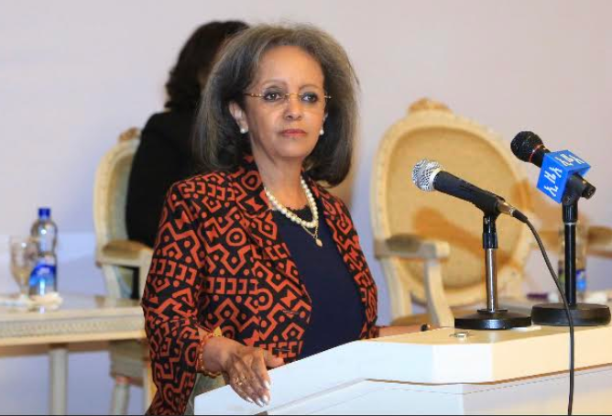
President Sahelwork of Ethiopia at the stakeholders meeting
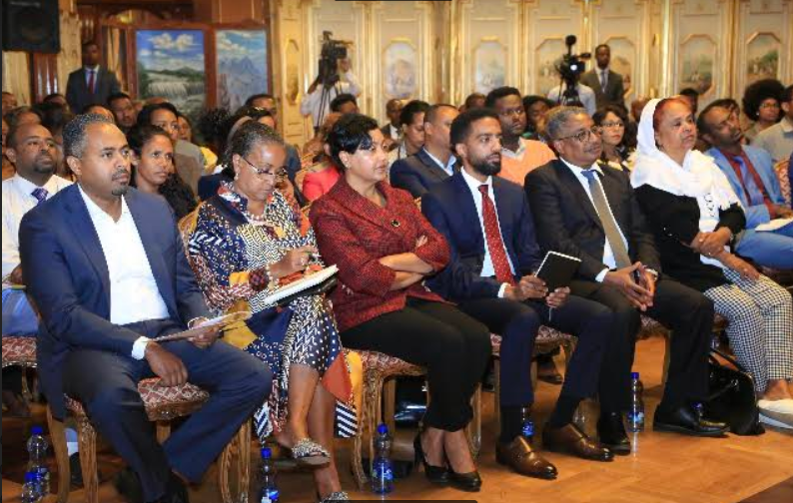
Seble Nebiyeloul, IFA’s co-founder and country director among front row participants at the stakeholders meeting

The Problems Addressed

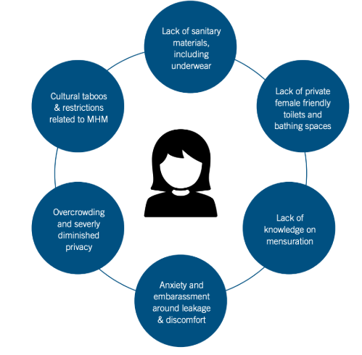
Source: USAID
The stakeholders meeting was attended by high level government ministers, media representatives, and nonprofit organizations, like IFA. The problems addressed by the panel speakers were:
- Lack of knowledge on menstruation and related cultural taboos
- Anxiety and embarrassment around leakage and discomfort
- Lack of sanitary materials
- Lack of private and female friendly toilets
A situational analysis based on a rapid assessment conducted in 2017 by John Hopkins revealed that only “28% OF women in Ethiopia report having everything they need to manage their menstruation. This does not vary by age, indicating that across their reproductive years, the majority of women are unable to adequately meet their MHM needs.”
These problems result in school absenteeism and contribute to girls dropping out of school, thus perpetuating the cycle of poverty.

IFA’s Achievements
- sensitizing and raising awareness in 30 primary schools regarding menstruation among students, teachers and parents
- delivered trainings on Menstrual Hygiene Management for 9,000 adolescent girls
- produced and distributed close to 60,000 reusable sanitary pads We strengthened the MHM supply chain by training women entrepreneurs, girls, boys, teachers, women and Health Extension Workers (HEWs) to engage in menstrual pad production and distribution
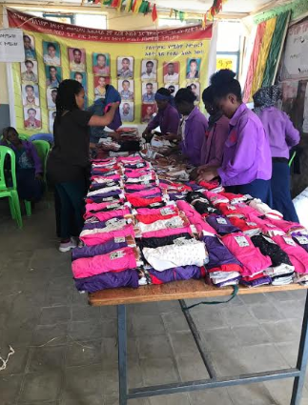

IFA’s Project Coordinator, Nardos Alemayehu and Fekerte Ayele distributing reusable sanitary pads and underwear in a rural school in Amhara region

Today IFA is part of the national steering committee that is committed to restore the dignity of girls

Please consider partnering with us by purchasing 1 MHM Kit for 100 ETB – the kit includes 6 reusable pads, 2 towels, 1 soap, and 2 underwear.

