IFA’s Rural Project Overview

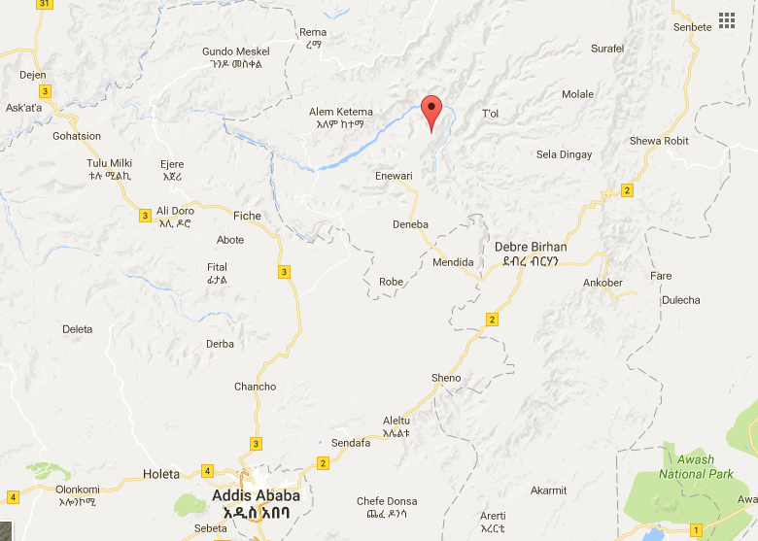
IFA’s rural project is located in Jihur, in Moret and Jirru District of Northern Showa Zone of Amhara National Regional State of Ethiopia; about 214 Kilometer North of Addis Ababa, the capital city of Ethiopia. The main road ends at Enwari, from there our teams travel for 80 kms on rough, gravel road to reach Jihur. Although Jihur is not too far from the capital – it seems remote and isolated due to the its very inadequate infrastructure.
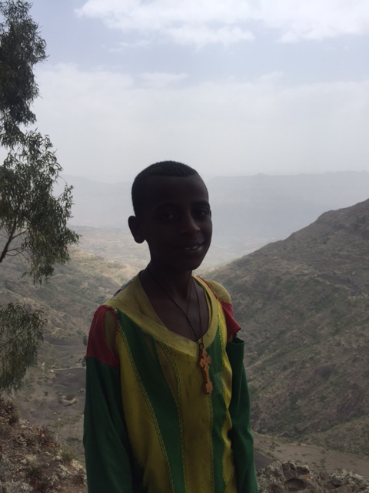
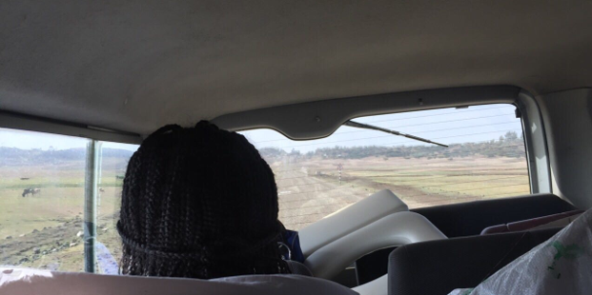
Jihur, with a population of 3,186, sit high on a plateau that overlooks a very deep gorge. It’s a town that serves both the highlanders and the lowlanders, and has a catchment population of 31,222. Jihur does have basic infrastructure: an elementary and a secondary school; a health center, electricity (but with very frequent interruptions); water holes (but no indoor piped water).

Overlooking the gorge and our team driving to Jihur on gravel road

IFA has worked in collaboration with the district and Jihur Primary Schools (JPS) for the past two years. At JPS, IFA is providing nutritious schools meals for 120 students. IFA also ensures that the students receive biannual deworming tablets, since most students are at risk of developing various parasitic infestation due to the lack of access to clean water.
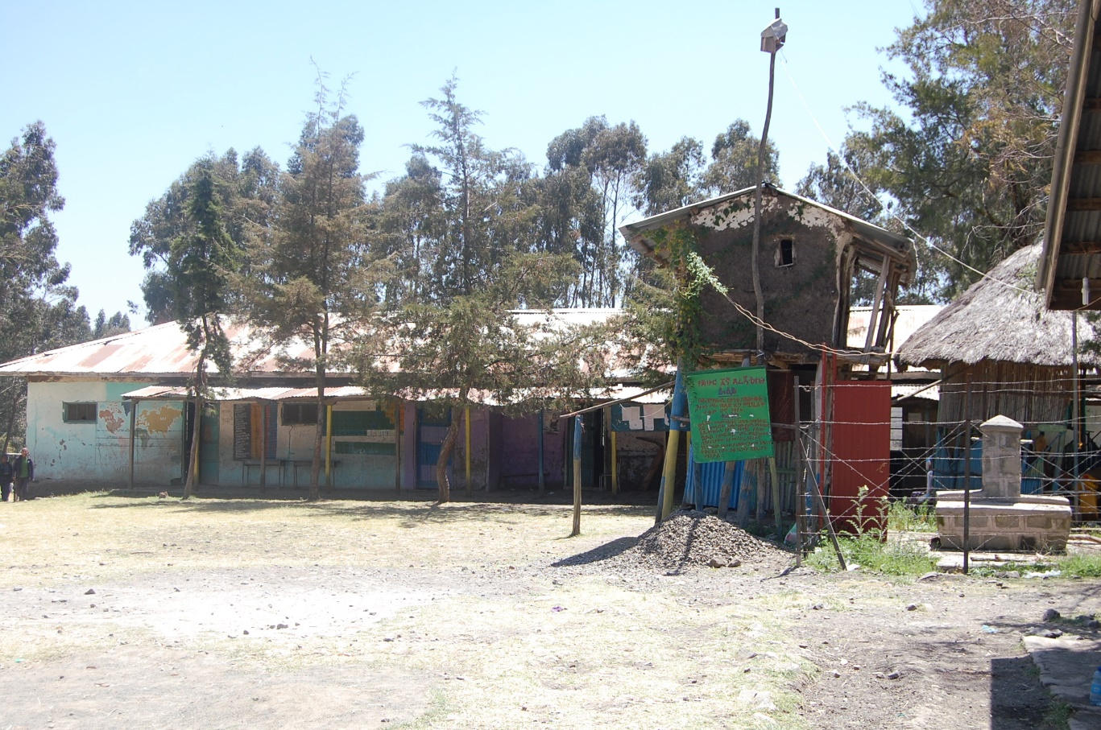
Jihur Primary School
IFA conducts annual anthropometric measurements of the students enrolled in the program to document their nutritional status – most are severely stunted due to chronic malnutrition.

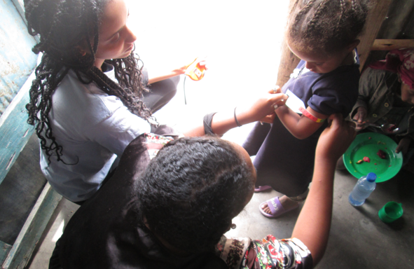
IFA volunteer conducting a mid-arm circumference measurement (MUAC)

Periodically, throughout the year students are given various trainings in nutrition, health education, and hygiene and sanitation. They are broken into two groups: grades 1-4 and grades 5-8.
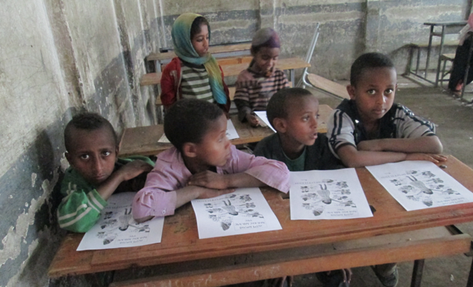

Younger students diligently attending the training session on nutrition

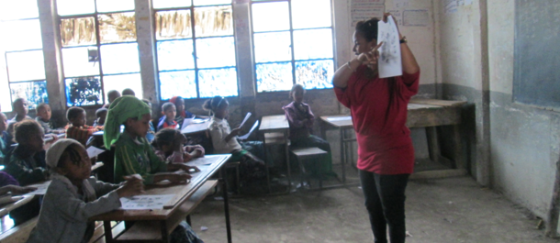

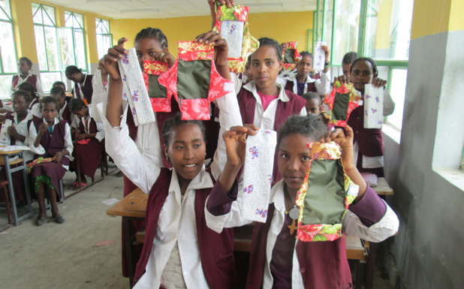
Another very successful and much needed training that is delivered to high school students in Jihur is one of IFAs flagship program in Menstrual Hygiene Management (MHM). Like most girls from rural towns and impoverished areas, the girls of Jihur secondary school do not have access to sanitary pads, in fact most use old rags – this results in them missing school days, which in-turn affects the quality of their education. Through IFA’s MHM program, these girls are taught to make their own reusable sanitary napkins and given the materials they need. The training also achieves in breaking some damaging cultural taboos that prevents girls from addressing sensitive, gender related issues.

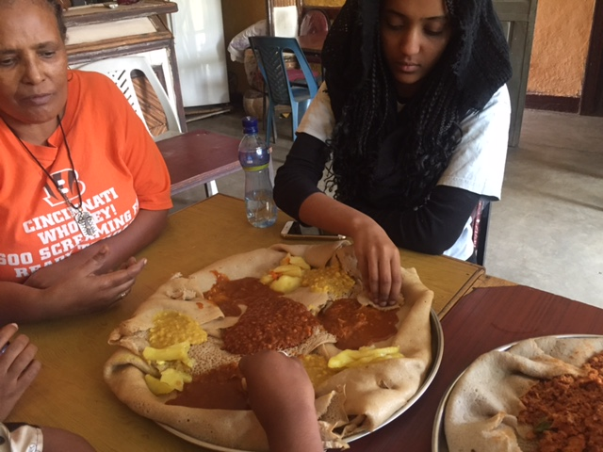
After the various fruitful activities – IFAs staff and volunteers regroup over a traditional evening meal.

