Summer 2018 in Ethiopia
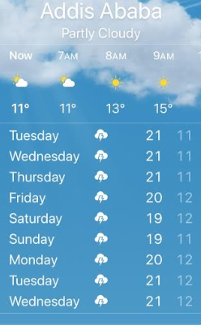
Ethiopia, a tropical country, lays between the Equator and the Tropic of Cancer and Addis Ababa according to its elevation falls in the cool zone known as Dega. It has an annual average temperature of 16 degree Celsius (60-degree Fahrenheit) and an annual rainfall between 1270 and 1280 millimeters. Addis enjoys four seasons, the summer season known as kiremt is the one that falls within the months of June, July and August – the season when the country gets its heaviest rains. It is also when the longest school break is taken by students.

IFA’s New Summer Program at Hana Primary School
Summer of 2018 is the year IFA extended its School Health and Nutrition Program into the summer months with the intention of providing much needed food and meals to vulnerable school children during periods when area schools are closed for summer vacation.
In addition to helping needy families and their children, IFA’s Summer Program at Hana Primary School included academic and structured fun activities for 200 students so that they may learn new skills.
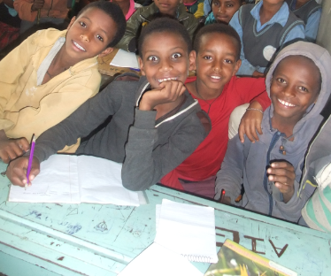
The summer school setting also addresses and contributes to healthy lifestyles and increased knowledge about hygiene and nutrition. All summer school activities guaranteed access to all the selected students, was based on the sustained participation of the dedicated staff of IFA and select teachers from Hana Primary School and the strong partnership of volunteers.
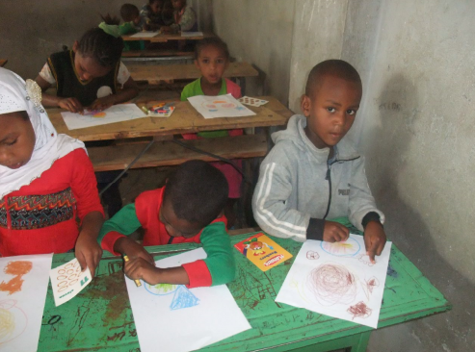

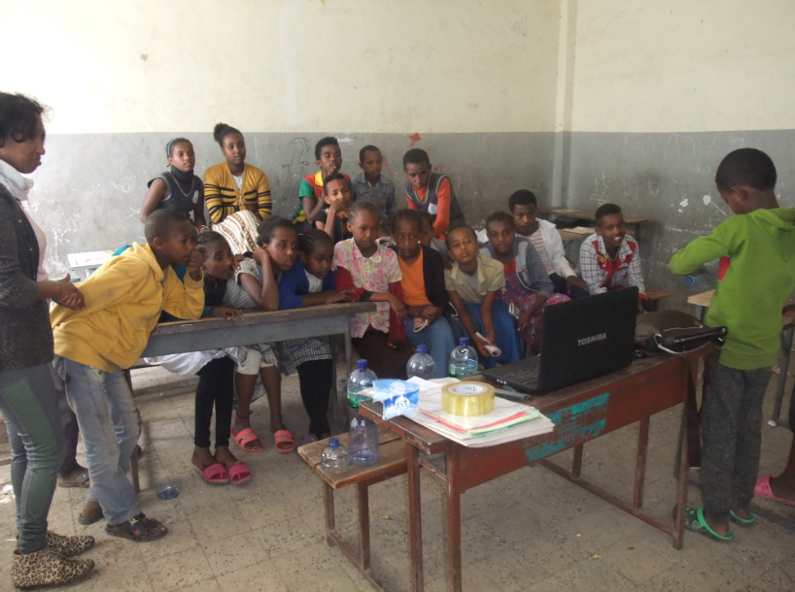

The major challenge faced by IFA as we launched the first of its kind summer program at Hana Primary School was the added financial load. Hana PS partnered with IFA by providing access to its premises and facilities free of charge. IFA’s staff took on additional workloads to meet the human resource demand and we humbly ask our supporters to generously support the work of IFA as we take on more and stretch every penny for the benefit of the school children we serve.

