Humanitarian Assistance for Displaced Children in Partnership with Vegan Compassion Trust
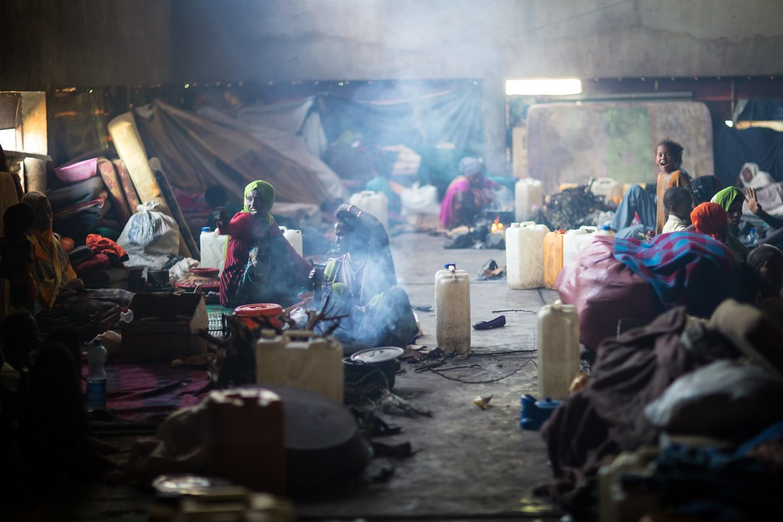
Internally Displaced Persons in Camps
Our partner ,"Vegan Compassion Trust", are truly generous and compassionate. When they heard about the conflict in Ethiopia they intentionally reached out to IFA sharing their concern and offering their assistance, knowing that war has far reaching consequences.
The offer came at a time when Ethiopia has 4.51 million Internally Displaced People (IDPs) (DTM 2022) and 12.4 million children who need humanitarian assistance (2022 draft HNO and HRP). The Regional Disaster Prevention and Food Security Program Coordination Office (DPFSPCO) reported :“In Amhara 11.6 million people are targeted for relief assistance, including an estimated 5.8 million children.” The office estimates that over 1.3 million IDPs are found in the region, sheltering in camps. The camps sheltering displaced persons face huge demands for ready to eat food supplements for the very young, especially the under 2-year-olds.
One of the camps where IDP’s are sheltered that reached out to IFA is located in Merhabete.
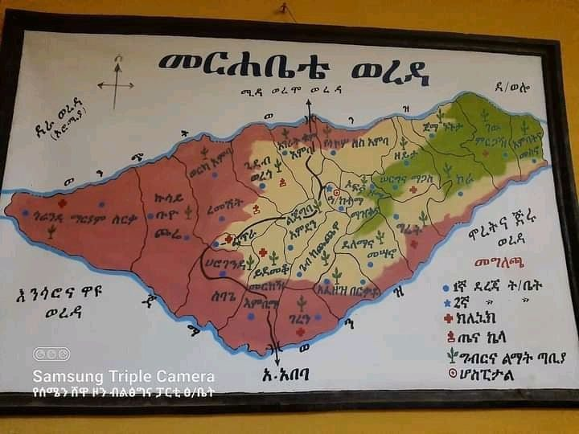
Merhabete Wereda
Merhabete is one of the districts in Northern Shewa Zone of Amhara Region in Ethiopia. It is a mountainous region with rough terrain that was the center of power in ancient times. The administrative city of the Merhabete district is Alem Ketema, and according to the district Finance and Economy Development office (2014), the total area of the woreda is 126,000 ha with a total population of 117,169, of whom 59,388 are men and 57781 are women. The majority of the inhabitants practiced Ethiopian Orthodox Christianity.
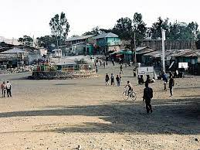
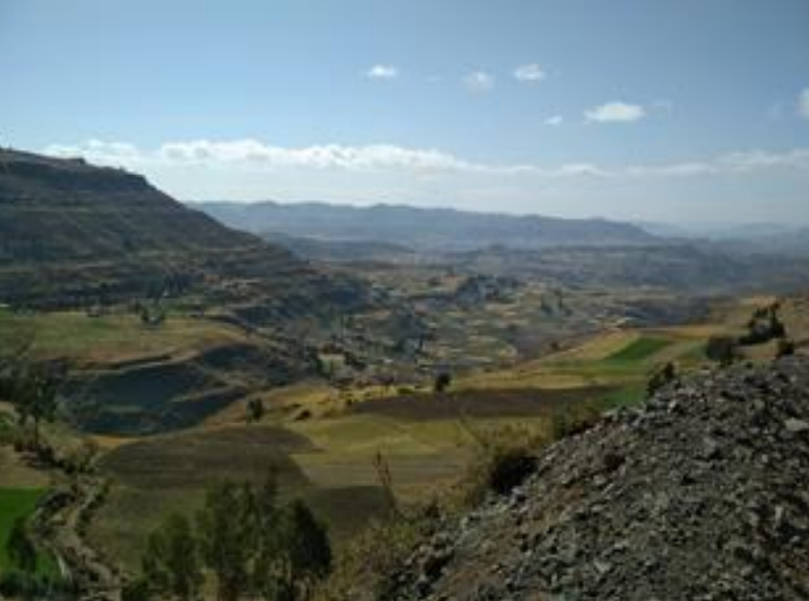
The ecology of Merhabete is sub-tropical (60%), 20% tropical and the remaining is temperate. The topographic setup is very diverse with lowland, midland and highland plains, mountains, rugged lands, undulating landforms, and chains of plateaus are common land features in the region. The rainfall has a unimodal distribution with the main peak in June-September, during which more than 80 % of the annual rainfall is received. Smaller peaks occur in May and October.
Like most parts of rural Ethiopia, Merhabete land use is dominated by traditional, rainfed, subsistence small hold farming focused on grain production using oxen. According to the Agricultural and Rural Development Office, only 40% of the land is arable in Merhabete making little use of irrigation from the two revivers running through it - Jamma and Wonchit.

Alem Ketema
Historically and currently, IFA works in close collaboration with North Shewa Zone of Amhara. In the past medical missions and health related capacity building projects were implements. More recently, IFA is running projects that help vulnerable school children by providing take home rations. Periodically the menstrual hygiene management project has contributed to helping girls stay in school by training and distribution MHM kits that contain reusable sanitary pads and under wear. Projects are run and supported by community members who hail from the area.
Over the past year, IFA has responded to the national call to assist IDPs and used all opportunities and venues to garner support. Therefore, when the request to prioritize the very young among the people displaced came to the attention of IFA, IFA partnered with Vegan Compassion Trust and was able to distribute ready to eat flour mix called FAMIX to two hundred children. FAMIX contains energy and protein. It is a mix prepared and packed in Addis Abeba and transported to Merhabete shelter camp with the collaboration of the Women, Children and Youth district Office.
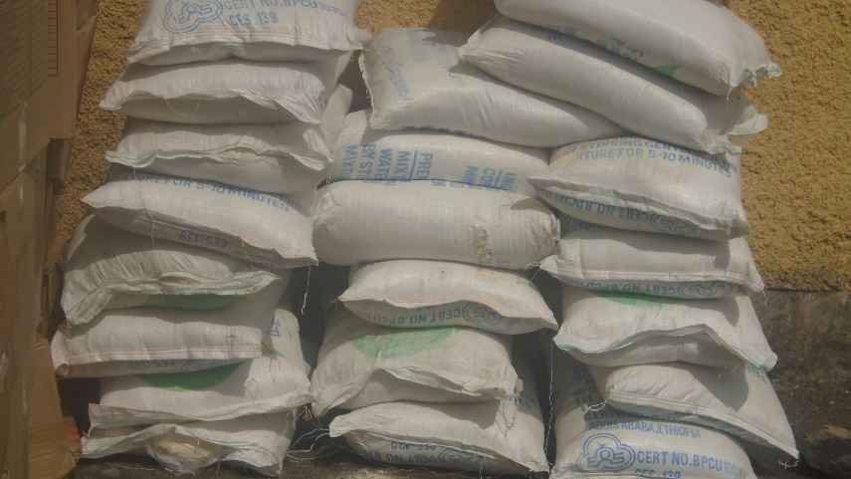
Mothers and district staff expressed their thanks and IFA has continued to support displaced persons, especially children as the need have persisted.

FAMIX – Ready-to-eat

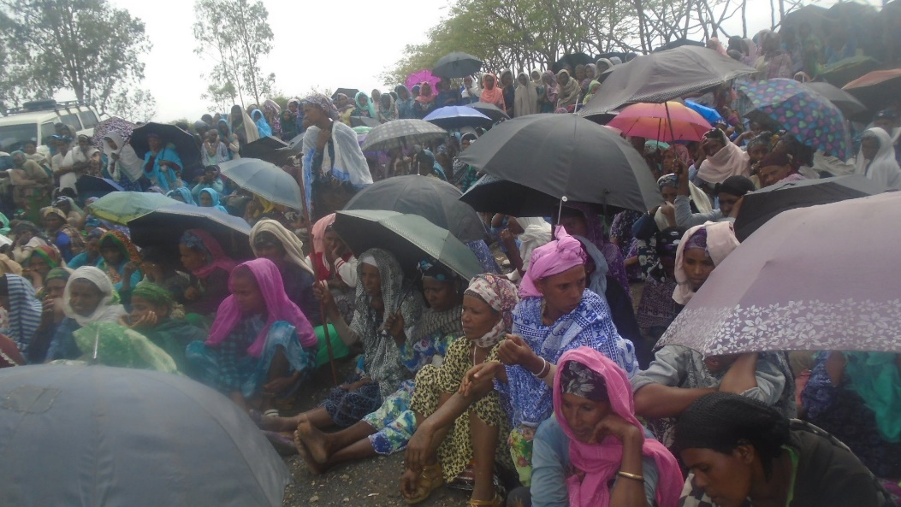
Compassion is what drives the work of IFA and our partners . Compassion is what lets us put ourselves in the shoes of those who are less fortunate. Compassion is the reason IFA is engaged in new humanitarian initiatives.
JOIN AND PARTNER WITH IFA’S HUMANITARIAN ASSISTANCE INITIATIVE

