Thank you for a sucessful year!
Thanks to our supporters IFA was able to finsih strong . Our flagship program – Sustainable School Health and Nutrition Program (SSHNP) - a comprehensive and integrated program in Ethiopia was able to achiev the following results:
- The nurtion component – improved the nutritional status of 500 school children by:
  - serving 83,600 hot palnt based nutrious lunches and 5,148 breafast for KG students
  - dispensing preventive deowrming tablets for 500 school children
- The eye heath component – improved learning opportinities by:
  - operating a vision screening program at 8 primary schools for 7,645 student
  - conductiond refraction for 296 students
  - dispensing 166 spectacles and treating 67 students with eye infection
- The school sanitation component – improved hygien and sanitaion by:
  - Training 1,200 girls on menustral hygien mangement andon how to make their own sanitory napkins with holders
  - Delivered varius capacity building initiatives on safe food preparation, proper handwashing, etc
- Sustainability – ensured through:
  - Shared project management to promote ownership
  - Constructed and equipped two bakeries as income geanerating schemes to establish a standalone program
This program helped hundreds of schoolchildrena and their families. This is the reason we want to say «Thank You»
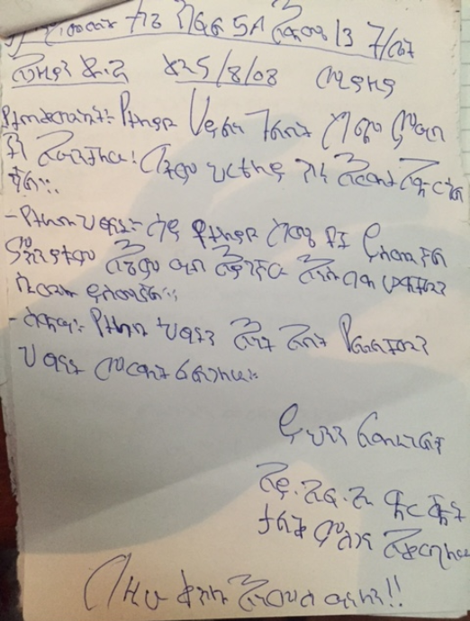
Reflection from some of the school children
Emebet, a 13 year old girl in grade 5A wrote:
« I benifited from the various types of food which provided me with enrgy and which was supportive for my education. I feel bad when I see other children who come to with empty stomachs. In the future I want to help such children and other helpless persons. I want to thank IFA, the organization that helps us.»

Tarik, a 16 year old boy in 7B wrote:
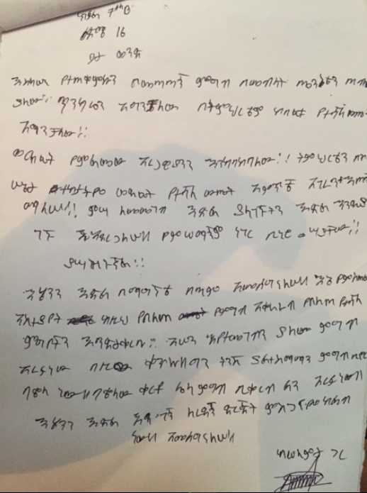
«The well balanced diet I recieved has helped me stay healthy and strongand my grades have also improved. I want to continue doing well in school; when I grow up I will help the elderly. I also want the school lunch program to continue giving us such good meals but would like to suggest that the beans be replaced by somthing else. I want to thank the organization that is helping us.»

Ammanuel, a 14 year old boy in 7B wrote:
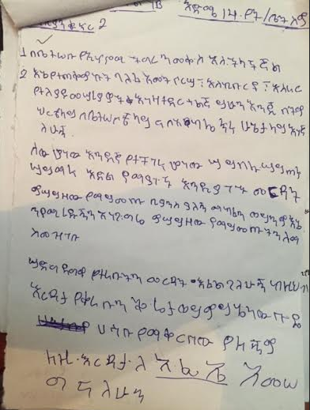
«My families economy and hardship has improved. I am doing well in my education, health and in my family. In the future I want to help and share what I have others who don’t have the opportunity to eart , drink and go to school. I will at laet help them get noticed. I have no other comment or feedback and I want to thank IFA.»

IFA says «THANK YOU» to all the generous people and organizations who have made possible the many big and small achievments with their donations and actions.

