Mission Accomplished by the School Health and Nutrition Program

We, at IFA are delighted to end the year on a high note. The School Health and Nutrition Program worked with a lean and committed team under a tight budget and with the help of our supporters to accomplish the following activities during the 2016/17 academic year:
- Prepared and served plant based, nutritious school meals (breakfast and lunch) for 550 students in 5 schools on all school days, totaling 242,000 meals served for the year.
- Dispensed biannual deworming tablets and micronutrient supplements
- Fully furnished the dining room of Hana Primary School
- Delivered various capacity building trainings:
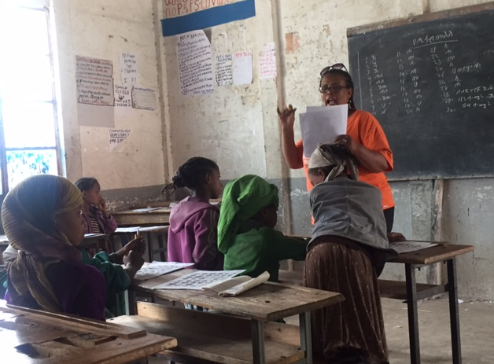
  - 3 training sessions for 11 cooks on hygiene, safe food preparation, school meal menu and recipe preparation
  - Health education for 300 parents on hygiene and nutrition
  - Hygiene and sanitation training for 550 students
  - Nutrition and balanced diet training for 550 students
  - School Health and Nutrition implementation strategy training for 28 SHN committee members
- Menstrual Hygiene Management (MHM) rolled out to 7 schools by conducting a training of trainers for 30 teachers, who in turn trained 2100 school girls on how to make reusable sanitary napkins
- School Eye Health
  - 150 teachers trained on vision screening from 9 schools
  - Vision screening conducted for 10,000 students; 600 underwent refraction
  - Dispensed 250 eye glasses and around 80 students were referred for further treatment
- Enrolled 11 young women in a fashion design and sewing vocational training program
- Established partnerships with four private companies and gained the support of five private companies committed to social enterprise
- Received numerous certificates of appreciation and from various stakeholders

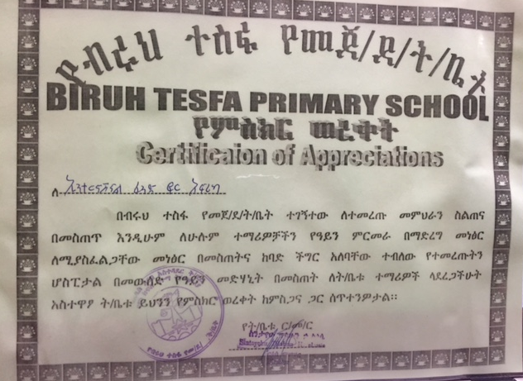
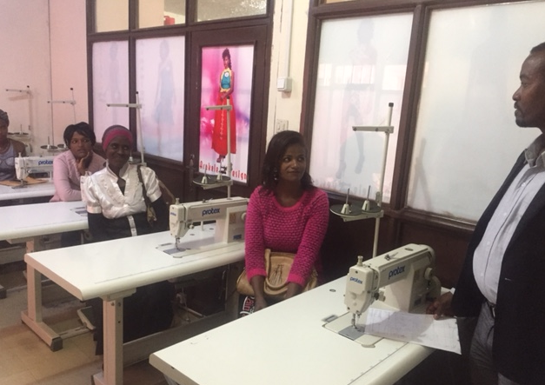
Fashion design and Sewing Vocational Training One of the certificates IFA got this year

