IFA’s BABY KIT – SERVING AS AN INCENTIVE FOR SAFE MOTHERHOOD AND NEW BORN HEALTH
IFA has historically worked on newborn care by partnering with government hospitals in Ethiopia to build the capacity of health facilities by providing much needed medical equipment and supplies. Today, Yekatit 12 hospital, one of the hospitals IFA worked with closely is recognized as a center of excellence in newborn care.
Currently as part of its capacity development and rural health system strengthening program IFA is building on its achievements in the past by focusing on safe motherhood programs. This program addresses the issues of clean and safe deliveries, essential obstetric care, and preventable death and disability among mothers, expectant mothers and newborns by promoting institutional delivery and skilled birth attendant.
Rural Ethiopia currently has one of the lowest skilled birth attendant rates at 28% according to EDHS 2016. It is a well-established fact that access to institutional delivery reduces the risk of complications and infections that result in high maternal and neonatal death rates. IFA is launching a new initiative to implement an intervention aimed at increasing uptake of maternal health services to address both the demand and availability of quality services
To facilitate access to institutional delivery many rural health centers in Ethiopia have constructed maternal waiting homes. These maternal waiting homes allow pregnant women who live in remote areas, where medical facilities and trained medical professionals are not available, to come to a clean and safe environment in anticipation of their deliveries.
One incentive with a proven success record is the provision of postnatal Baby Kits containing essential items for newborns for mothers who come to the maternal waiting homes. The baby kit will contain essential health and hygiene items which will help improve the lives of mothers' and babies' thus giving babies a good start in life.
Baby Kits serve to mitigate one of the factors that hinders pregnant women from delivering at health facilities, which is the embarrassment mothers feel when coming to health facilities with poor clothing and baby wrappers – in some settings this was cited as the biggest challenge mothers feared. With this “wonder kits”, mothers will mobilize fellow mothers and amplified impact will be reduction in both maternal and newborn mortality rate.

IFA’s Baby Kit includes:
1 - Blanket (at least 70x80 cm)
1 – Towel and wash cloth
1 – Baby Soap
3 – Fabric/Reusable diaper
2 – Body shirt and pants
- Sweater, hat and socks

The Baby Kits will be delivered to rural health centers in remote towns like Zemero:
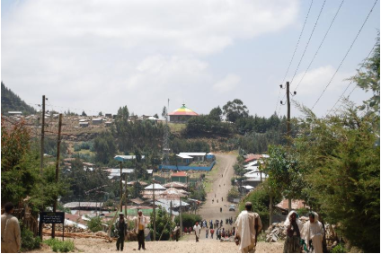

Please join IFA in this new initiative

IFA’s completes a need assessment for School Health and Nutrition at Hidasse Primary School
Although Ethiopia is one of the least urbanized countries in Africa, the urbanization rate is among the highest in the world. The population of the capital Addis Ababa has doubled every decade since 1984 and UN-Habitat has predicted that the population will reach 12 million in 2024. This high rate of growth is the result of the combination of rural-urban migration, natural birth and expansion of the city boundary. Addis Ababa is now characterized by high unemployment rates, concentration of slum dwellings, poor housing, infrastructure and sanitary development. Therefore, the livelihoods of many households are affected, the effects being worse on children.
The area IFA has selected to implement its School Health and Nutrition program in is Nefas – Silk Lafto sub city, where Hidasse Primary School is located. Addis Ababa has ten sub- cities of which Nefas Silk Lafto sub-city is the third most populous, with a population of 316,108 (148,984 Male, 167,299 Female - CSA 2007).
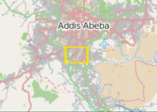
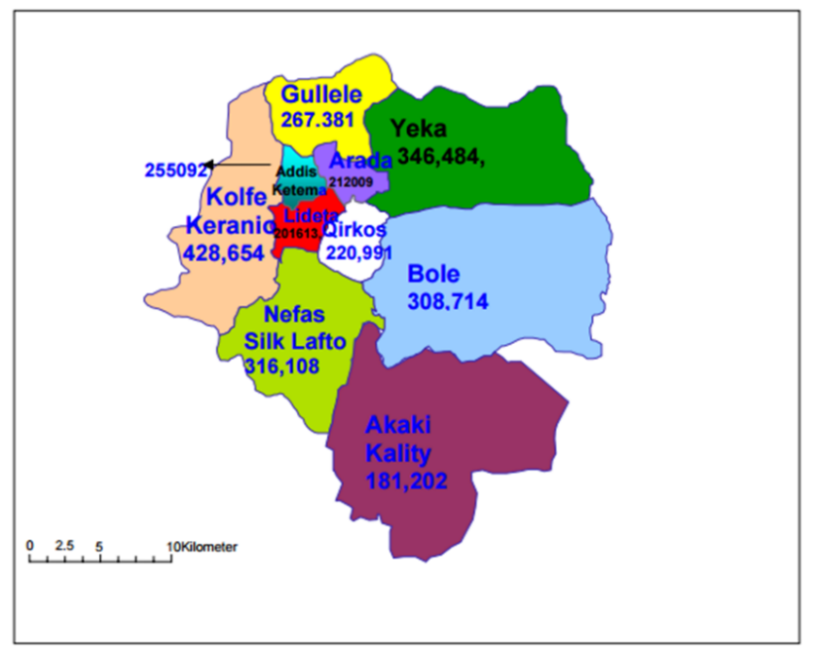
Furthermore, the Addis Ababa City four-years population program and strategic plan document indicates that over 50 per cent of the population is living below the poverty line, unemployment rate in the sub-city is 29.4 (CSA 2007) per cent and about 20 per cent of the population is engaged in informal sector activities

Hidasse PS was selected following key informant interviews with sub-city education office and school community. It is a public/government school that has some of the poorest children from the surrounding community.
- It has 2,302 students ranging in age from 4-15 years, of which 910 are boys and 1,057 are girls from grade 1-8, additionally there are 130 boys and 175 girls in Kindergarten.
- The catchment area of the school has a population of 34,000 people and many of their children go to school underfed. For selection, the schools had to be within a poor community where 25% of students had no parents, one parent only or parents that were not working.
- Additionally, most families with children at Hidasse PS, are internally displaced and are engaged in menial work.
- All stakeholders showed a commitment to working on a SSHN Program
- The school compound had the capacity and infrastructure to run the SFP
Before the start of the SSHN program, there are capacity-building needs to be met:
- Training in safe food preparation and hygienic practices
- Renovation of the kitchens and construction of dining rooms
- Procurement of kitchen and dining room equipment
- Signing contract agreements with suppliers and cooks

Please join IFA expand the School Health and Nutrition Program to Hidassie Primary School

