IFA contributing to Zero Hunger by 2030
World hunger is on the rise, as per FAO the number of undernourished people increased to nearly 821 million in 2017, from around 804 million in 2016, reaching levels a decade ago.
The situation is worse in Africa, especially East Africa. This dire situation is due to the persistence of conflict and instability, adverse climate change, and the slowing down of economic growth.

Most people who have never experienced hunger may not realize what hunger really means. Hunger is painful. In our world there are over 800 million people who go hungry. This means 1 out of 10 persons are hungry. FAO measures lack of access to food on a spectrum - someone will experience food insecurity first and when they go without food for more than a day or more, they experience hunger. This is well shown in the figure below (Source FAO):

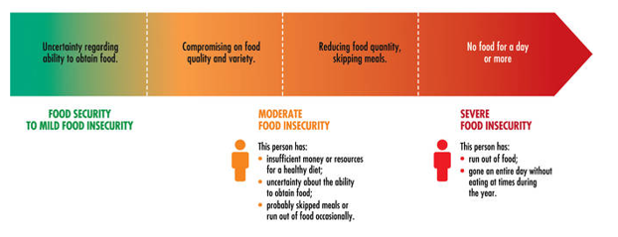
More worrisome is the double burden posed by food insecurity and malnutrition. When food commodities are scarce, people eat whatever is cheaply available. Highly processed foods that are energy-dense, high in saturated fats, sugars and salt are often cheaper and easier to come by than fresh fruits and vegetables. This contributes the rise of obesity. Children facing hunger, food insecurity and undernutrition today are thus at a higher risk of overweight, obesity and chronic diseases like diabetes later in life. In many countries, undernutrition and obesity coexist and both can be consequences of food insecurity.
IFA is thus working towards the Zero Hunger Goal by providing access to safe and nutritious meals to vulnerable schoolchildren by serving school meals that contain fresh fruit, vegetables and legumes. Promoting such healthy diets can break the intergenerational cycle of malnutrition.

Please join IFA’s effort in breaking the intergenerational cycle of malnutrition

