March of Time at IFA

The highlights as we look back at IFA’s Sustainable School Health and Nutrition Program

School Sanitation and Hygiene
- The Mensural Hygiene Management component which empowers school girls has reached 8,550 girls and 51,500 reusable sanitary pads/ kits have been distributed.
- To improve access to water, IFA has installed 7 water tanks in 5 primary schools
- To improve waste removal, IFA has built 2 septic tanks in 2 school
- To promote sanitation and hygiene, IFA A has installed 2 hand washing facilities

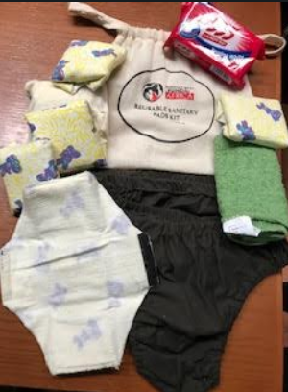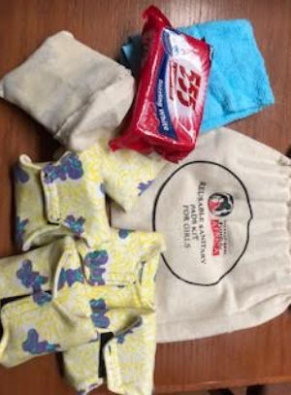
Reusable Sanitary Pad Kits

Schools Nutrition
- IFA implemented a school feeding program in 5 schools – serving well balanced, plant based nutritious school meals for breakfast and lunch
- 792,000 school meals were served to 600 vulnerable school children who come to improve their learning capacity
- Built and equipped 5 kitchens and
- Set up and furnished 5 dining rooms
- Trained 10 cooks

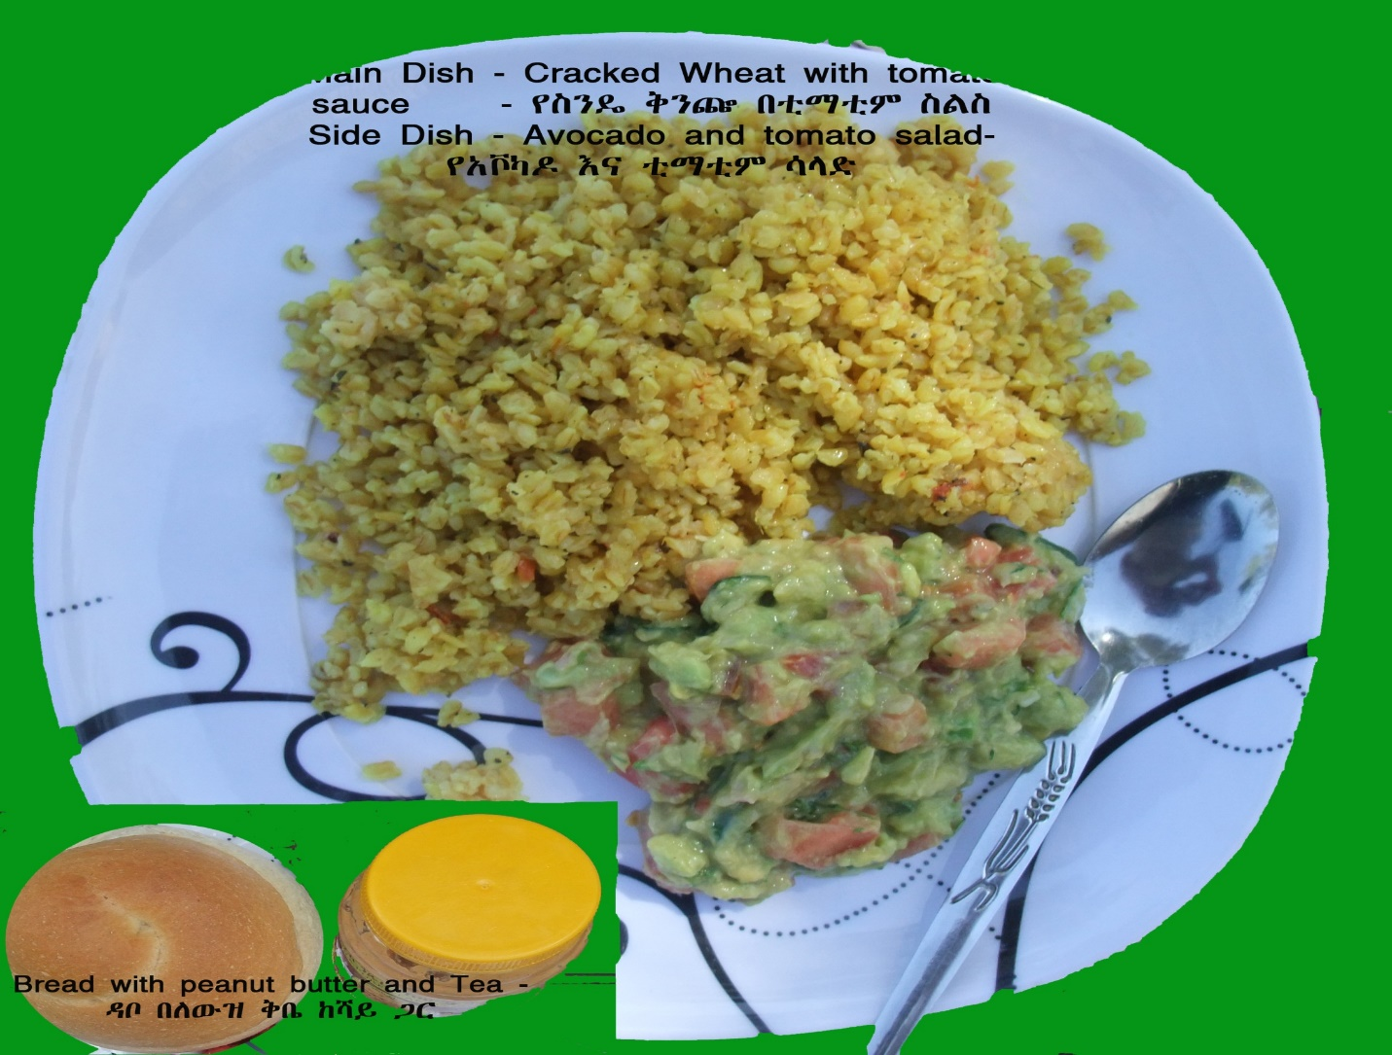

School Eye Health
- School Eye Health identifies school children with poor vision by training volunteer teachers and eye glasses are provided for children whose vision can be corrected with eye glasses
- IFA has conducted the school eye health in 40 primary schools
- 42,871 students received vision screening
- 400 students received medical Rx for eye health related problems
- 950 students received eye glasses

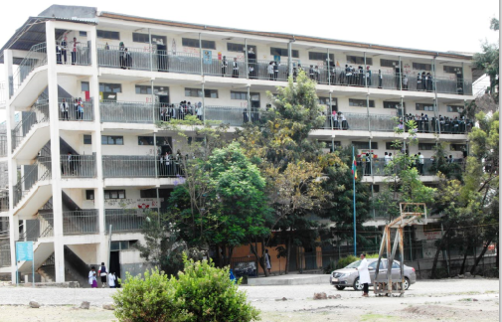

These successes and achievements were made possible through all of IFA’s supporters.
A new horizon is ahead for IFA as the landscape for civic societies is now much less restrictive towards income generating activities. IFA has several IGAs in the pipeline which will be launched in 2019.

