NAVIGATING THE COVID-19 PANDEMIC

In Ethiopia schools closed on March 16 after the first four cases of CoVID 19 were identified. School closure caused the suspension of school meals and many of IFA’s school-based programs including the school eye health and the school sanitation programs. Such crucial projects which serve vulnerable children who come to school hungry are now at risk as the coronavirus crisis stretches on with no clear end in sight.

In these uncertain times IFA is complying with advise and guidelines announced by the government in an effort to mitigate and suppress COVID 19 outbreak. Thus, IFA now has a skeleton crew at its HQ. The mushroom farm remains open with protective measures in place.

IFA has taken a nimble step to ease the burden on the supply chain by producing reusable face masks and distributing them to persons at risk. We use multiple layers of cotton, elastic bands and ordinary thread and contoured to resemble the shape of N95 masks. These masks are NOT to be used as a replacement for conventional and approved face masks.

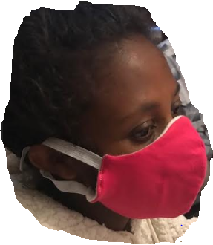

KEEPING A SEMBLANCE OF NORMALCY

Let’s observe the Day of the Mushroom - April 16

As we all attempt to keep healthy and maintain our balance in these unprecedented stressful times we want to highlight April 16 – Day of the Mushroom/
IFA is producing both fresh and dried mushroom. Drying serves as a preservation technique and increases shelf life indefinitely. Drying also increases the flavor of mushrooms by removing moisture and leaving glutamates intact. These flavors are immediately released at time of rehydration.
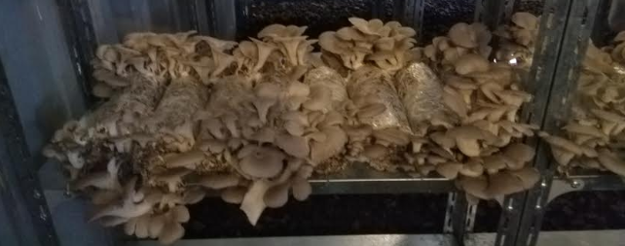
Remember fresh mushrooms are 80% water and the best way to keep them from spoiling is to refrigerate (don’t freeze) them in brown bags and to use them within a week. They must be cleaned gently just before use. When making a mushroom dish, its best to sauté quickly on high heat or simmer slowly on low heat but avoid boiling them in water to prevent loss of water-soluble vitamins
Shitake Mushroom ready for harvest at IFA’s Mushroom Farm

Mushrooms are one of the most sustainably produced food. Some key points about how mushrooms are good for our planet and our health. Its gentle on the planet as it requires only 1.8 gallon of water, 1 kilo watt of electricity and produces 0.7 lbs of CO2 to produce 1 pound of mushroom. Its gentle on our bodies as mushrooms are low in calories and sodium, fat-free and cholesterol-free, a good source of vitamin D and antioxidants.
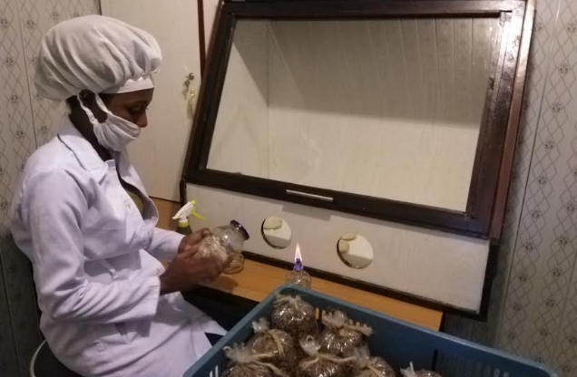
IFA’s Inoculation lab

IN CLOSING
COVID 19 has reminded us all yet again how interconnected we all are. This is evident in how quickly and easily the virus transitions from one species to another species, from one country to another country across all types of boundaries. The problem also points us to the solution - our best response must also cross all the boundaries that divide us – we must unite our efforts, empathize with all and cooperate with each other fully as we prepare for the worst and hope for the best.

