IFA’s Rural Sustainable School Health and Nutrition Program
After a bumpy start IFA’s flagship SSHNP our first rural program at Jihur primary school (JPS), has taken off and is currently reaching 100 students. Although Jihur is only 214 kilometers away from Addis Ababa, the capital city, it is located in one of the most underdeveloped areas of Ethiopia, in Norther Shoa. Jihur, as is typical of rural areas in Ethiopia is populated by subsistence farmers. Jihur Primary School is the only school in the area and has some of the poorest children in the surrounding community attending it and many of the children come to school underfed.
One of the toughest decisions faced by the school was the beneficiary selection process, in which the district and the school management team had to pick the 100 most vulnerable students from among 1,800. Every effort has been made to target school feeding assistance to individual children on the basis of vulnerability.This is because the program has the capacity of serving only 100 students at the present time and the the vulnerability criteria used include: Death of mother/father or both, mother and/or father do not work, no sustainable source of food for the family, usual number of meals per day is one, do not have support from anyone and children with higher number of absenteeism from school. Therefore, the SSHNP at JPS has 21 special needs students, and another 34 with partial disability, but still attending regular classes, 60 students are one-parent orphans and 9 students are two parent orphans. 50 students have no access to regular meals due to various reasons.
A classroom at Jihur Primary School
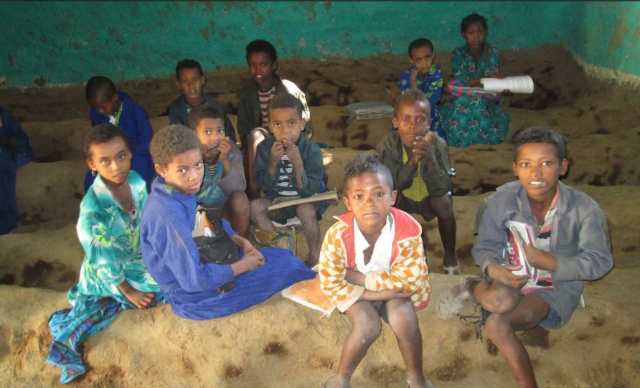

The SSHNP at JPS has accomplished much that we at IFA are proud of – the construction and equipping of the kitchen and a dining room, training of cooks, conduction of baseline anthropometric measurements, the dispensation of deworming tablets and the provision of nutritious plant based meals on school days.
Some of the implementation challenges and constraints we are working under are – increased transport cost, unavailability of VAT registered food commodity suppliers, frequent power outages, and lack of reliable water supply.
An outstanding feature of the SSHNP at JPS is the enthusiastic support IFA has garnered from the school community evidenced by volunteer hours the teachers are devoting to the running of the program. They are urging IFA to expand our services to reach more student who also desperately need the educational and nutritional support of the SSHNP.
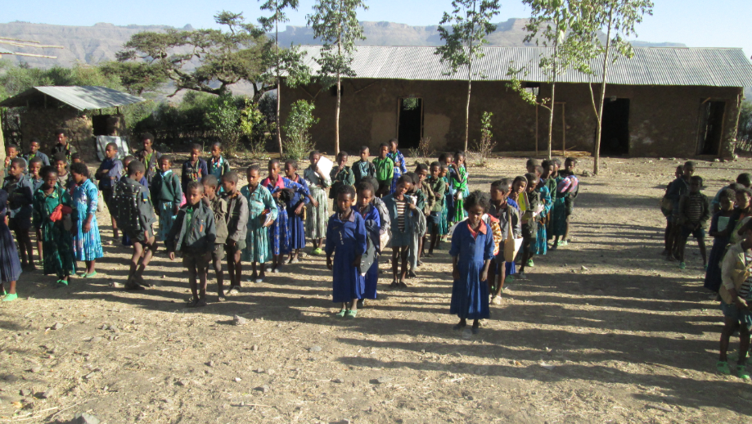
Jihur Primary School

