IFA’s Menstrual Hygiene Management work aligned with SDG

Menstrual hygiene is one of the challenging development issues of many developing countries like Ethiopia. Women and girls often lack access to hygienic sanitary materials and basic facilities (such as toilets, clean water and soap) necessary for good menstrual hygiene management (MHM). It is also associated with deep-rooted taboos and myths. The challenges of hygienic management have many economic, educational, health, psychological, social and environmental implications which in turn can impact development.
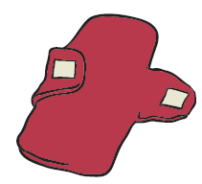
A study conducted in Ethiopia showed 92% of students were aware of menstruation before menarche, but a considerable proportion, 62.4%, were using rags and pieces of cloth. Menstruation-related problems resulted in 43% - 50.7% of students being absent from school between 1-4 days per month. Moreover, students had a difficulty concentrating in class due to menstrual-related problems such as pain and fear of sudden menstrual blood leakage, as they did not use proper sanitary napkins. About 39% of respondents perceived that menstruation had affected their academic performance. They also had discomfort and shame sitting beside male students in the class (Teketo and Mitike, 2014).

Sustainable Impacts of MHM
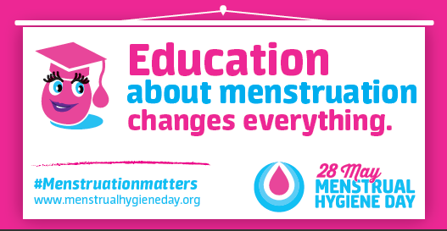
Educational Impact - over 40 percent of the menstruating women in the world have been absent from school due to their menses, mostly because of non-existence of female hygiene products (Fehr, 2012). According UNICEFs estimates to estimates one in ten school-age African girl didn’t attend school during menstruation or dropped out at puberty due to lack of cleanliness and separate toilet facilities for female students at schools. Lost school days from poor MHM leads to low educational performance which indirectly affects future employment opportunities for girls. Therefore interventions, such as an MHM program increase years of schooling.
Environmental impacts -relate especially to the disposal of menstrual hygiene materials. When using sanitary napkins, an average middleclass woman will dispose 15,000 pads during her menstrual lifetime. Globally, over 12 billion pads and tampons are disposed of annually, filling up latrine pits or ending up in city dumps and landfills. Currently they also form an estimated 6.3% of the so-called sewage-related debris along rivers and beaches (Larsson and Olsson, 2014). Whereas, MHM programs teach girls to make and use reusable sanitary napkins.
Health Impacts - Poor MHM can be detrimental to health. Health outcomes related with poor menstrual hygiene include lower reproductive tract infections (RTIs), such as vulvovaginal candidiasis and bacterial vaginosis and urinary tract infections. It is well established that untreated lower RTIs (from any cause) can lead to serious complications such as upper RTIs including pelvic inflammatory disease; adverse pregnancy outcomes including ectopic pregnancy; and infertility.
Promotes Gender Equality - girls face gender-related difficulties, as most must use old cloths, toilet paper or similar free but unsuitable materials to catch the flow as most commercial sanitary napkins are still priced too high to be affordable for the poor. Therefore, the availability of sustainable, reusable sanitary napkins promotes the dignity and confidence of girls and women.
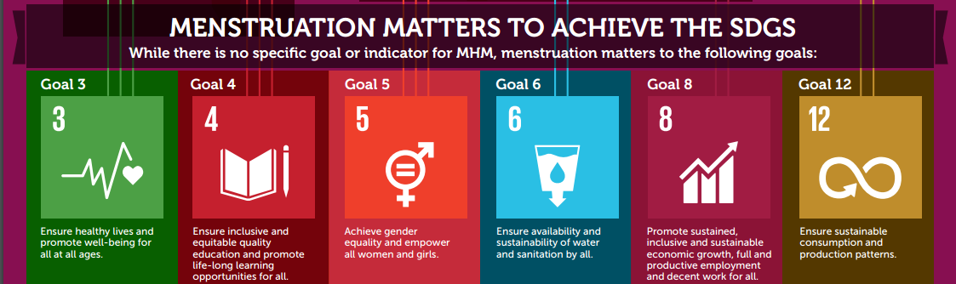

IFA’s MHM Program Achievements
- Improved menstrual hygiene knowledge amongst teachers, adolescent girls and boys in 7 public primary schools
- Distributed reusable sanitary napkins to 2,100 girls age 12 to 17 in 7 public primary schools and taught them how to make and use them hygienically
