International Fund for Africa

Producing & Distributing Reusable Sanitary Pads to Empower Girls
IFA’s Effective Menstrual Hygiene Management Project
The way in which women and girls deal with their menstruation is called Menstrual Hygiene Management (MHM). Unfortunately, many factors can affect the attainment of effective MHM, especially in countries like Ethiopia where girls are often ill-informed about menstruation, a topic still regarded taboo. Ethiopian girls lack access to appropriate infrastructure, and commercial menstrual management supplies are either available or unaffordable. This lacking not only impacts their health, well-being, and education, but also reinforces gender inequities and exclusion.
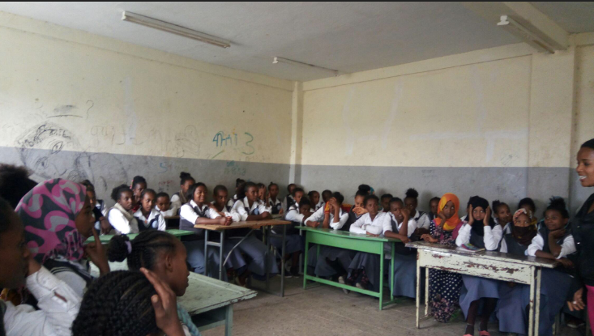
A study conducted in Ethiopia showed the utilization of sanitary napkins was as low as 37.6% and a sizable proportion (62.4%) were using rags and pieces of cloth. Urban–rural disparity in access to sanitary napkins stood at 37.1% for urban girls vs 1.6% for rural girls. Sanitary napkin use was limited due to access and financial constraints. 43% - 50.7% of students were absent from school between 1-4 days per month. About 90% of students reported that their school did not have a separate sanitary facility for females. Lack of separate facilities were also related with a high rate of female school dropouts in Oromia (65%) and Amhara (33%) regional states of Ethiopia. Moreover, students had difficulty concentrating in class due to menstrual-related problems such as pain and fear of sudden menstrual blood leakage, due to using substandard sanitary napkins. About 39% of respondents perceived that menstruation had affected their academic performance or caused them to rank negatively when compared to their rank before menarche. They also had discomfort and shame sitting beside male students in the class. In rural Ethiopia, most girls are at risk of getting genito-urinary tract infections due to their unhygienic practices during menstruation; this can lead to further complications if left untreated. However, sufficient attention is not given to this problem and studies on menstruation and hygienic management as well as its influence on girls’ education are limited and scarce in Ethiopia (Teketo and Mitike, 2014).
IFA IS MITIGATING GENDER INEQUALITIES THROUGH AN EFFECTIVE MENSTRUAL HYGIENE MANAGEMENT PROGRAM
Additionally, the environmental footprint of traditional sanitary pads must be tackled as they are not biodegradable and can take up to 500-600 years to decompose. Although there are new production processes, some can still contain chemicals including pesticides and dioxins, serious environmental pollutants. The lack of waste disposal management and infrastructure in many countries means feminine hygiene products commonly end up on the street or are thrown down the toilets, causing blockages and breakdowns of sanitary systems, both of which can produce added public health problems. Groundwater can be affected by those that do end up in landfills
IFA’s Intervention Package
It is to address the afore mentioned challenges that IFA has designed intervention packages to improve Menstrual Hygiene Management for girls in elementary schools by producing reusable, affordable, absorbent and hygienic sanitary pads made of cotton. These re-usable, washable napkins made from absorbent fabric are an appropriate alternative (House et al, 2012). These napkins are used with a napkin holder that secures the placement of the napkin to the underwear. Re-usable napkins can be used for up to a year if handled properly. They will need to be washed before, during and after a period. Thus, providing female students with reusable sanitary pads introduces environmentally friendly, healthy and sustainable option for school girls.
IFA’s MHM project uses a participatory approach with strong collaboration between the school, parent and teacher associations where applicable, teachers and students. Involving all these groups makes it easier to create awareness about good MHM and allay negative perceptions of menstruation, thus addressing socio-cultural constraints.
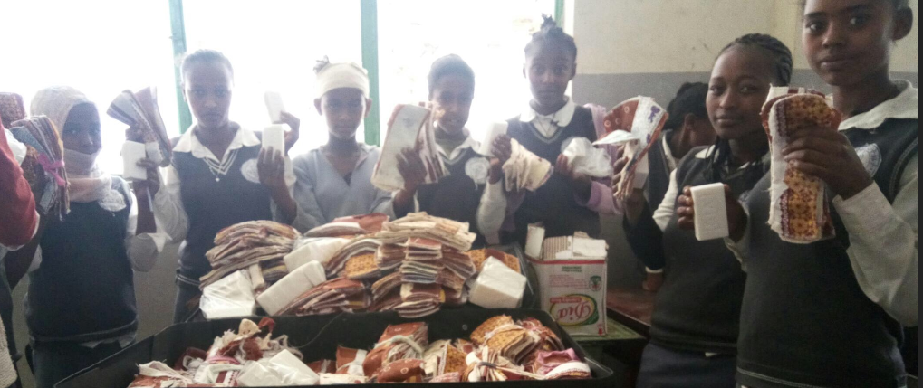

Voices of the girls
…we now are not missing school now.
Girls from Gofa School …
The training on MHM was new and informative
…we now are not missing school.

Increased the production capacity
IFA has created a sewing center operated by two female tailors recruited from the tailoring vocational training program the NGO co-sponsored last year; the center now produces close to 100 reusable sanitary pads per day. The pads are made from highly absorbent flannel materials. The demand for these affordable, user friendly pads is based on the feedback IFA collected by repeat users and this is without considering the demand amongst rural communities.
Economical Sustainability as a Social Enterprise
IFA envisions converting the reusable sanitary pad production project into a social enterprise and anticipates production can be quadrupled by the addition of modern, efficient sewing machines. The cost per pad stands at 0.13 USD. After providing one round of 10 pads per girls, IFA will set up a cost sharing arrangement for school girls but will generate marginal profit by selling to the public. The sales revenue will be re-invested back into the MHM project to establish a sustainable program the will help to scale up the project to reach as many school girls as possible.
Impact of MHM
The primary impacts of the MHM project is related to the empowerment of girls through health and education benefits. There is also a positive environmental impact as reusable and easily degradable materials are used. Additionally, when the MHM project is converted into a social enterprise, IFA will build a new value chain which creates local employment opportunities and income.
Last but not least, raising awareness around the health and hygiene issues girls face is paramount to the project. As IFA raise awareness about girls’s health, hygiene and empowerment in school communities the stigma attached to these issues lowers. To date, IFA has trained 4,300 girls on MHM, enabling them to make healthier decisions about their menstrual management.
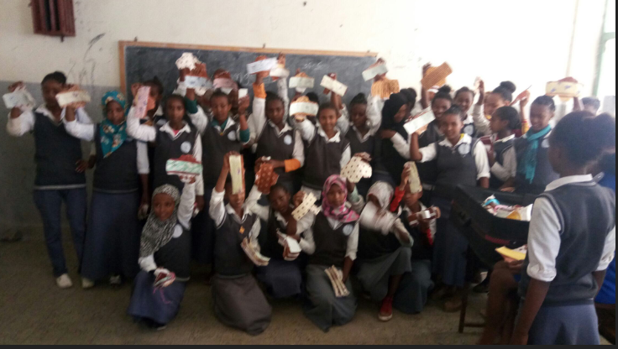
 | Girls are enabled to avoid social discrimination and attend school | Health is another important social impact of the MHM project by providing a safe and hygienic alternative to other cheap, unhygienic options that are common in Ethiopia | Creating a positive attitude towards menstruation management that will support girls and women
It only costs $1.30 to provide a girls 10 reusable and eco-friendly pad – Please join hand with us to empower schoolgirls
Join IFA’s Co-founder and MHM Champion’s call
Seble Nebiyeloul

