Eyeglasses for School Children

School Eye Health in Ethiopia
The Government of Ethiopia has recognized blindness as one of the major public health problems of the country, but much remains to be done in terms of resource allocation and prioritization. The latest national survey reported a prevalence rate of 1.6% and 3.7% blindness and low vision, respectively. Cataract, Trachoma, and Refractive error were reported as the leading causes of blindness and low vision in the country accounting for 70% of all causes. In Ethiopia over a million people suffer from uncorrected refractive error (URE) excluding presbyopia which occurs in people over the age of 40 years. If presbyopia is included the number of people affected by URE may reach 3-4 million and this disability has a huge deleterious impact on economic productivity and learning capabilities of young children. URE treatment is affordable by using correctly prescribed eyeglasses.

IFA’s School Eye Health
IFA in partnership with Better Sight for Better Learning (BSBL), a Dutch Foundation, launched the School Eye Health Program in October 2015. The School Eye Health Program conducts vision screening for primary school children, refraction on site and dispenses eyeglasses to those identified to have refractive errors. The provision of eyeglasses has improved learning opportunities for children who previously lacked both the awareness and the access to vision care services. This in turn has allowed schoolchildren to continue their education and ultimately improve the quality of their life.

To date IFA, with the strong and continued support of BSBL has accomplished the following:

Schools Reached | 40
Teachers Trained on Vision Screening | 924
School Children Screened for Visual Acuity |  | 46,700
Eyeglasses Dispensed | 983

Sustainability of IFA’s School Eye Health
IFA values and strives to ensure that all its programs reach financial independence – this is shared by BSBL. In May 2019, as part of their annual visit, the chairperson of BSBL’s board visited IFA’s school eye health program and together we are working on an income generating scheme that will provide the necessary funds to sustain and scale up IFA’s SEH.

IFA is pleased to share that Professor Redda, the founder of Grarbet Hospital – a renown eyecare hospital in Ethiopia, has agreed to coach and mentor IFA on its journey towards achieving sustainability. To grasp the full and detailed understanding of what it will entail to make IFA’s SEH sustainable our team conducted a project site visit by traveling to Butajira, where Grarbet Hospital is located - 130 kms south of Addis Ababa.
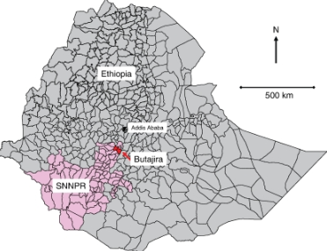

Our journey south into the rift valley was picturesque – under the blue African skies and savannah land strewn with the famous acacia trees, known as Grar and from which the hospital takes its name. The Grar tree sustains life when water is scares.

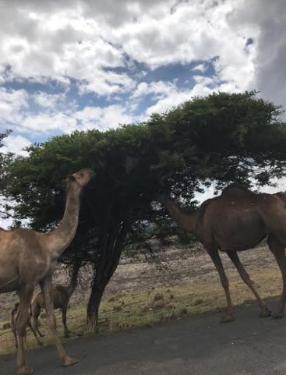
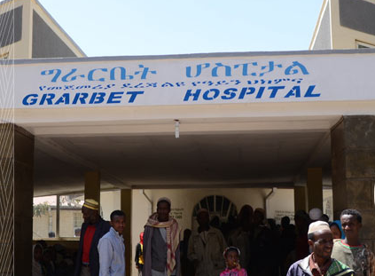

The highlight of the visit for our team was seeing first-hand the efficient workflow of an eye care center – from registration, to refraction to prescription of eyeglasses to the inner working of an optic workshop and dispensation of prescribed eyeglasses.

Waiting and registration area

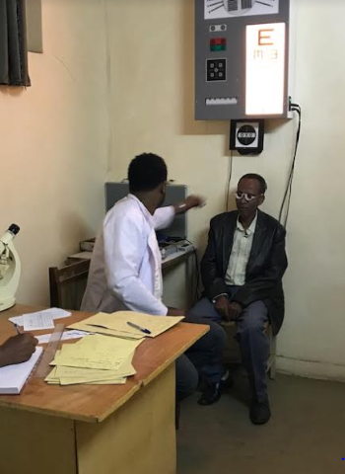
The team at Grarbet identified and showed us all the essential equipment’s and models that are necessary for the setting up of an optic shop and an optic workshop.

The optic workshop has four sections:

- Curve generation and grinding section
- Polishing and Centering & Edging section
- Metrology section
- Coating and assembly section

Refraction by optometrist

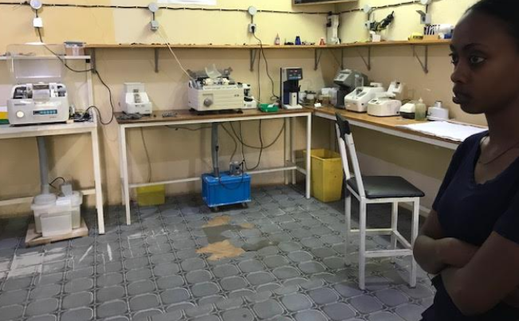

Optic workshop
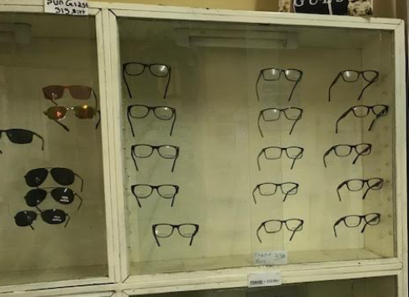
Optic Shop – dispensing prescriptive glasses and sunglasses

Here is our wish list for making IFA’s Optical workshop and optic shop become a fully functioning IGA that will sustain the work of the school eye health program:
- automatic edger & hand edger
- blockers
- markers
- focimeters (lensometer)
- nylon groover
- drill
- parallel rules
- papillary distance (PD) or millimeter rules
- frames & frame tools
- lenses
- adhesive and protection pads/films
- formers
- frame heater
- soldering unit

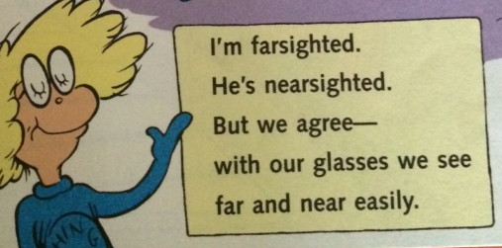

Please join our efforts as we serve schoolchildren who can now proudly say …….

Together it is possible to make access to eyeglasses a reality for all schoolchildren in Ethiopia.

