COVID 19 Pandemic in Ethiopia
First case of COVID 19 in Ethiopia was disclosed on March 13, 2020. By the end of May, Ethiopia is seeing the spiking trend seen in other countries as the rate of new cases increases, crossing the 1000 mark at the end of May. In Africa there are a total of 69,578 infected cases and 2,403 deaths. It is expected that up to 3.3 million people can die due to COVID 19 if nothing is done to stop the spread.
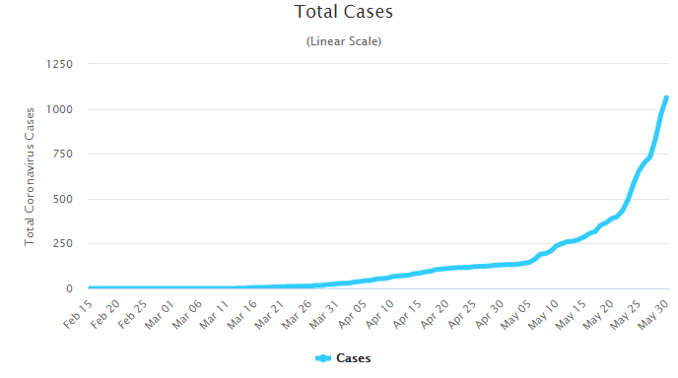
Source: www.worldometers.info
COVID-19 is affecting the economy, health, transportation and the social life of people. The country is under a semi lockdown to prevent worsening of the already high unemployment rate. To ensure preventive measures are fully implemented, a State of Emergency was declared in Ethiopia.
There are several organizations at all levels leading the fight in this pandemic. The WHO is the leading international organization coordinating across all countries. It is providing support with equipment, creating awareness, testing and trials of vaccines and other solutions. The World Food Program (WFP) is an organization that has been helping with food security and is now using Ethiopia as a connecting point to other African countries. The Ministry of Health in Ethiopia is focused on communicating to the public by working with well-known celebrities. The Jack Ma foundation has supported Africa with much needed supplies by using Ethiopian Airlines to transport and Addis Ababa as a connecting point to the other countries.
The economic impact of COVID 19 at a global level, regional and national level is huge. Lockdowns has reduced many economic activities across the globe. The decline in trade, travel, oil prices, and tourism have had a negative impact on economies. In Africa, the economy of countries will need the support of the World Bank where it will get funding of $2.3 billion. Ethiopia’s low foreign currency is further strained due to low exports, travel restrictions and curtailment of tourism. Furthermore COVID 19 is impacting the politics by necessitating the postponement of elections resulting in debates and opposition among various political parties.
The challenge in many countries, as is the case in Ethiopia, is that millions of people live in densely populated cities so complying with WHO guidelines is difficult. Thus, Addis Ababa is the where the highest case cluster is found in Ethiopia.
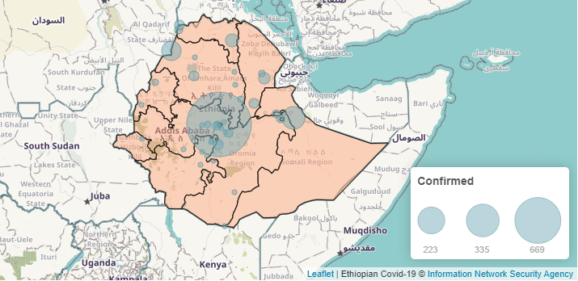

IFA and COVID 19 in Ethiopia
Globally the livelihood of close to half the workforce is jeopardized according to the ILO by COVID 19 pandemic. Unemployment is harder on countries like Ethiopia where 71% are informally employed, therefore lack safety nets.
IFA remains open during this time while treating its staff responsibly. IFA is taking innovative and proactive measures such as cross training its staff, repurposing its staff, creating work schedules that minimize face to face time. These measure are helping to reduce risk of transmission and sustain employment opportunities to protect its staff and their families from economic hardship thus sealing the goodwill between IFA and its staff during these unprecedented times.
Reorganizing and repurposing its employees helped IFA launch its new initiative of producing much needed standardized face masks for the city. This measure has also provided an opportunity for IFA to strengthen its income generating mushroom farm.

To emerge stronger and better is our goal – therefore we ask all our partners and supporters to stand with us during this crisis

