Thank You for a Successful Year!
Thanks to our supporters IFA was able to finish strong this academic year. Our flagship program – Sustainable School Health and Nutrition Program (SSHNP)- a comprehensive and integrated program in Ethiopia was able to achieve the following results:
- The school nutrition component – improved the nutritional status of 500 school children by:
  - Serving 83,600 hot plant based nutritious lunches and 5148 breakfasts for KG students
  - Dispensing preventive deworming tablets for 500 school children
  - Dispensed micronutrient supplements
- The school eye health component – improved learning opportunities by:
  - Operating a vision screening program at 8 primary schools for 7,645 students
  - Conducted refraction for 296 students
  - Dispensed 166 spectacles and treated 67 students with eye infection
- The school sanitation component – improved hygiene and sanitation by:
  - Training 1,200 girls on menstrual hygiene management and on how to make their own sanitary napkins with holders
  - Delivered various capacity building initiatives on safe food preparation, proper hand washing, etc.
- The sustainability component – ensured through:
  - Practiced participatory project management approach to promote ownership
  - Readied two fully equipped bakeries as income generating schemes to establish a standalone program
This program helped hundreds of school children and their families. This is the reason we want to say “Thank You”
End of year Reflections from some of the school children
Here are some heartwarming letters from the students – written in Amharic (the national language in Ethiopia) and translated to English by our staff.
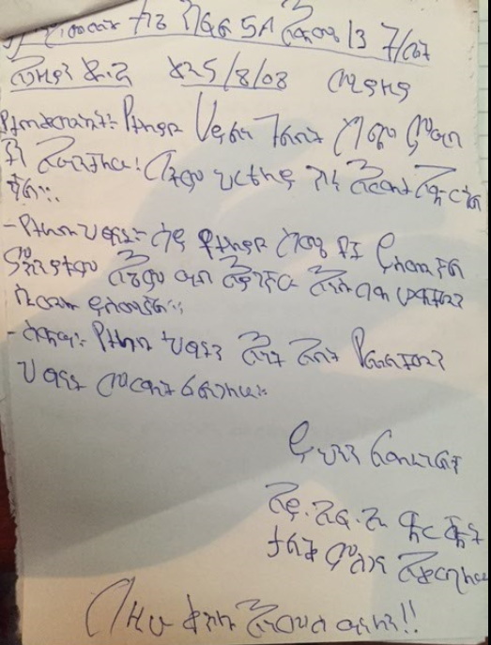
Emebet, a 13-year-old girl in grade 5A wrote:
“I benefited from the various types of food which provided me with energy and which was supportive for my education. I feel bad when I see other children who come to school with empty stomachs. In the future I want to help such children and other helpless persons. I want to thank IFA, the organization that helps us”

Tarik, a 16-year-old boy in grade 7B wrote:
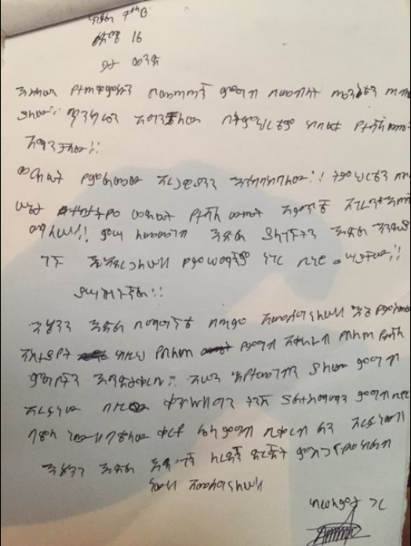
“The well-balanced diet I received has helped me stay healthy and strong and my grades have also improved. I want to continue doing well in school. When I grow up I will help the elderly. I also want the school lunch program to continue giving us such good meals but would like to suggest that the beans be replaced by something else. I want to thank the organization that is helping us.”

Ammanuel, a 14-year-old boy in grade 7B
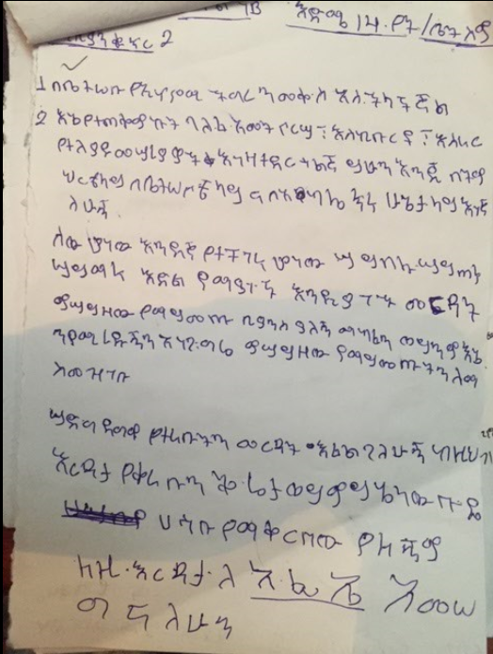
“My family economy and hardship has improved. I am doing well in my education, health and in my family. In the future I want to help and share what I have with others who don’t have the opportunity to eat, drink and go to school. I have no other comment or feedback and I want to thank IFA”

IFA says “Thank you” to all the generous people and organizations who have made possible the many big and small achievements with their donations and actions.

