Menstrual Hygiene Management Training of Trainers Workshop Held for Primary School Teachers

Menstrual hygiene management for many women and girls’ can have devastating outcomes such as debilitating urinary tract infections, loss of education and future employment opportunities. Most women and girls in developing countries face gender-related difficulties. Taboos abound with regards to menses limiting open discussions within the family. Many resort to using old cloths, pages from their note books, leaves or other unsuitable materials to catch the flow. Lack of private places to wash and dry the cloths can force them to re-use still half-soiled and humid materials, making them feel uncomfortable and dirty. Lack of awareness and education for men, and taboos around discussing the subject can prevent girls and women from asking for money for sanitary materials from their fathers and husbands. Most commercial sanitary napkins are expensive and unreliable.

Therefore, IFA’s Sustainable School Health and Nutrition Program (SSHNP) sought to address this need through its new initiative to promote better understanding of girls’ menstrual challenges and enable school girls to make their own sanitary napkins so that they may attend school during menses without fear of leaks.

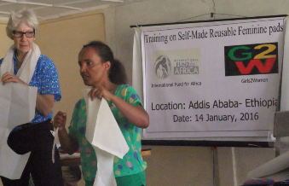
Thus a Training of Trainers (ToT) on “Menstrual Hygiene Management for Girls” was held on January 14, 2016 in Addis Ababa, at Sibstie Negasi Public Primary School. The training was organized by the International Fund for Africa (IFA) and funded by Girls2Women, a US based organization. The one-day ToT was conducted by Mary Moran, the founder of Girls2Women and Nursing Instructor at Columbia University School of Nursing and six of her students.
Mary Moran from G2W & Hela Genet from IFA

The course was attended by 38 participants, 20 primary school teachers, 8 government representatives from the District Health, Education and Women, Youth and Children Offices, 3 from an NGO and 6 from IFA.

The outcome of the workshop was:
- Greater understanding of the female reproductive system
- Teachers equipped on how they can appropriately explain the normal process of menses to school girls
- Skills developed in making reusable feminine pads and cotton underwear from Ethiopian cotton transferred
- Improved knowledge of menstrual hygiene and how to care for the pads

Participants expressed the necessity of the training, especially for girls who cannot afford to buy manufactured sanitary napkins. Equipped with this empowering skill, participants are mandated to teach the skill they acquired and to promote girls menstrual hygiene sanitation management. In closing Dr. Gebreab Barnabas, researcher and eLearning expert strongly encouraged the attendees to take their leadership role to its maximum by teaching and empowering the girls in their charge with knowledge of menstrual hygiene management.

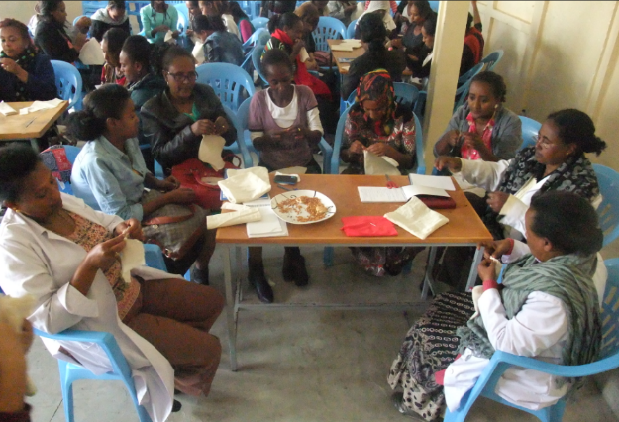
IFA is committed to supporting the trainers roll out the menstrual hygiene management training in their respective schools so that school attendance during menses will increase for 1,350 girls age 12 and above in 4 public primary schools in Addis Ababa during GC year 2016.
Trainees making reusable self-made pads

