IFA’s School Eye Health – Showcasing Abyot Fana Primary School
Child eye health is a significant public health issue, particularly in low income countries like Ethiopia, where blindness is recognized as one of the major public health problems. Globally the principal causes of visual impairment are uncorrected refractive error (UREs) and cataracts, 43% and 33 % respectively.
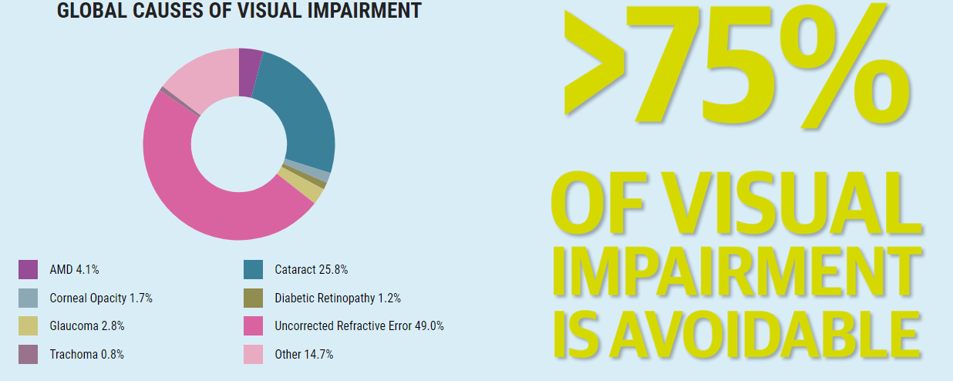
Source:2015 Vision Loss Expert Group
The high prevalence of vision impairment among children in Ethiopia has a devastating impact. A child's eyes are constantly in use in the classroom and at play; good vision is important for the visual task students perform daily such as reading, writing, chalkboard and computer work. When a child has poor vision, their education and participation in other activities suffers.
According to a 2012 report from WHO, more than 80% of all vision impairment can be prevented or cured. School health programs provide a unique opportunity for providing such preventive and curative services, and in many countries school screening for URE is a routine practice. In Ethiopia School Eye Health (SEH) is a component of the National School Health and Nutrition Strategy, never the less, school screening is not commonly practiced except in some private schools and in some areas where local and international NGO’s are working. For IFA School Eye Health is one of the components of the School Health and Nutrition Program that IFA is implementing in Ethiopia.

Impaired vision can seriously impede learning.
Early identification and treatment can prevent or at least alleviate many vision problems.

School Eye Health Showcase - Abyot Fana Primary School
Abyot Fana Primary School (AFPS) was identified as one of the needy schools by the Education Bureau of Addis Abeba. It is located around Gofa Sefer of Lafto Subcity, in close proximity to one of the well-known landmarks of the city – Bihere Tsige Public Park (meaning a “grace-giving-park-for-all)
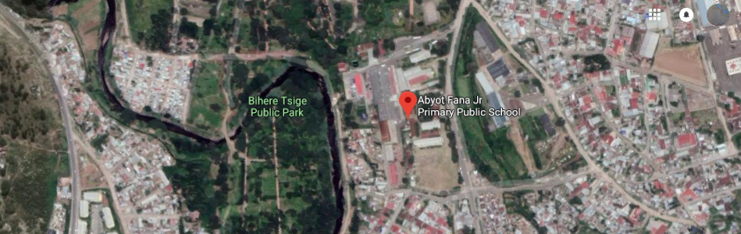
AFPS has a total school population of 1,381, of which 785 are girls and 596 are boys, ranging in age from 7 to 18. IFA’s School Eye Health Team implements SEH in collaboration with the respective school management teams.
Through the SEH project IFA provided practical hands on training for 17 volunteer teachers on vision screening at AFPS. Such trainings allow us to screen many children in a short amount of time. Certificates, reading glasses, frames and clip-ons are distributed for the volunteer teachers as an incentive. The teachers at AFPS identified 94 students who failed the vision test.
The shortlisted school children were rescreened by IFA’s SEH team of optometrists to avoid over referral as some students need a quiet atmosphere with one to one attention at a slower pace. On rescreening at AFPS 63 students were identified to need refraction and or further examination.
Refraction was done on school premises, at which time 28 eye glasses were prescribed and 8 students were referred for further medical evaluation to a private eye care provider that partners with IFA. There, 6 students received eyeglasses, 2 were diagnosed to have squints and one student was diagnosed and treated for Vernal keratoconjunctivitis (VKC).
Totally 34 spectacles were distributed to the beneficiaries in the presence of their parents.
Nov 19, 2018
“By wearing eyeglasses, I can see better than before. I have better vision now. My grades in school have improved because now I can see the black board clearly – I now don’t have any problems and therefore my grades are better”
Rahma
One of the students, Rahma, who received an eyeglass through the SEH project at AFPS had this to say:
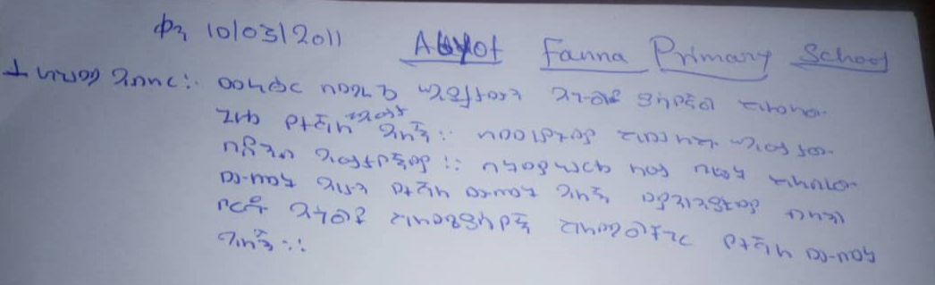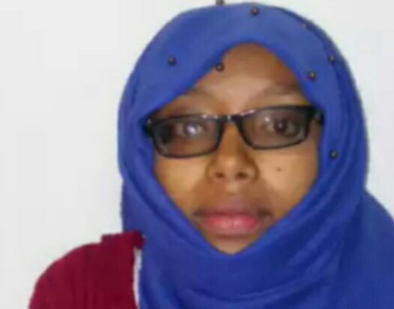

Using a standard driven approach IFA to date has implented the SHE in 30 primary schools in Ethiopia. This was made possible through strong supportive partnerships - both donor foundations like Better Sight Better Learning in the Netherlands and private companies like Sam Vision in Ethiopia.

Invitations to our Supporters
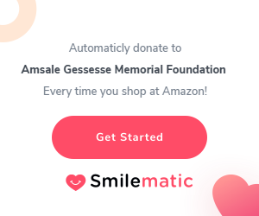
IFA’s work in Ethiopia is focused on establishing “Health Promoting Schools” which are recognized as a strategic vehicle to promote positive development and healthy behaviors among schoolchildren.
With your support, we can impact our community in a lasting way.
Please join us by making your gift on our online donation form or automatically donate to Amsale Gessesse Memorial Foundation [ doing business as International Fund for Africa (IFA)] whenever you shop on Amazon by using this link:
https://couponfollow.com/smilematic
Thank you for your continued support.

BEST WISHES FOR THE COMING HOLIDAY SEASON

