IFA Rural Project – Where We Work

ETHIOPIA
IFA’s overseas office is located in Ethiopia, East Africa. It is a nation filled with a rich culture and heritage. Bordered by Kenya, South Sudan, Sudan, Djibouti, Eritrea, and Somalia, Ethiopia has an estimated 2019 population of 112.08 million, which ranks 12th in the world. The median age in Ethiopia is approximately 17.9 years of age. 60% of the population in Ethiopia is under the age of 25 heavily pressuring the demand for health services, education and employment.
Ethiopia remains one of Africa’s poorest nations with a third of the population living below the poverty line. According to the HDI of the UNDP (2014) Ethiopia ranks 173 out of 187 countries. Almost 80% of the working population are engaged in agriculture, and agricultures share to GDP is at approximately 50% (WORLD BANK 2015)
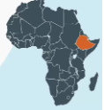
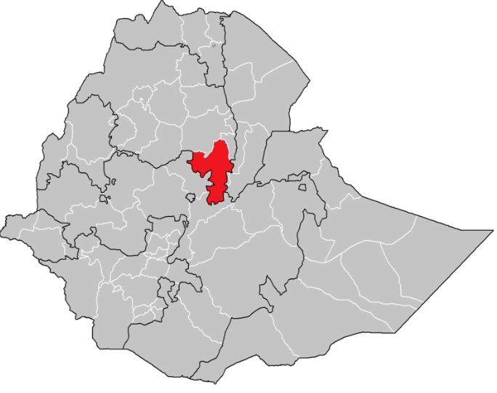
Full Name: Federal Democratic Republic of Ethiopia
Population: 107.5 million (World Bank, 2018)
Population Growth (Yearly): 2.46%
Capital: Addis Ababa
Area: 1,104,300 SQ KM (426,371 SQ Miles)
Major Languages: Amharic (Official)
Major Religions: Christianity, Islam, Traditional Beliefs

NORTH SHEWA ZONE OF AMHARA REGION
IFA has historically worked in North Shewa Zone of Amhara Region, and building on its past work IFA proposes to strengthen its rural development through health and education related interventions that are need based.
In the past IFA conducted successful medical missions and following on from these missions IFA is moving forward with a strategic rural development program in capacity development to strengthen the healthcare and education system. IFA’s rural development program targets Northern Shewa Zone where IFA has established longstanding partnerships with health facilities: Debre Berhan Hospital, Mehal Meda Hospital, Zemero Health Centre and government offices.

Mehal Meda Town
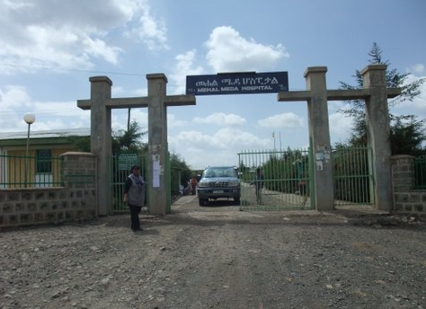
Mehal Meda Hospital is one of the four hospitals in North Shewa Amhara Region serving more than 360,000 people residing in five woredas (districts) including the Menz Gera Midir woreda where the hospital is located. The hospital was established in 1998 with a mission of providing curative and rehabilitative services to ensure all patients have access to high quality, cost effective health care; it also had a vision to see healthy and satisfied productive people by providing a standardized, quality health service. In the past few years the hospital has purposefully engaged in improving the quality of the health service it provides by adding new services such as:
- Medical Unit–It incorporates both inpatient and outpatient departments and includes chronic case follow up and comprehensive HIV care for pregnant mothers, children, men and women
- Pediatric Unit–It incorporates both outpatient and inpatient departments and includes the recently established neonatal care unit
- Ophthalmic Care Unit
- Emergency Surgery
- Laboratory, X-Ray &Ultrasound
Starting from 2012 G.C. the hospital started providing emergency surgery services including emergency obstetric care which has strongly influenced the society’s health seeking behavior, awareness and understanding of the use of the health facility. These improvements have resulted in the decline of maternal and perinatal mortality rates that were recently registered. Furthermore, the increase in public awareness is resulting in an increase in patient flow and to accommodate these changes, services are being expanded. IFA visited the facility and witnessed firsthand the commitment of its health workers who are highly motivated to provide a quality health care service. During the visit a rapid needs assessment was made of the neonatal care, maternal care, and operation room unit.

Zemero Town - Zemero Health Center is also located in Norther Shewa; it is a health center that serves a population of 65,000. One of the areas identified as lacking the necessary medical equipment is its Outpatient Therapeutic Program (OTP). The OTP is instrumental in managing severe malnutrition (hypoglycemia, hypothermia, dehydration, electrolyte imbalance, infection, micronutrient deficiencies.
As of September 2012, 73% of the health posts and 62% of the health centers in Ethiopia are running Outpatient Therapeutic Programs (OTP). 30% of health centers and 96% of hospitals are treating the complicated cases of severe acute malnutrition.
JIHOOR - Jihoor Primary School is located in Moretena Jirru Woreda, Kebele 01, 214 Kilometers north of Addis Ababa, and about 84 kilometers north from the capital of the zone Debreberhan, with a catchment population of over 10,000. There are 1,802 students in the school ranging from 4-16 years, which equates to grades 1-8. It is the only school in the area and has some of the poorest children in the surrounding community attending it and many of the children come to school underfed. The District Education Office and IFA selected JPS for the implementation of the school Health and Nutrition program based on the following criteria:
- The school is in a very rural area and 97% of the populations are farmers.
- JPS serves children with disability – of the total population, 21 have special needs and another 34 have partial disability, all attending regular classes. 60 students are one-parent orphans and 9 students are two parent orphans. 50 students have no access to regular meals due to various reasons.
The school has to be prepared to commit fully to the program. IFA seeks a participatory approach with a commitment by the school to operate a SHN program and to be instrumental in the operation and management of the selected income generating activities in order to secure sustainability. The latter involves a commitment by the school to set up a SHN Committee to include teachers, students, and local community elders. To date IFA has been encouraged by the enthusiasm and commitment to all aspects of the prospective program from the teachers, students, parents and community at JPS.
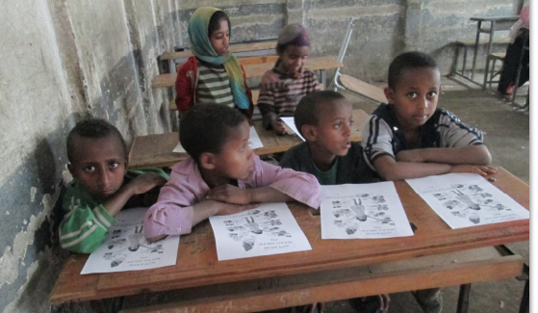

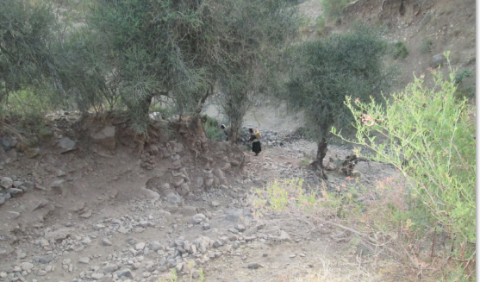

Jihoor

