IFA in 2020 – The Unforgettable Year
2020 is a year we will all remember, young and old.
March 2020 - World Health Organization (WHO) declared the outbreak of coronavirus disease 2019 (COVID-19) was a pandemic. As COVID-19 is going through a second wave globally, Africa continues to have the lowest confirmed cases and deaths due to COVID-19. Of the African nations, Ethiopia has the 4th highest number of cases with a low fatality rate of 1.5%, which is still lower than the 2.4% average for Africa.
The pandemic changed our world, our work, our schools. Urgent adaptations were quickly instituted. For IFA it meant shifting to serving take home rations instead of school meals. Producing face masks while halting the production of reusable sanitary pads. We became adept at rearranging, repurposing and learnt to be resilient.
This birthed the forging of new partnerships. One such partnership was a close working relationship with the city of Addis Ababa’s Administration. IFA sought to ease the burden on the city’s health care system by leveraging IFA’s network among the diaspora to gain access to much needed medical commodities.
Knowing very well the risk COVID-19 poses for healthcare professionals who are the frontline defense in in the fight against COVID-19, IFA sought to support the city’s health facilities with appropriate personal protective equipment (PPE) kits, since shortages of PPE is a major concern.
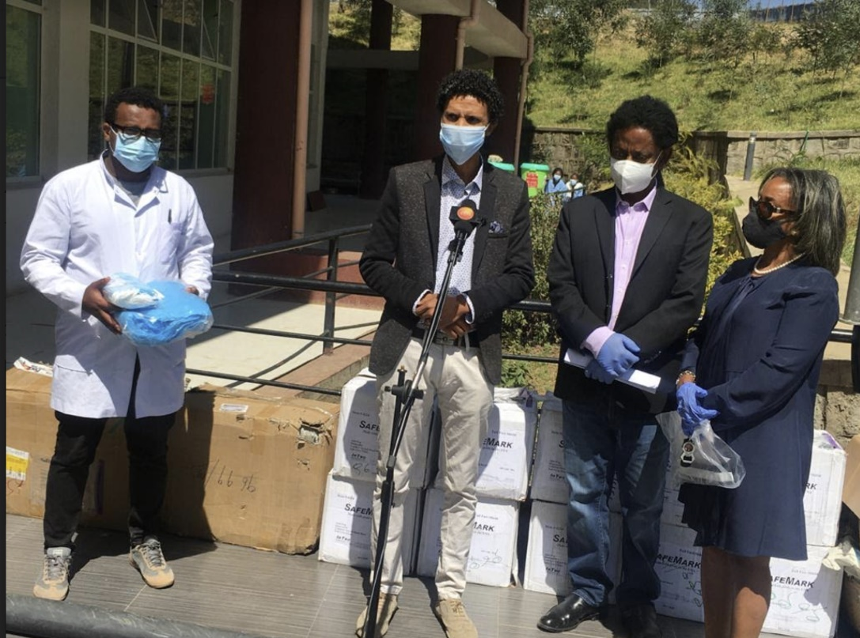
Thus, thanks to the advocacy and close working relationship IFA formed with Artist Zeleke Gesesse, a well-known musician and social entrepreneur, IFA received a shipment of PPE from North Western Hospital in the US. The donation was made to the main health facility in Addis Ababa that is reserved as the COVID- treatment center.

On site PPE kit donation
Both the city administration and the health facility were grateful, but this is really like a drop in the bucket. Medical facilities still need many more PPE kits due to the on-going response to COVID-19.
IFA on behalf of Ekka-Kotebe COVID Treatment Center in Addis Ababa, Ethiopia deeply thanks the well renown Singer Zeleke Gesesse and North Western Hospital.

Zeleke Gesesse
Ekka-Kotebe COVID Treatment Center 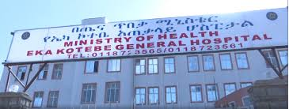

We invite all our supporters to join IFA’s effort to make a significant impact on meeting the PPE supply need in Ethiopia.

