IFA - A Catalyst
As we near the end of the year we reflect back not only at the year that is passing but all the years past. We see our story – our story includes so many. We are appreciative of the good and the challenges that have made IFA what it is.
The words that capture IFA are
- Catalyst –used for accelerating progress in nutrition, school health and newborn care
As catalyst for newborn care
IFA established a neonatal intensive care unit (ICU) at Yekatit 12 hospital. Prior to IFA's intervention, Yekatit 12 Hospital (a referral hospital with 265 beds, treating over 15,000 patients each year) and Gandhi Hospital (the only maternity hospital in Addis Ababa) lacked medical equipment and supplies needed to treat newborns. Because of IFA’s efforts two neonatal units were opened for the in both hospitals, thus contributing to the decreasing neonatal mortality rate. Latest data shows that “Since 2000, Ethiopia has reduced maternal and child mortality by half” ( USAID Fact Sheet, 2022). Community-Based Essential Newborn Care is now a national initiative that incorporates a newborn care program into the continuum of maternal and child health care to enhance community participation and thus reduce child morbidity and mortality.
A catalyst for school health and nutrition
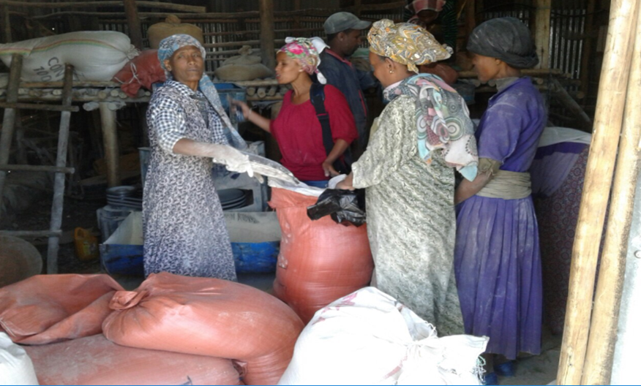
In 2014 IFA launched a school health and nutrition program targeting vulnerable schoolchildren. The program had a comprehensive and integrated approach of providing nutritious plant-based school meals, deworming program, vitamin supplementation, vision care, sanitation and hygiene coupled with building the capacity of teachers and parents. The model was highly applauded and duplicated by others. The provision of school meals was then fully adopted by the city government in Addis Abeba.
Since malnutrition and stunting continues to be a challenge for rural children , IFA is continuing the take-home ration program in Jihur Primary School , Northern Shewa.

Another word that captures the essence of IFA is :
- Sustainability - Sustainable practices support ecological, human, and economic health and vitality ( UCLA)
Sustainable girl empowerment through menstrual hygiene management
One of the major sustainable practices of IFA are captured in its Girl Empowerment Program that serves the multipronged approach to ensuring ecological, human, and economic health. The focus of this program is the production and distribution of reusable sanitary pads in conjunction with menstrual hygiene management training . Through this program IFA has distributed over 100,000 reusable sanitary pads thus enabling girls to engage more in their school and work, improve their educational outcomes, economic and livelihood security. Eco -friendly products are produced, human capital is built, and economic vitality becomes feasible as girls are empowered.
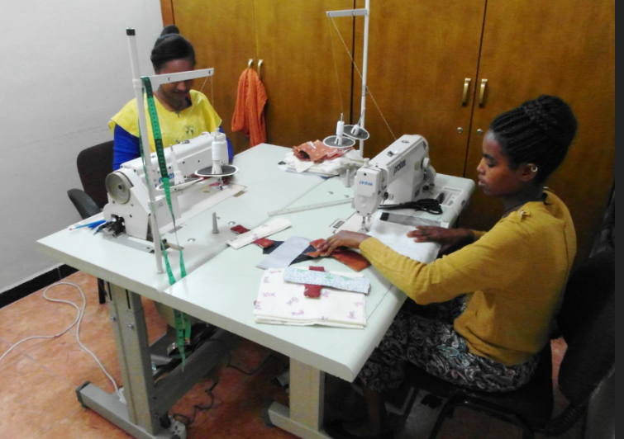
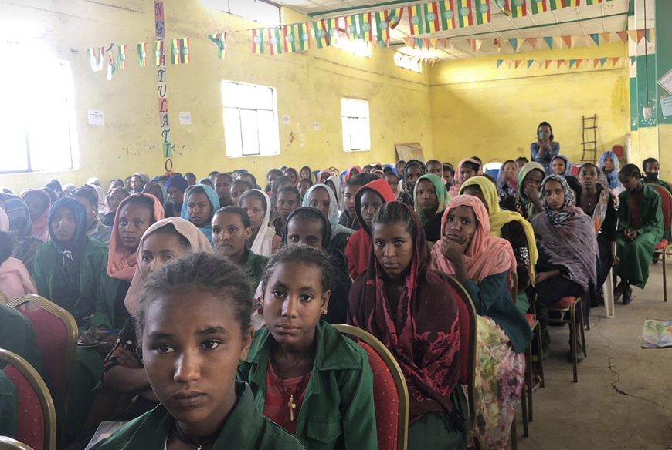
Sustainability through vocational training and income generating activities
The economic vitality of IFA is a long-term goal that IFA adopted at its inception to reduce donor dependency and to this end IFA setup and mushroom farm that is an eco-friendly product. The revenue generated from the farm is used to support the various projects of the farm. Additionally , the farm serves as a vocational training center for unemployed youth to improves their livelihood.
Another word that captures the essence of IFA is : Thankful
IFA is Thankful
The world and Ethiopia in particular have come through a turbulent year and yet we remain thankful and hopeful. Despite financial constraints IFA has met its goals for the year. IFA has shared the hardships of many vulnerable communities who were displaced by making “ lemonade from lemons”

As you , our supporters think about whom you’ll support this continue coming year would you kindly consider making a donation to help the work of IFA and its many beneficiaries?

