Become Our Hunger Fighting Partner
“Children are the living messages we send to a time we will not see.”
J F Kennedy

No child should come to school hungry in the 21st Century
IFA continues its work of fighting hunger and undernutrition among school children as the School Health and Nutrition Program took off successfully this year in partnership with local schools allowing food insecure school children to receive nutritious meal on school grounds.
The impact of our work:
Over 600 vulnerable children are saying:
- NO to hunger and YES to good nutrition with de-worming and micronutrient supplementation!
- NO to poor education and absenteeism and YES to improved learning ability!
- NO to gender inequality and YES to gender empowerment!
- NO to contamination and YES to hygienic and sanitary practices!
- NO to poverty and YES to socio-economic value transfer to households!
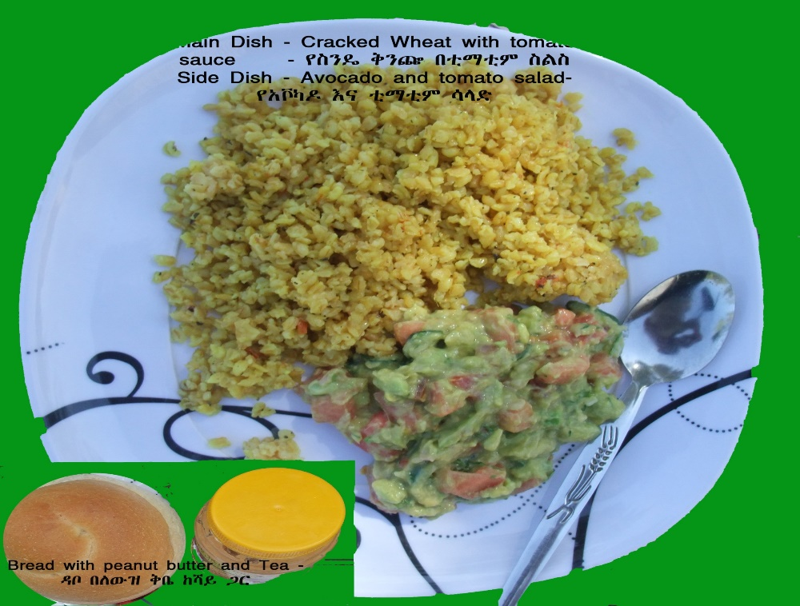
We, at IFA believe the SHN program has an innovative approach that will not only provide children with more nutritious meals when they are at school, but the additional nutritional education and the introduction of diverse food introduced in this year’s revised school menu will transfer knowledge to school community households. The new dishes promote food diversity and ensure the well-being of undernourished children with a well-balanced diet. The healthy recipes include fresh produce, avocado, peanut butter, soya and injera (Ethiopian pancake-like bread made from teff grain considered as a superfood).

School Children at lunch receiving the first round of de-worming tablets
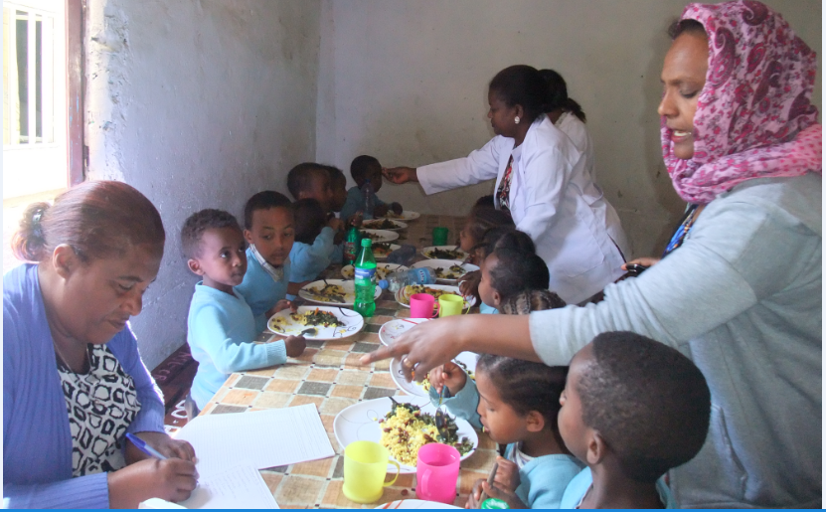

The Devaluation of the Ethiopian currency

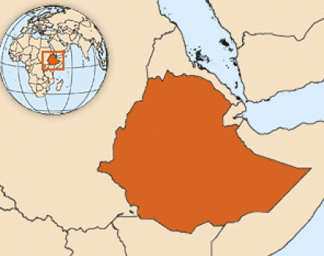
Although Ethiopia’s economy is one of the fastest growing in Africa, with the IMF expecting a growth rate of 9 percent for the 2016/17 fiscal year, Ethiopia devalued its currency by 15% against the dollar to boost export. This means the purchasing power of the Ethiopian Birr is lowered by 15%.
IFA, like all development actors is monitoring the rate of general and food commodity inflation rates which are closely linked to devaluation and currency exchange rate fluctuations. See figure below depicting food inflation rate prior to the devaluation of the Ethiopian Birr.

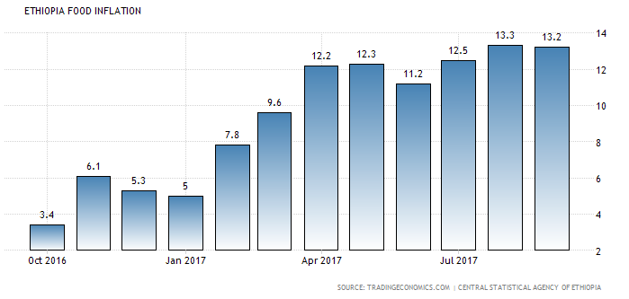
In light of this it is encouraging to realize the investment returns in the area of nutrition.
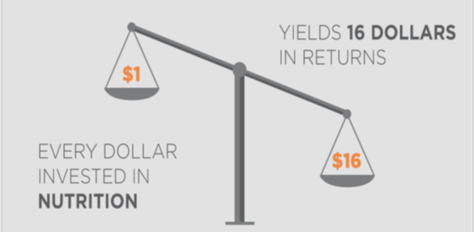
Source World Food Program

IFA Welcomes Your Year-End Giving
Your support for our efforts with gifts of time, talent and financial contribution since our inception in 2006 is needed now more than ever to ensure that our programs continues to serve those most in need.
Wishing You Happy Holidays

