Felekech Amanuel Joins IFA as School Eye Health Program Coordinator

IFA is proud to announce that Felekech Amanuel has accepted the position of School Eye Health Program Coordinator. Felekech is a healthcare professional with over 18 years of professional experience working in the health care field. After getting her bachelor’s degree in English Language, Felekech felt drawn to the healthcare field and proceeded to obtain her training in optometry at Signum Vetae, a renowned German Eye Care Center in Addis Ababa, Ethiopia. She also obtained another diploma as a druggist (Pharmacy Assistant).

Her expertise, experience and skills makes Felekech a valuable member of the team involved in building up the Sustainable School Health Program of IFA. She comes with awards and certificates for her work among disadvantaged and visually impaired children.

It is with excitement that IFA welcomes Felekech as we seek to reach our ambitious goal of providing spectacle for children from needy families after conducting school wide vision screening in ten schools years per year.

School Deworming Program and its Health Benefits

With the start of the new academic year (2015-2016) and commencement of the second year of our Sustainable School Health and Nutrition Program, IFA has just undertaken the administration of deworming medication for all the beneficiaries at Agazian No 2 Primary School and Sibiste Negasi Primary School for the third time. The beneficiaries at the three new schools on the SSHNP will receive their deworming medication next month.
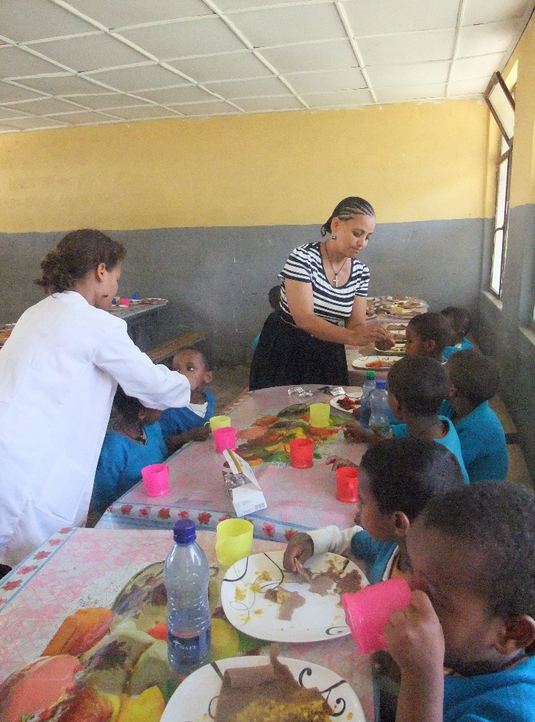
Most common causes of parasitic infection include bathing in or drinking water that contains parasites, eating uncooked food and exposure to untreated sewage. Ethiopia, like developing countries is undergoing rapid urbanization, meaning many people are crowded together into fast-growing cities with inadequate sewage treatment facilities. Raw (untreated) sewage, when dumped into rivers used for drinking, bathing, washing, and cooking easily results in the spread of parasitic diseases.
The World Health Organization currently recommends that schoolchildren in endemic areas are regularly treated with drugs which kill parasitic worms such as hook worm, round worm and pin worm. Treating schoolchildren biannually will help towards reducing anemia, improve growth and consequently improve school attendance, school performance and economic development.

IFA working in collaboration with the Woreda (District) Health Extension Workers administered the medication. Health and educational indicators will be used to measure the effect of this treatment on the students.

