The Launch of the IFA’s School Based Eye Health Project
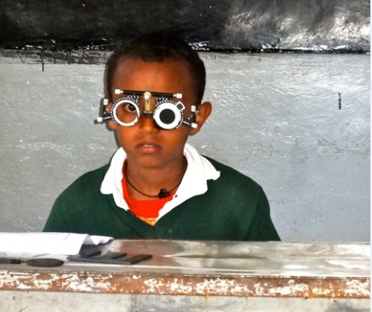
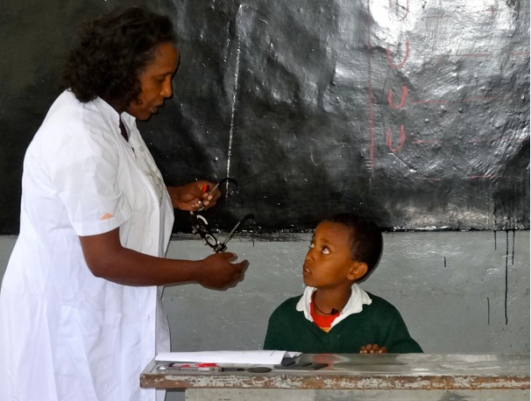
IFA in partnership with Better Sight Better Learning Foundation, based in Netherlands and a private eye clinic enterprise, Signum Vitae Eye Care Center, in Ethiopia has launched its school based Eye Health Program to help primary school children with eye problems by means of supplying spectacles and medical treatment.
Many children with poor vision due to refractive error remain undiagnosed and perform poorly in school. The situation is worse in Sub-Sharan African, including Ethiopia. In these countries, the link between uncorrected refractive error and poverty is very high.
Based on studies, refractive error comprises 33% of low vision in Ethiopia next to cataract. Refractive error as a cause of blindness has not been given much attention due to lack of awareness and unaffordable spectacle prices. For schoolchildren, it restricts their performance. As a result, its impact on their future career and opportunities is huge.
IFA believes no children should attend school with avoidable refractive error; therefore, the objectives of our Eye Health Program are to:
- Increase access to and use of eye health services by underprivileged primary school age children by providing vision screening, eyeglasses and referrals for further treatment when necessary in 10 primary schools in Addis Ababa during 2015/16 academic year
- Raise awareness regarding the importance of eye care and vision screenings by offering health education on eye care and vision problems in schools.

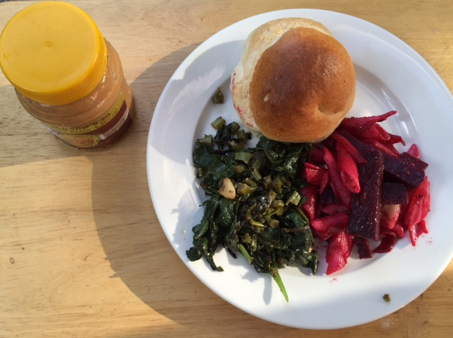
IFA Staff Revamping the Menu for Better Nourishment of Schoolchildren in our SSHN Program
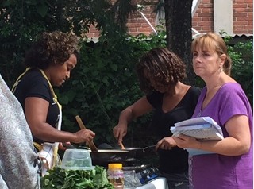
Based on the annual SHN feedback from students, parents and teachers gathered at end of the last academic year, the SHN team at IFA decided look into modifying the school lunch menu to make it even more nutritious and appealing.
Under the guidance of Seble, the co-founder and director of IFA, who is in her own right a renown vegan chef, our “SHN Menu Testing and Tasting” day turned out to be both enjoyable and educational. The outcome is that our new menu now has various spices and the nutritional value is greatly enhanced by learning new cooking techniques and the addition of tastier, vitamin-rich food items like avocado, pumpkin, and string beans.
In response to the demands of the schoolchildren, this year IFA will provide “injera” once a week. Injera is the staple Ethiopian bread, baked from Teff, a superfood grain, which is gluten free and rich in iron, and other minerals.

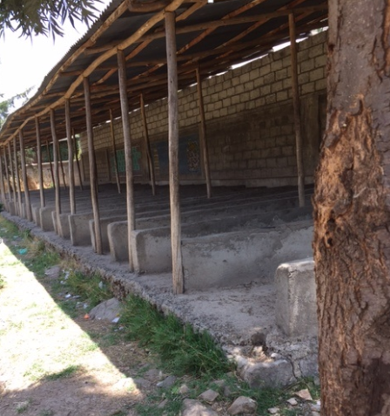
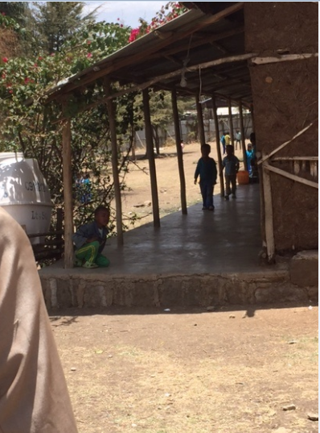
IFA Scales Up its SSHNP to 3 More Schools
Hana Primary School Lafto Primary School
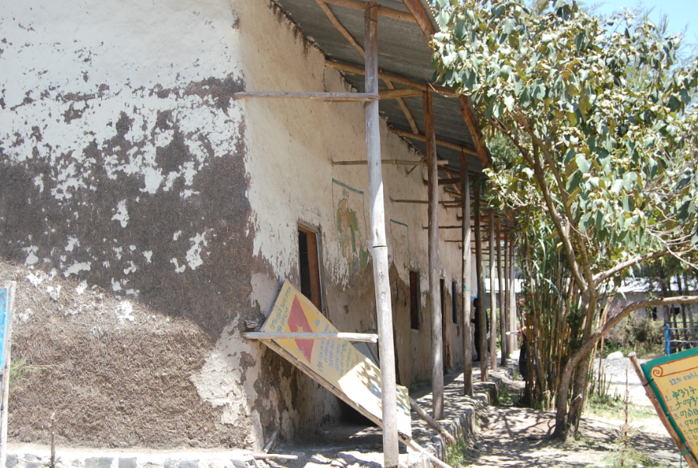
Jihur Primary School
Globally, Ethiopia is committed to “SDG 2 - End hunger, achieve food security, improved nutrition, and promote sustainable agriculture”. At the national level, Ethiopia is committed to the Seqota Declaration ‘A commitment to end child under-nutrition in Ethiopia by 2030’.
IFA is proud to say that only a year after launching its first full-fledged Sustainable School Health and Nutrition Program in 2014, it is scaling up the program to three schools by adding two more urban schools ( Lafto Primary School and Hana Primary School) in Addis Ababa and one rural school ( Jihur primary School) in Northern Shoa of Amhara Region. This brings the total number of schools in which IFA is implementing its flagship program to five and the number of schoolchildren benefiting from the program will go up from 170 to 500.

