IFA OFF TO A GOOD START - Improving children’s health and boosting their capacity to learn
Chronic malnutrition constitutes 80% of all forms of malnutrition, and it continues to cause irreversible consequences on children’s physical and mental health. It is estimated that 40% of all Ethiopian children are stunted from the effects of chronic malnutrition. Such children are more likely to develop severe infections secondary to compromised immune responses, which is further compounded by the high prevalence of bacterial and parasitic diseases, thus aggravating malnutrition among children. In Ethiopia malnutrition contributes to over half of child deaths.

It is well known that adequate supply of food does not guarantee food security at the household level, as it is mainly determined by the price of food, and other socio demographic factors like gender empowerment and the adequacy of the infrastructure. One proven program that addresses hunger and malnutrition among children is the provision of school meals which helps overcome some of these barriers. School meals are helping eliminate hunger for millions of children around the globe and is contributing to their education, nutrition, health and future productivity as adults. School feeding also serves as a social protection system for vulnerable families and children. School meals have been shown to increase the nutritional status of school-age children in a variety of ways. For example, there is a notable reduction in malnutrition via diet diversification and an increased absorption of micronutrients. Overall, the amount of kilocalories in a child’s diet is expanded when they are given nutritional resources that they would otherwise have little or no access to. It is proven that well fed children are able to concentrate better on their lessons. With a solid education, growing children have a better chance of finding their own way out of poverty.

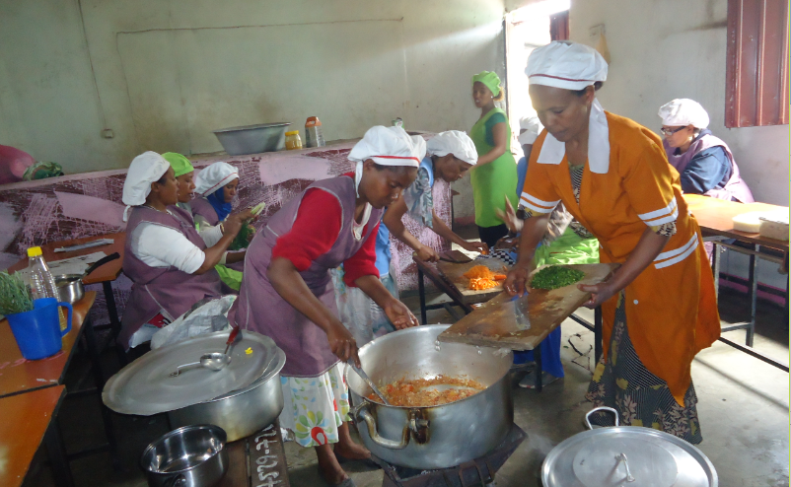
IFA’s SHNP supports 500 vulnerable children in five primary schools by serving nutritionally balanced school meals that provide 70-80 percent of the daily dietary energy needs. Meals are prepared and served on school premises throughout school year.

IFA and GESHEN PHARMACY WORKING TOGETHER
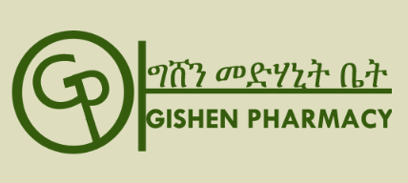
Gishen Pharmacy, is a chain retail pharmacy established in Ethiopia in 1994 with the vision of ‘'Serving for the best of humanity''. They value and participate in community development.
IFA gratefully shares about the valuable support GP offered at the launch of the school health and nutrition program this October. Eight staff members of GP under the guidance of IFA’s SHN coordinator assisted in conducting anthropometric measurements for all the children enrolled in the program at Sibiste Primary School and Aghazian Primary school by bringing on site their own state of the art measuring tools which produced printouts of height, weight and BMI for each child.
GP also provided the children with much needed school supplies such as pencils, erasers and sharpeners. Additionally, GP has given IFA a 5% standing discount for all medicine supplied to the children such as deworming tablets and medication prescribed to children identified to have eye infections through IFA’s school eye health program.
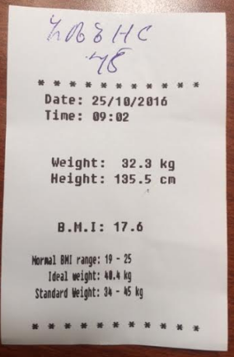
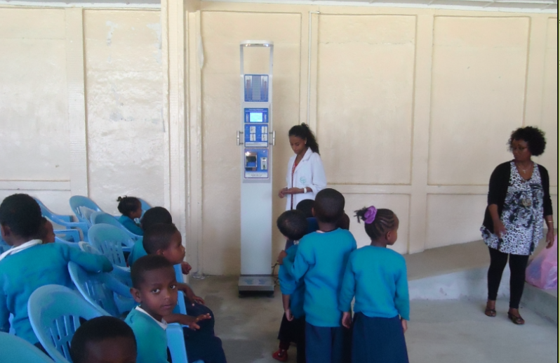

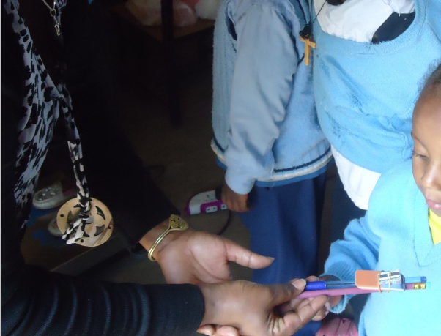

Year-end Reminder
Please remember to nominate International Fund for Africa (IFA) as your chosen charity at smile.amazon.com. It is a simple way to support IFA’s activities in Ethiopia. All you need to do is to shop at smile.amazon.com and search for International Fund for Africa. Remember, it is only purchases made at smile.amazon.com that are eligible for donations. Amazon will donate 0.5% of every purchase you make at smile.amazon.com. You do not incur any extra expense as the donation comes from Amazon.

