IFA’s Human Capital Engagement

IFA and Gender Equality
IFA as an organization with a mission to ensure the wellbeing of women and children is excited about the unprecedented transformative changes sweeping through Ethiopia. The month of October is when the country’s new Prime Minister – Dr Abiy Ahmed – ushered in a ministerial cabinet in which 50% of the posts are now held by women. In the same month Ethiopia appointed its first female president. The country is tremendously hopeful that these changes will have a ripple effect on societies – especially the vulnerable members.
IFA as an organization that has long worked by example - posting women in leadership positions and through projects such as our menstrual hygiene management project that empower girls is helping reduce gender disparity.
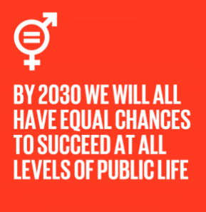
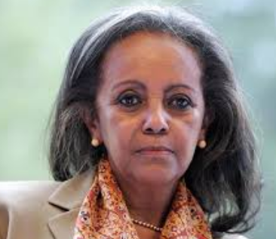
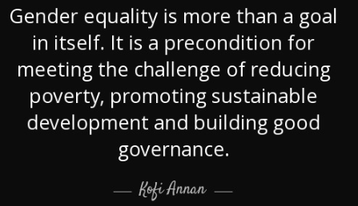
President of Ethiopia – Sahle-work Zewde
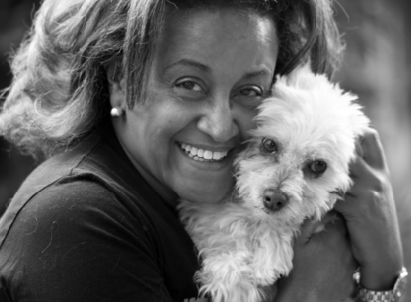
Co-founder and Director of IFA – Seble Nebiyeloul

IFA and Children

IFA’s School Health and Nutrition Program is positioning children for an independent future in Ethiopia. Studies show that earnings increase by 8-10% for each additional year a person is schooled, and the returns can be as high as 22%.
IFA’s School Health and Nutrition Program continues to invest in school children – a powerful intervention that prevents hunger and addresses malnutrition, improves the learning capacity and health of children. IFA’s SHN program targets vulnerable children who face poverty and neglect. The interventions transfer value to households by freeing up resources within households.
IFA has:
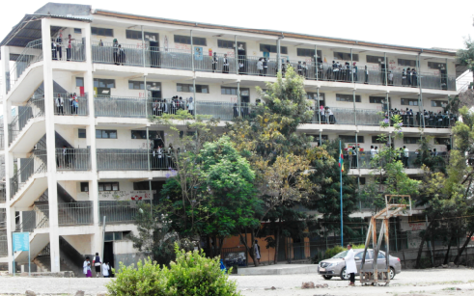
- served over 700,000 school meals in 4 schools
- screened the visual acuity of 30,000 school children
- provided reusable sanitary pads for 7,000 school girls
- installed 5 water tanks and 2 hand washing facilities
- provided many trainings on nutrition and hygiene
- provided many school supplies

As we near the end of 2018 we invite you to Kick Start IFA’s Human Capital Championship

Get and accumulate points until December 31, 2018 to become a champion.
Choose the intervention that appeals to you ….
School Meals
Get 8 Points by providing Breakfast and Lunch for 50 Children for One Day ($ 25)
Get 15 Points by providing Breakfast and Lunch for 100 Children for One Day ($ 50)
Get 20 Points by providing Breakfast and Lunch for 20 Children for One Month ($ 220)
Get 30 Points by providing Breakfast and Lunch for 50 Children for One Month ($ 550)
Get 50 Points by providing Breakfast and Lunch for 100 Children for One Month ($ 1,100)
School Eye Health
Get 6 Points by providing 1 Spectacle for 1 Child ($13)
Get 18 Points by providing 10 spectacles for 10 Children ($130)
Get 18 Points by providing 20 spectacles for 10 Children ($260)

School Girls Hygiene
Get 2 Points by providing 1 Girls with 1-set of 6 reusable sanitary pads ($2)
Get 5 Points by providing 10 Girls with 1-set of 6 reusable sanitary pads ($20)
Get 12 Points by providing 50 Girls with 1-set of 6 reusable sanitary pads ($100)
…and we have winners! To be announced Jan 2019

