NEW SCHOOL YEAR HEALTH AND NUTRITION PROGRAM OFF TO A GOOD START

Zero Tolerance for Stunting

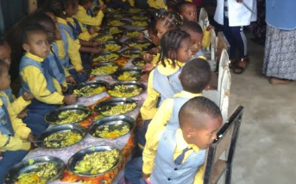
Serving breakfast and lunch for 800 KG students to reduce and prevent child undernutrition - stunting, wasting and micronutrient deficiencies

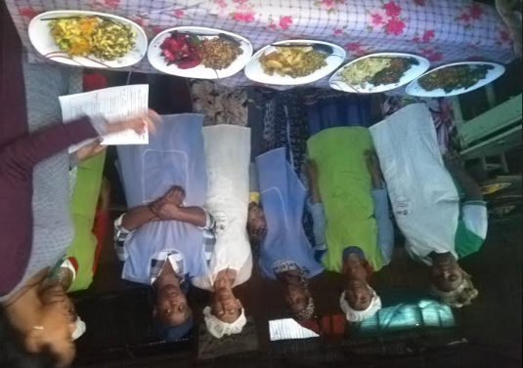
There is increasing interest in policies aimed at improving Early Education and Care in Ethiopia. The school serves as a health promoting environments, both as a place for healthy eating and where health promoting behavior can be ensured.
IFA serves balanced meals in an education settings making a significant contribution to the children’s total diet. The meals have all three groups – starch, vegetable and protein. Good quality school meals are improving children’s diets and health.

IFA has shifted its focus to reaching preschool children
Globally, one out of three preschool children are affected by malnutrition. In 2018, about 155 million children under the age of 5 years were stunted and 52 million wasted worldwide. Asia and Africa contributed 56 and 38% of stunting, and 69 and 27.2% of wasting, respectively, of the global undernutrition burden.
Wasting reflects acute undernutrition due to inadequate food intake that causes weight loss. Stunting reflects chronic undernutrition due to failure to receive adequate nutrition over a long period Additionally, undernutrition directly contributes to child mortality.
In Ethiopia, child undernutrition continues to be a serious public health problem. In 2016 it was reported that the rate of stunting was reduced to 38% while wasting remained unchanged at 27%. IFA’s focus on kindergarten students contributes to reducing wasting and stunting for over 800 preschoolers by providing balanced nutritious meals on a regular schedule and in adequate amount.

IFA Strengthened its Strategic Approach to School Health and Nutrition
IFA has streamlined and strengthened critical linkage processes of the SHN, including food procurement, meal planning and food preparation, capacity development of foodservice staff, the food environment, community involvement and food and nutrition education. These strategic links aid and re-enforce each other.

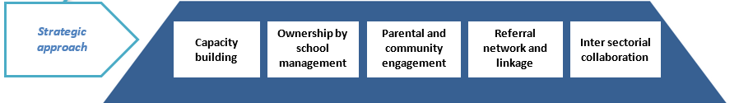

Ownership by school management and staff - IFA works closely with the SHN committee whose members represent the school and community to integrate the SHN program into the schools ongoing plan. This is motivating teachers and school management to volunteers their time and take responsibility for the health and well-being of the children.
Parental and community engagement - together with the school health team and teachers, the school community is partnering with IFA in meaningful ways as IFA shares information on the gaps and needs of the SHN program. Parents with the school community participated this year by building additional dining space, they are taking a more active role when asked for support.
Capacity building – IFA trains students, teachers and parents on hygiene, sanitation and nutrition teachers to further strengthen the sustainability and ensure ownership the SHN program. Volunteer teachers are also trained on vision screening to identify children who may need spectacles.
Referral network and linkages – companies dedicated to meeting their corporate responsibility have partner with IFA. Currently IFA works with SAM Vision, a private for-profit eye care center to provide refraction for children with poor vision. H&M supports IFA in providing girls with reusable sanitary pads. This year, due to the high inflation rate wholesalers organized by district offices of the schools IFA works with are offering some food commodities at prices below the retail price.
Inter-sectorial collaboration – Since school health is not the responsibility of one single sector, IFA has attained strong harmonization of its programs by working closely with the Ministry of Health, Addis Ababa Education Bureau, Ministry of Women, Children and Youth, Ministry of Agriculture and Northern Shewa Zone Office. IFA’s collaboration and networking with these stakeholders is playing a central role in facilitating joint planning and implementation of the school health activities.
IFA launched the SHN Program in 2014 and we are now in our sixth year!
We started with 200 students and just one package today we are reaching:
- 900 students with two school meals per school day
- 12,000 students per year receive vision care
- 1,500 girls per year receive reusable sanitary pads
- An income generating mushroom farm about ready to be launched

IFA acknowledges and honours our partners and stakeholders as all achievements were made possible through their support
These lean times call for more dedication
Please share our news and let others know about the work IFA is doing.
Celebrate October 22 – Make a Difference Day
by supporting IFA make a difference in the lives of children

