BACK TO SCHOOL WITH A NEW APPROACH - Integrating agricultural production with plant based nutrition in Jihur

IFA is piloting a new approach in Jihur Primary School. As we start the new school year the vulnerable school children enrolled in the school health and nutrition (SHN) program will receive generous amounts of take home rations of high nutritional value that will help feed the whole family.
The take home ration is a multigrain composite mix prepared from different cereals, legumes, millets, nuts along with condiments. All the ingredients grown in the area will be purchased from local farmer cooperatives thus providing an assured market from the SHN program and useful in creating a strong link with the community.
Additionally, this approach provides employment opportunity and further community involvement as preparing the mix will entail cleaning, destoning and toasting. Furthermore, IFA will continue providing relevant nutritional training on how to prepare meals from these take home rations. The training will focus on the benefits of good nutrition and what it can do for their minds and bodies as studies show some of the reported malnutrition in Ethiopia is not directly due to food insecurity.
IFA and the school community are equally enthusiastic to launch this pilot program and will closely monitor the process and evaluate the outcome to ensure that we meet our health and education related goals. Take home ration distribution will be closely tied to student’s attendance to encourage school attendance. The mix includes the following 17 ingredients:

- Barely
- Oats
- Teff
- Corn
- Wheat
- Check peas
- Beans
- Peas
- Sunflower
- Niger
- Flax seed
- Fenugreek
- Soy beans
- Sorghum
- Red bean
- Peanut
- Salt

IFA anticipates fluctuations in price may pose a serious challenge during implementation and procurement as was recently witnessed in the market when the price of maize soared by close to 80% from a year ago (FAO Country brief -August 2017).

BACK TO SCHOOL WITH A NEW MENU – promoting food diversity in school meals served in Addis Ababa

Yearly, IFA introduces new school meal menus that promote food diversity – this year the lunch menu includes appetizing, nutritious choices that meet the standard. Although the meals expose the children to new tastes we make sure we are responsive to their feedbacks.
Mondays Lunch Fridays Lunch
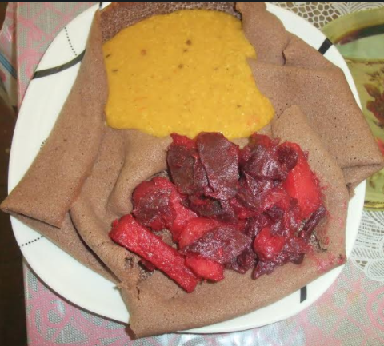
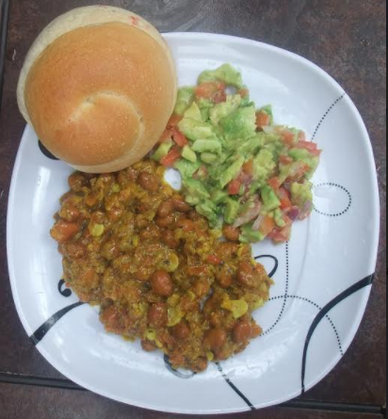
Teff Injera with lentil stew and potato and beetroot salad
Kinche (cracked whole wheat) with avocado and tomato salad

This year IFA is pleased to scale up the coverage of school health and nutrition program to serve 650 students. These achievements are made possible through our committed supporters. A recent study conducted in Kenya indicates that the investment of 1 US dollar in school meals returns 9 US dollars to the economy (WFP, 2016. Investment Case Study for School Meals Program in Kenya). It’s not only the return on the investment that drives our work among school children but investment in human capital is rewarding at all levels.

