September Highlights

The month of September (Meskerem), is the beginning of the new year in Ethiopia. It’s the time of year when the heavy rainy season ends, and gloomy-cloudy days are replaced with bright sunny, warm days. The seasonal, beautiful “meskel flower” blooms, carpeting the landscape in bright yellow color.
This September marks a unique time as it also seems to have lifted the heavy blanket of the COVID pandemic scare, as we witnessed infection rates and infection fatality proportions that are much lower than the prediction – after seven months of fighting the pandemic the numbers in Ethiopia are encouraging at:

Coronavirus Cases:73,332 Deaths:1,170 Recovered:30,363
IFA continues to join the effort to fight the spread of the novel corona virus by supplying communities with face masks and take-home rations for vulnerable school students and their families.

IFA’s Wins Recognition

September 2020 also brought IFA highly valued recognition for its work among the disadvantaged in Addis Ababa. IFA was awarded a certificate of recognition during a nationally televised ceremony as IFA’s Co-founder and Country Director, Seble Nebiyeloul was called upon to receive the award from the Deputy Prime Minster of Ethiopia, Demeke Mekonen. This means a great deal for the organization and the team.
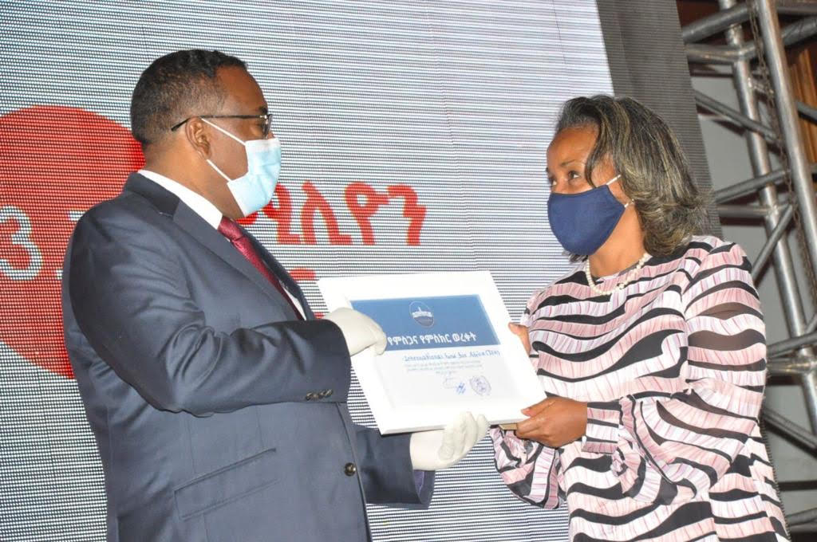
Seble Nebiyeloul receiving outstanding service recognition on behalf of IFA from
His Excellency Demeke Mekonen - Deputy Prime Minister of Ethiopia

Promoting Self-Sufficiency for People with Disability
IFA in partnership with Wheels for Africa worked closely with the Mayor’s Office of Addis Ababa and the Bureau of Labor and Social Affairs to promote self-sufficiency for persons with disability by providing much needed wheelchairs to meet their mobility needs as we help in the building of inclusive societies.
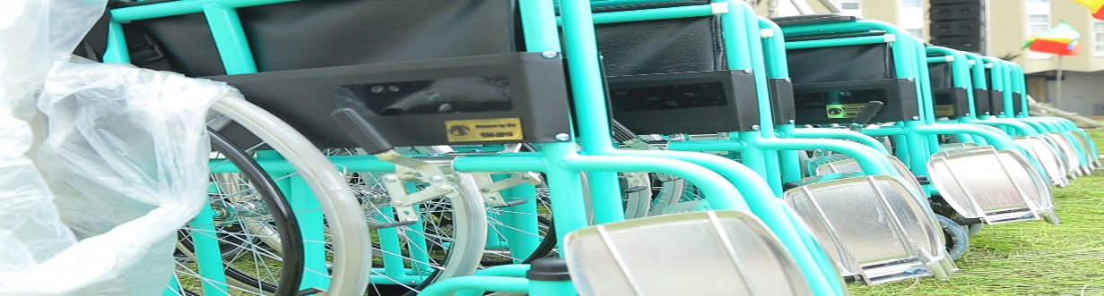
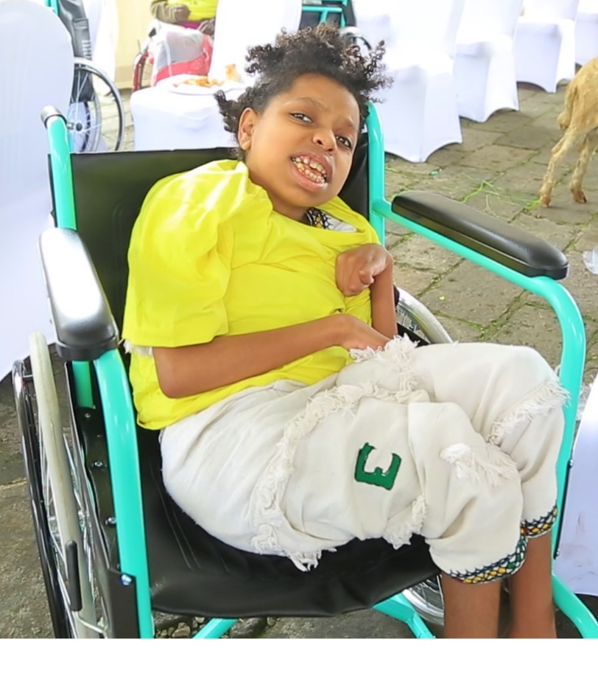
This project began as a deep concern held by Seble, the Country Director of IFA, as she witnessed the many disabled persons crawling on the streets of Addis. The final call came for her when she witnessed a man who was nearly run over by an SUV at a streetlight as he was crawling on the ground to cross the street. These incidents are the norm for most but not for Seble. Thus, IFA sought to address this gaping need in Ethiopia by networking with friends and supporters which resulted in forging a successful partnership with Wheels for Africa.
IFA’s long-standing policy is to work in close collaboration with national and regional government bodies in compliance with existing disability policies. Therefore, after signing an MOU with the Bureau of Labor and Social Affairs, IFA delivered 300 wheelchairs under the jurisdiction of the Mayor of Addis Ababa.
This is just the beginning as IFA hopes to inspire the support of many to join its effort in securing the dignity and self -sufficiency of people with disability so they can meet their education, health, and livelihood needs. IFA plans to raise the funds for setting up a wheelchair repair workshop and possibly a wheelchair assembly plant so that wheelchairs can be obtained and maintained at an affordable price in Ethiopia.

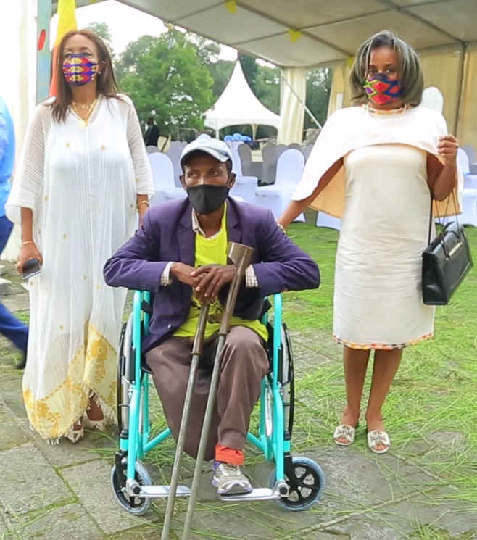
IFA is grateful for our partner, Wheels for Africa and Roman Kifle for serving as the facilitator in building the partnership.
IFA is very grateful for the collaborative effort of the Mayor’s Office, City Administration Staff and the Bureau of Labor and Social Affairs in assisting IFA during selection of beneficiaries and distribution during the difficult days of the COVID 19 pandemic.

IFA is eagerly looking forward to expanding it work for people with disability. We invite all interested join this rewarding work.

